**Pre-Work for Mapping Your Current Fundraising System**

**What is the Mapping Exercise?**

This activity is foundational to the work your team will be doing together over the next six months. Having a clear understanding of the roles you activate for fundraising and development and the people who fulfill those roles is important before planning to make fundraising more widespread. It’s as important as your fundraising goals, strategies and, along with a database, the people and roles that comprise the current development system.

1. Consider all the activities that occur during the year to raise money from individuals and institutions.

Create a list of those actions, organized around these categories: *Identifying prospective supporters; Cultivation of prospective supporters; Asking for new support and renewals; Recognition and Thanks; Stewardship.* List any events within these categories based on the function that the event is serving.

Example: a house party may be “asking for new support or renewals” an open house might be “identifying prospective supporters” a gala event may be “Asking” as well as “Stewardship.”

|  |  |
| --- | --- |
| **Category** | **List all activities in the year** |
| **Identifying potential supporters “prospects”** |  |
| **Cultivation** |  |
| **Category** | **List all activities in the year** |
| **Asking** |  |
| **Recognition** |  |
| **Stewardship** |  |

***Bring this list to Day 1! You’ll need it for the rest of the mapping exercise.***

**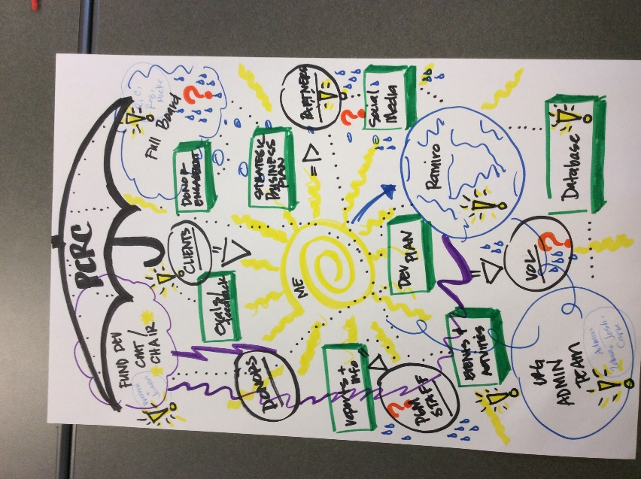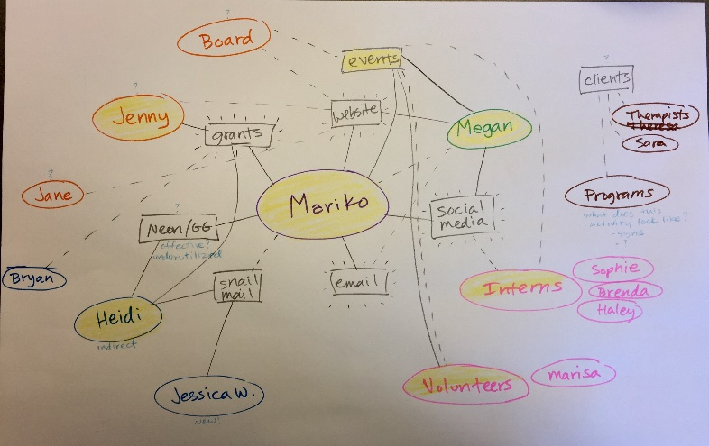*(Just as a preview – here’s a few examples we’ve seen in other Bright Spots Cohorts).***