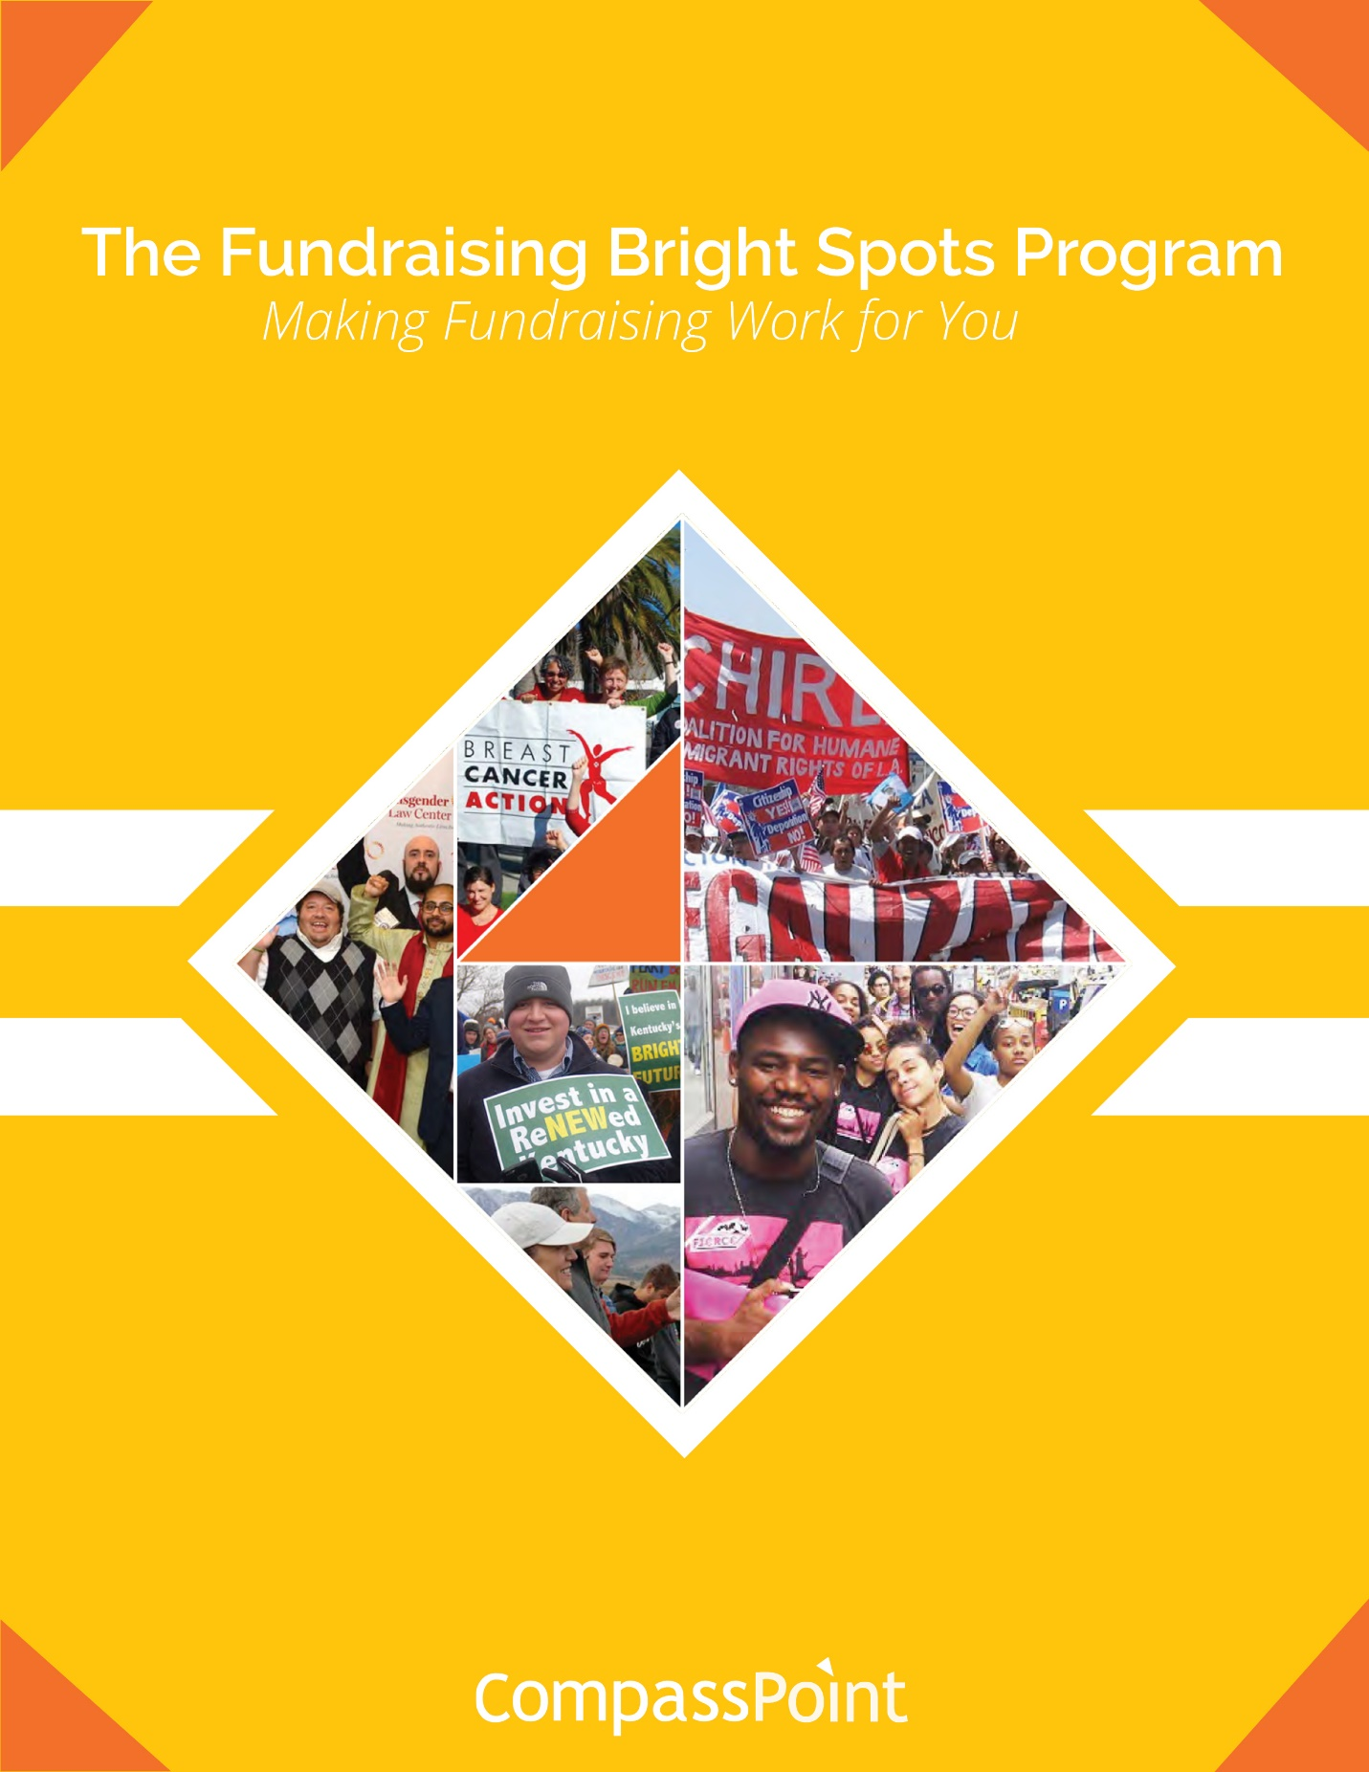

**Distributed Fundraising:   
Leadership Roles and Skills, Building and Sharing Power**

**Session 2: October 11, 2018**

**Disclaimer**

All material is provided without any warranty whatsoever, including, but not limited to, the implied warranties of merchantability or fitness for a particular purpose. Any names of people or companies listed in this book or in its companion computer files are fictitious unless otherwise noted.

**Copyright**

©2018 CompassPoint Nonprofit Services unless otherwise indicated. All rights reserved. This publication, including any companion computer disk, or any component part thereof, may not be reproduced or transmitted in any form or by any means, electronic or mechanical, including photocopying, recording, storage in any information retrieval system, or otherwise, without the prior written permission of the author.

CompassPoint,

500 12th St, Suite 320 Oakland,

CA 94607

ph 510.318.3755

**LEARNING AGREEMENTS**

* **Confidentiality** is often defined as “what’s said in the room stays in the room” and we agree not to discuss what happens here in a way that would identify any individual or organization. There is another dimension to confidentiality that includes “asking permission” to share or discuss any statement another person makes of a personal nature. It helps to remember that the story belongs to the teller, not the listener.
* **Move-up Participation**. Honor different beliefs and encourage empowerment by making a space for all voices, experiences and ideas to be heard and shared. Talking does not equal participation. Generous listening is a form of participating. If you speak a lot, try listening more. And it you tend to sit back and listen, consider speaking up more.
* **Intent is different than impact**, and both are important. It is also important to own our ability to have a negative impact in another person’s life despite our best intention. In generous listening, if we assume positive intent rather than judging or blaming, we can respond, rather than reacting or attacking when a negative impact occurs.
* **It’s okay to disagree**. Avoid attacking, discounting or judging the beliefs and views of yourself or others – verbally or non-verbally. Instead, welcome disagreements as an opportunity to expand your world. Ask questions to understand other people’s perspectives.
* **Be open to new ideas and perspectives**, and be open to having your current ideas and perspectives challenged.
* **Embrace inquiry**. Ask difficult, reflective questions as a matter of course.
* **Create space to make mistakes, celebrate success, and learn from both**.
* **Care for yourself, your learning partner, and this learning community**.

**SESSION TWO:**

**DISTRIBUTED FUNDRAISING: BUILDING AND SHARING POWER  
Today’s objectives:**

* Have named potential shifts in your personal beliefs about fundraising, money, power and leadership.
* Have begun to identify ways to apply “fundraising bright spots” concepts to your fundraising staffing structure.
* Have a deeper understanding of the competencies needed throughout your organization to strengthen fundraising.
* Have begun to name the systems you use, and how they might support further distribution of fundraising.

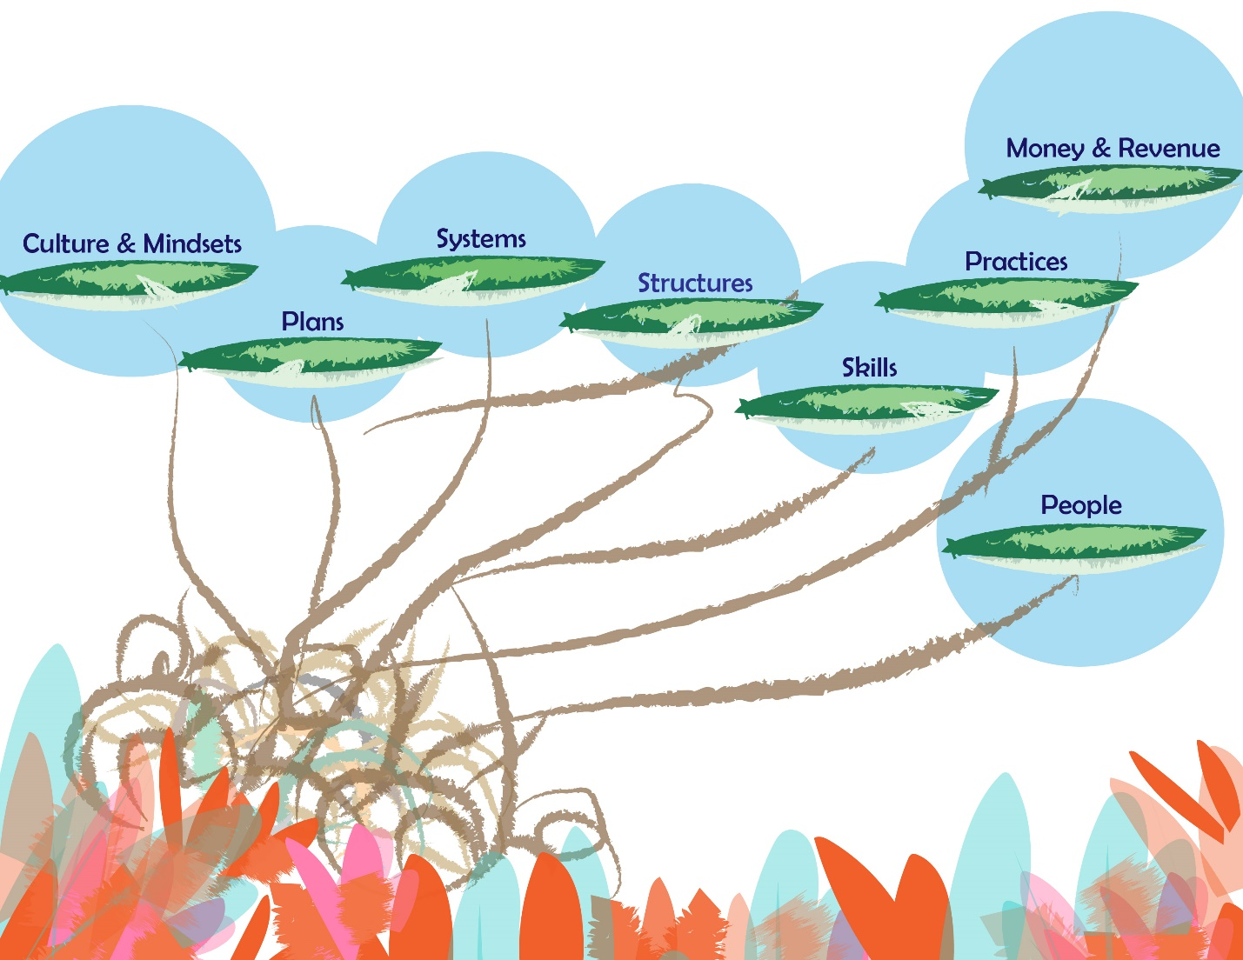

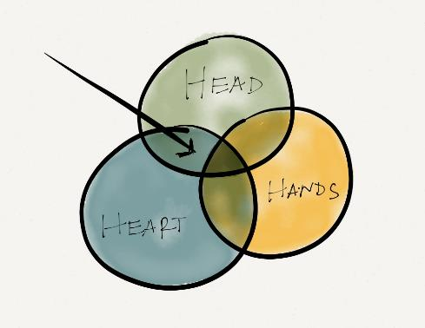**What Are You Curious About?   
What’s Different Now?**

**In small groups, discuss:**

* Any new actions and/or ideas since session 1?
* What’s a question you want to think about today related to organizational roles, structure or culture?

**NOTES**:

**Exercise on Money and Power**

**First round: Home Culture.**  What did you learn in your home about money? When did your family talk about money, how did they talk about it? How was money shared, given away in the community you grew up in? You can share both positive and negative memories about money and power in your home culture.

**Second round: Dominant Culture.** What does the mainstream/dominant culture teach us about the relationship of money & power? What did you learn in school or from news, entertainment media? How does that influence your thinking and behavior with regard to money?

**Third round: Money Culture.** Who is perceived to be good with money? Who is trusted to handle money, and the power that comes with it? How does culture impact philanthropy for your organization? How do your bright spots illuminate or obscure perceptions about money and power? What strategies can you use to expand your bright spots?

**How can we disrupt certain behaviors and beliefs in fundraising?**

**Notes for personal reflection: Changing Power Dynamics.** Think of your work as a fundraiser. What we think and feel about asking for money can change over time. What have you learned or tried in changing power dynamics so that you and others are more powerful when asking for money?

**Group Debrief – Group Mind Sets**

Name any group mind sets that hold back power building and fundraising in your organization?

How can we disrupt, challenge them?

**Fundraising is Distributed Broadly across Staff, Board and Volunteers**

**From Bright Spot Interviews**

**We engage staff in two fundraising vehicles a year: our gala and our membership drive. They know these are coming and when they’re going to end; they know they’re going to have to set a goal. We provide talking points, tracking sheets, trainings, one-on-ones, all kinds of materials that people need to engage. We do regular check-ins about the outcomes; it’s very transparent. It’s not about public shaming but collective accountability.**

**It’s not about someone being professional or educated in a certain way. It’s really about shedding light on the fact that we already have these skills in communities of color. It’s about making visible and lifting up the resourcefulness that we’ve always had.**

**My primary job as Development Director is leadership development. Leadership development is the first among equals of all of [our] strategies. Without leadership development of staff, board, and members, none of our other strategies are possible.**

**From the Research**

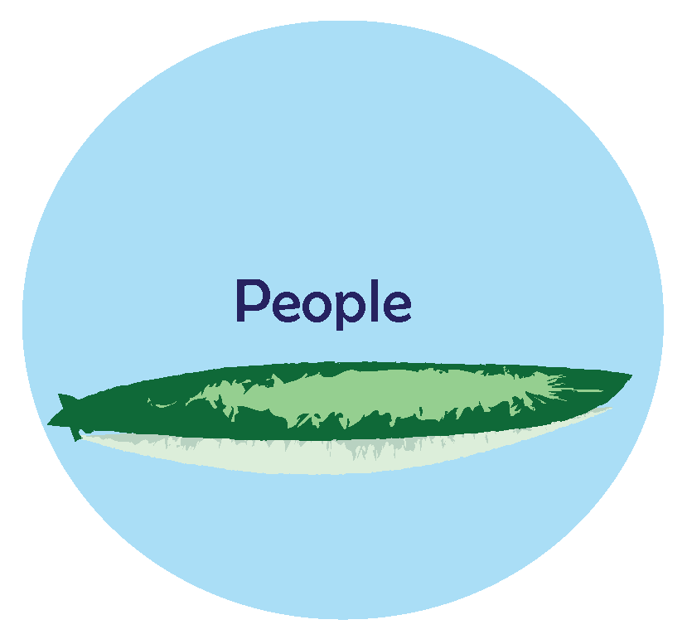The *UnderDeveloped* report revealed many organizations think that the answer to their fundraising challenges lies in finding that elusive, perfect development director. Surprisingly, we found that the majority of the people we interviewed from each Bright Spot organization—all of them involved in fundraising in one way or another—did not have development in their title. Some organizations intentionally did not have the word development in their titles. In fact, some organizations intentionally do not have a development director. Instead, fundraising roles and responsibilities are distributed among staff, board, and volunteers, who often use online crowdfunding platforms to allow the fundraisers to tailor the message of the campaign to resonate among their own peer networks.

And, whereas organizations constantly hear and read that their board of directors should be the center of gravity for their fundraising—and often bemoan board members’ lack of engagement—the Bright Spots engage non-development staff and volunteers just as actively as they do board members. Board members play an important role, but they are not viewed as more or less capable of fundraising as other stakeholders.

“Bright Spots” organizations don’t view spreading the responsibility and work for raising funds across the organization as simply distributing a burden. Instead, they see fundraising skills as intrinsically valuable for all people doing social change work, not just those pursuing careers as professional fundraisers. For example, a number of Bright Spot see supporting young people of color to engage in fundraising as part of developing their leadership and lifting up their stories and experiences.

This broad distribution of effort has significant implications for the role of the development director, when there is one. Time and again, we heard from the development directors at these organizations that their job is to coordinate, to teach, to coach, and to inspire. These skills—skills that are very relational—are also deeply satisfying as they enabled staff, board, volunteers, and members to be successful fundraisers.

**Bright Spots Conversation with Lupine & Sammie:**

**Sammie Ablaza Wills** is ED of Asian and Pacific Islanders for Equality Northern California (APIENC), was in the 2017 Bright Spots cohort with MLin, the one other paid staff at APIENC, and their distribution work started from an intricate "map" of core team, interns and board since there are just two paid staff. <https://www.apienc.org/> .

**Lupine Reppert** is Development Director at California School Age Consortium (CalSAC) and was in the 2016 Bay Area Cohort with their ED, Ruth.  There is a great article that Lupine wrote about introducing fundraising into staff of eleven, board and more recently volunteer 'ambassadors', in the Grassroots Fundraising Journal-  <https://www.calsac.org/>

**Roles & Structure**

**Yoyour current**

**What do you want your fundraising map to be?**

**Distributed Fundraising Model Archetypes**

**TYPE 1: Board as the Center of Gravity** e.g. National Center for Lesbian Rights

* 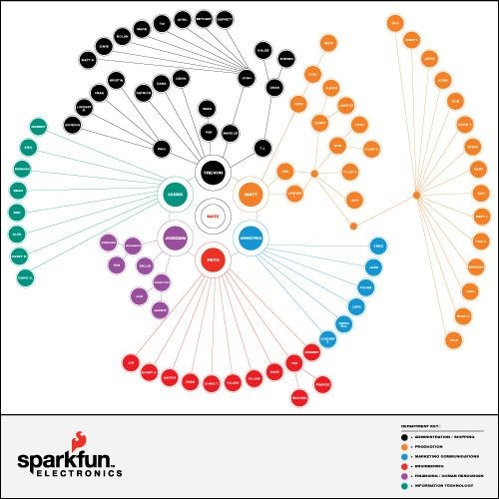600k raised by 30 people- NCLR board members, staff and former board members. Gifts of $1,500 and above.
* Campaign structure: Co-Chairs, Major Gifts Campaign Captains, Solicitors mostly from board
* Raised over 3 months. October – December
* Solicitors send letters, follow on by email and calls to meet with existing donors who give > $1,500.
* Weekly check ins of Campaign Captains with Major Gifts Officer
* Fun Fact: There is NO “give or get” amount for board members.

**TYPE 2: Significant Use of Volunteer Fundraisers Online** e.g. Students for Farmworkers

* 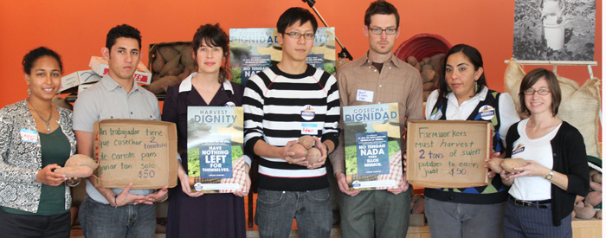Train and support 50 program participants, alumni, donors and board members to raise $42,000 through online fundraising pages in short spurts, between 2 days to a week.
* 2 months before the campaign: Recruit 50 volunteers
* 1 month before campaign: provides training and materials to set up pages
* Frequent contact with volunteers so they are successful online fundraisers

**TYPE 3: Staff Driven (different roles by team)** e.g. Mujeres Unidas Activas

**Mujeres Unidas Activas** has experimented with matching work team roles with fundraising strategies.

-Organizing team identifies new supporters in their neighborhood outreach and work with small businesses.

-Direct services team calls lapsed donors because they are familiar with the personal stories of their members.

-Operations team reaches the annual supporters to renew.

-Directors steward and ask for major gifts.

**TYPE 4: Donor Portfolio** e.g. Jewish Voice for Peace

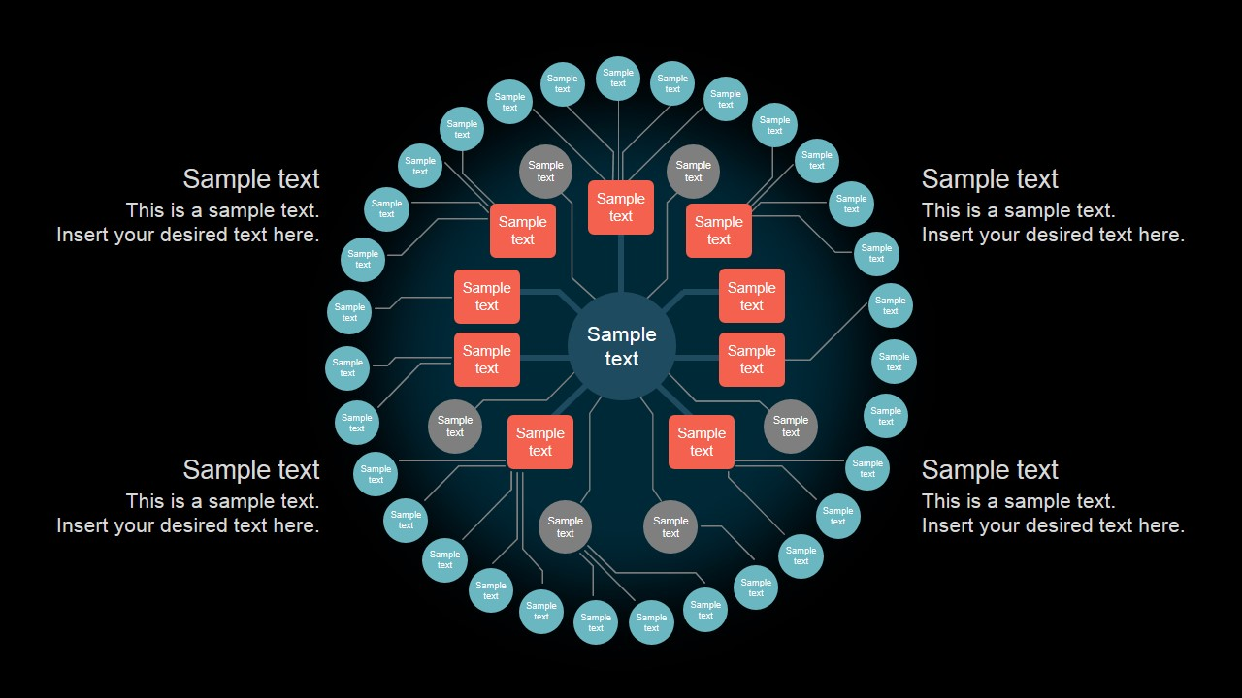**Jewish Voice for Peace (JVP)** employs the portfolio system on an impressive scale in support of its major donor program. The organization has 57 portfolio managers from across the staff, board, and volunteers who together manage 600 major donor relationships in addition to other roles they play within the organization. “We all take seriously as organizers that our work is also to inspire people to build and sustain JVP,” said Rabbi Alissa Wise, co-director of organizing, who has 30 major donors in her portfolio. With so many people so deeply engaged in fundraising and donor stewardship year-round, Development Director Ari Wohlfeiler sees his primary role as coordinator. Portfolios are assigned based on common interests and styles of the fundraiser and donors. It’s relational and resonant when the fundraiser stays in touch with the donor throughout the year, makes periodic asks, and communicates personal thank-you’s.

**Distributed Fundraising Model Archetypes**

**TYPE 1: Board as the Center of Gravity** (e.g. National Center for Lesbian Rights example)

**TYPE 2: Significant Use of Volunteers** (e.g. Students for Farmworkers example)

**TYPE 3: Staff Driven (different roles by team)** (e.g. MUA example)

**TYPE 4: Donor Portfolio** (e.g. Jewish Voice for Peace example)

**What’s Your Ideal Staffing Structure?**

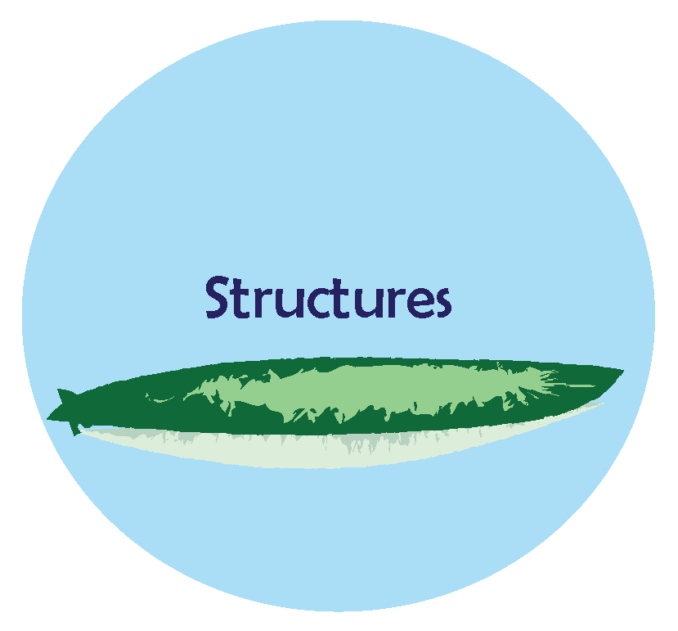**Exercise**

**Return to your work from session 1 and review:**

1. Your “map” of current fundraising system
2. Your revenue model (noting who are the people who maintain and grow each revenue stream)
3. Where staff and non-staff such as board, donors, members, volunteers are located.

**Discussion in your organizational team:**

1. Name the specific places that distributed fundraising shows up in your organization (e.g. strategy creation, planning, and specifically in implementation – the activation of the strategy and the plan).
2. What changes or improvements do you want to make with your current fundraising staffing structure?
3. Within your development role, how can you share power & leadership more and support others in the system?
4. Draw a new map to show your desired/aspirational staffing structure OR, write it out below:

**Give Your Aspirational Staffing Model a Name: ___________________________________________________**

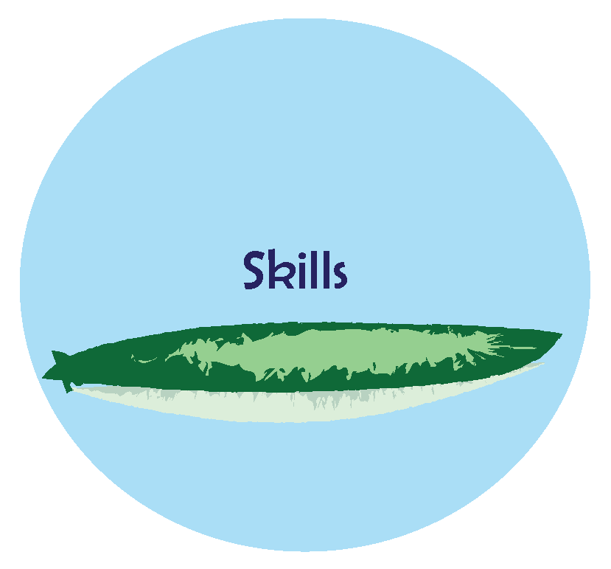**Competencies and Skills to Activate Aspirational Staffing Structure**

Competencies are observable and measurable characteristics of a person that include using knowledge and demonstrating skills, behaviors, and abilities that contribute to performing well.

***Development Directors are organizational leaders focused on skills building, culture change, and systems development to activate and support others in fundraising.***

A competency can be a behavioral skill, a technical skill, an attribute (such as empathy, creativity or connectedness).

|  |  |  |
| --- | --- | --- |
| **Sample Competencies** | **How it Contributes to Success** | **Who in our organization has these competencies-strengths? How can we incorporate them into our development model?** |
| Ability to influence without authority | Working with volunteers and community members who do not “report” to me |  |
| Tact | Ability to partner with board members and others with positional power |  |
| Systems thinker | Being able to see and hold holistic, organization-wide perspective and how dynamics are playing out |  |
| Coaching/mentoring | Enabling, supporting, empowering volunteers and staff |  |
| Analysis | Interpreting and making meaning of data |  |
| Empathy | Understanding donors motivations, cultivating and building relationships with people |  |
| **Sample Competencies** | **How it Contributes to Success** | **Who in our organization has these competencies-strengths? How can we incorporate them into our development model?** |
|  |  |  |
|  |  |  |
|  |  |  |
|  |  |  |

Who is your “Talent Development” person?

Who’s the right person in your organization to steward and integrate the system? What skills and authority do they need to succeed?

You can learn more about talents and strengths in your team, staff and board by taking the [Strengthsfinder](http://strengths.gallup.com/default.aspx) assessment tool, and having others assess themselves.

**Right, Integrative Systems**

Key systems that most organizations require for fundraising success:

**Explicit: Tech and IT**

* + Technology and information systems for the collection, analysis and reporting of prospects and donors
  + Evaluative data from program
  + Financial systems
  + Staff structures; fundraising roles across paid staff, board and volunteers. Work processes within the structure

**Implicit: People and Power**

* + Integration and alignment of communications & fundraising data
  + Understanding power dynamics that exist interpersonally and across positions and roles throughout the organization- sharing power, distributing power
  + Ways to activate “integrator” role(s): person or people that stewards the strategy, make meaning of data, support and provide leadership across the system

**What systems do we have? How do we use them?**

|  |  |  |
| --- | --- | --- |
| **Name your systems** | **Name the key functions** | **How do you want to use this system to support future distribution?** |
|  |  |  |
|  |  |  |
|  |  |  |

**What’s Next for You?**

**Before session 3, each team should complete the following:**

1. Continue to inventory/audit current systems; create a list.
2. Assess each element that you currently have in place. Rate how well it is utilized for meaningful decision making:

1 = utilized regularly

2 = utilized sometimes

3 = rarely utilized

4 = never utilized

1. Connect with your Coach before session three.
2. Read the article “Insights of a Methodical Communicator: From Creating a Plan to Managing a Calendar” by Yee Won Chong (in the January-February 2015 issue of *Grassroots Fundraising Journal*)
3. Scan the GFJ article archive to download topics you want to discuss in future session.

**NOTES:**

**NOTES:**