**Exercise on Money and Power**

* 4 groups with 5 people each (mixed groups not in pairs) count off 1-4
* Have a timekeeper to let groups know when to move to next round.

First round - 30 minutes - ***Home Culture***. See questions on worksheet and make sure everyone has a chance to share and cover a few questions. Do not summarize and or make conclusions about what people say.

***What did you learn in your home about money? When did your family talk about money, how did they talk about it? How was money shared, given away in the community you grew up in? You can share both positive and negative memories about money and power in your home culture.***

Second round - 30 minutes - ***Dominant Culture***. See questions on worksheet and make sure everyone has a chance to share and cover a few questions. Try to get people to name several things rather than go back or forth on one single idea. You might summarize or ask people what meaning they are making from the conversation.

***What does the mainstream/dominant culture teach us about the relationship of money & power? What did you learn in school or from news, entertainment media? How does that influence your thinking and behavior with regard to money?***

**Third round: Money Culture- 30 minutes-** Try to get people to name several things rather than go back or forth on one single idea.

***Who is perceived to be good with money? Who is trusted to handle money, and the power that comes with it? How does culture impact philanthropy for your organization? How do your ‘bright spots’ people illuminate or obscure perceptions about money and power? What strategies can you use to expand your bright spots?***

When finished, ask people to start on the reflection on page 5 called: **How can we disrupt certain behaviors and beliefs in fundraising?**

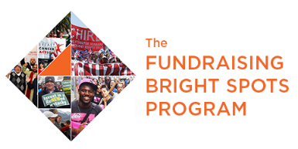

**How can we disrupt certain behaviors and beliefs about money, power and fundraising?**

**Notes for personal reflection: Changing Power Dynamics.** Think of your work as a fundraiser. What we think and feel about asking for money can change over time. What have you learned or tried in changing power dynamics so that you and others are more powerful when asking for money?

**Group Debrief – Group Mind Sets**

Name any group mind sets that hold back power building and fundraising in your organization?

How can we disrupt, challenge them?