Objectives

## Upon completion of this session, we will:

1. Have a better understanding of resilience and why **daily self-care is an important practice of liberation**.
2. Understand the importance of embracing **ancestral ways of being in response to healing** and the dismantling oppressive systems.
3. Deepen our understanding of the “**oppressive mindsets**” that have contributed to our conditioned response “**away**” from self-care and that are **obstacles** to our healing and self-care.
4. Begin to develop **our own unique set of daily healing practices** to allow us to **rest, rejuvenate and strategize**.

Goals & Agenda

**Session Goals**

1. Expand our knowledge of what self-care is, why it’s important, and how it is a radical act of liberation for Black women.
2. Cultivate the wisdom in the room around self-care practices that are grounded in our ancestral knowledge and lived experience.
3. Reclaiming and Remembering our Magic to heal ourselves.

**Agenda**

* **Check-In**
* Goals & Overview
* Movement: Grounding in our Ancestors and Our Bodies
* **Break**
* Developing a Deeper Understanding: Multi-Generational Oppression w/Roots in Slavery
* **Lunch**
* Grandma’s Kitchen Table: Storytelling
* **Break**
* Re-Claiming our Legacy of Magic: Mind, Body, Spirit & Boundaries
* Black Woman’s Magic: Creating Your Medicine Bags
* Circle: What’s in YOUR Medicine Bag?
* **Debrief & Closing**

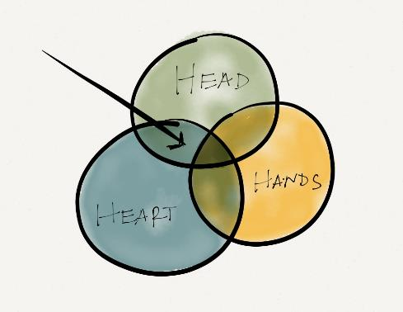

**General:**

* Show up
* Trust the process
* Step up/step back
* Bring heart, not just mind
* Relaxed rigor
* Confidentiality
* 5x bolder
* Accept and expect non-closure

Your Additions:

* Assume authenticity and believe people are coming from a good place.
* Space & patience – from others to be authentic
* Transparency of participants to build trust
* Make room for marginalized voices to be heard, and recognize they don’t speak for their entire group.

**Community Guidelines**

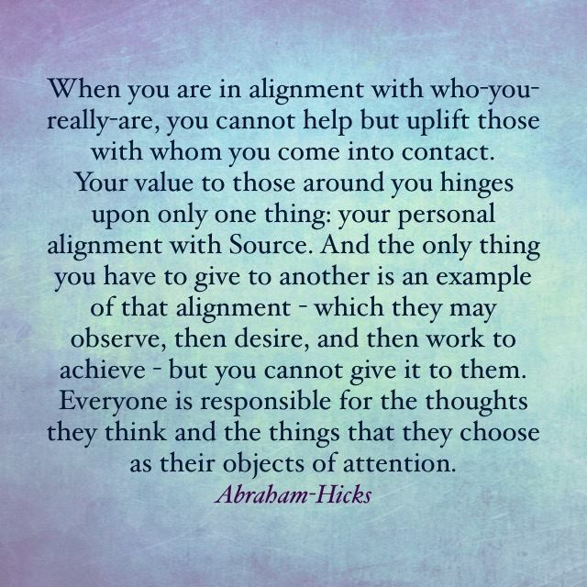

# Morning Ritual/Morning Flow Chant

One practice of many African and Indigenous cultures is to welcome and end the day with a chant of appreciation. Below is an open source chant taken from **Ancestral Resistance: Offerings + Practices**.

The following is a short practice of affirming your strength and setting intentions that can be used to begin your day.

* Place your hands on your belly
* Become present with your morning rhythm, sounds and your body
* Breathe in over that area with a slow calming breath, inhaling for a count of three (3) and releasing.
* Stand if you are comfortable doing so and either in your mind or out loud…chant the following:

Good morning beautiful being of mine.

With these morning breaths, I rise.

I rise with love filled vibrations.

I rise with power.

I rise with grounding energy.

I rise with gratitude for another day.

I rise for collective peace.

I rise for collective liberation.

I rise for collective existence in resistance.

I rise for those present and those to come.

I rise…

# This is Your Space

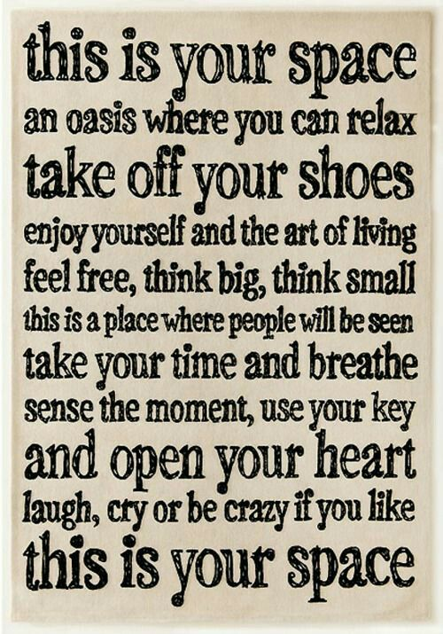

(taken from Nichole Albert-Little’s Facebook page)

# Definitions

**Resilience:** is the ability to renew ourselves during and after difficult, oppressive and/or traumatic experiences. It is our ability to keep hope, to “bounce back” to find a way through that has some integrity and is life affirming.

Somatically we see resilience as our ability to shift ourselves from traumatic, alert reaction to a calmed and more cohesive way of being. Resilience brings back a positive imagination for the future, and allows for both safety and connection to be re-established.

(taken from Regenrative Somatics; <http://www.generativesomatics.org/>)

**Self-Care:** is the care of self without medical or other professional consultation.

(taken from Dictionary.Com; <http://www.dictionary.com>)

**Practice:** is simply the act of doing something, whether that something is as complicated as doing a piano solo or as simple as washing the dishes. We call it practice when the act becomes a repeated behavior. Practice can be both distinct and indistinct. We set aside time to intentionally focus on our practice, such as when we set aside time to practice a musical instrument, basketball or meditation. Practice is also indistinct in that we are always practicing something, whether we are conscious of it or not.

(taken from The Transformative Power of Practice, by Ng’ethe Maina and Staci Haines; <http://www.racialequitytools.org/resourcefiles/TransformativePracticeIndiv.pdf>)

# Why is Self-Care a Radical Act of Liberation?

Many Black women have asserted, created and implemented self-care practices gleaned from ancestral and lived ways of being, into their lives and bodies of work, especially those in academia and the nonprofit industrial complex.

Writers such as Audre Lord and June Jordan have written about the act of self-care in a world that targets Black women, as an immediate act of resistance, liberation and self-love.

In her writing, *Healing Circles as Black Feminist Pedagogical Interventions (Chapter 16), Jennifer Richardson, states…

”I argue that in order to produce true social transformation and strive for a radical notion of collective freedom, we must pay attention not only to our political/ideological positions, but also to our individual and collective practices of self-care and healing – practices that are themselves deeply political.

Pedagogies and praxis in the Black feminist tradition that are accountable to oppressed communities must take a serious look at healing, balance and self-care as powerful forms of resistance to hegemonic cultures and structures.”

To further illustrate this point, we look to the work of **Dr. Joy DeGruy** for the historical markers of why self-care is radical and an act of liberation within a racist construct.

Video: Dr. Joy DeGruy’s, Thomas Jefferson video (**8 mins.**) (<https://www.youtube.com/watch?v=TI7LyhTAktM>)

*Healing Circles as Black Feminist Pedagogical Interventions, Jennifer Richardson, Black Women’s Liberatory Pedagogy, pg. 282

As illustrated in the image below, in order for the colonized worldview to perpetuate itself, it requires:

* A **disconnect** from **Source**/Spirit (key)
* A **disassociation** from the **Body**
* A **denial or distancing** from **Emotions/Feelings**, and
* A **distortion** of the **Narrative/Story**

This is necessary in order to quell the guilt around the genocide and enslavement of nations of “people” via an agenda of violence.

If you will recall the video on Thomas Jefferson; in order for him to embrace his ideology around slavery – he had to disconnect from Source, especially, in order to carry out such barbarism against two nations of people…AND his own children…*shut the front door ☹…

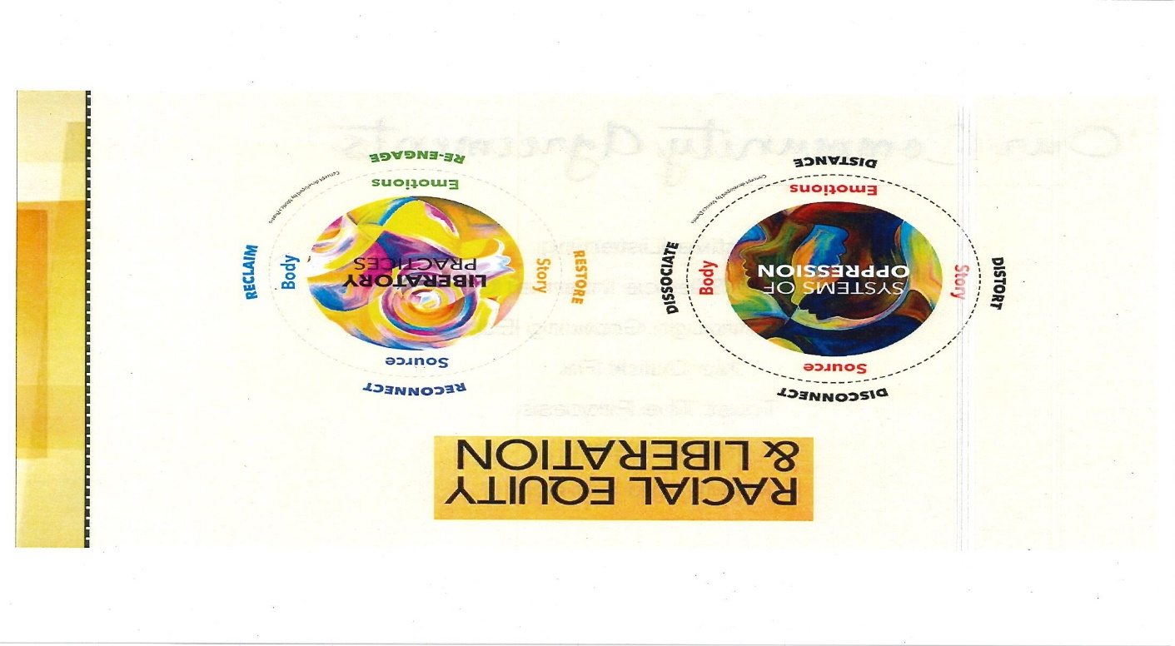

Thus, the act of **(re)connecting** to Source/Spirit, a **(re)claiming** of sovereignty of our Bodies, a **(re)engagement** with our Emotions/Feelings and a **correcting** of the Narrative are the practices that will assist us, as leaders, in liberating ourselves and our people and will dismantle this system of racism.

(taken from, Racial Equity & Liberation symposium, facilitated by Monica Dennis and Racheal Ibrahim in connection with the Move to End Violence movement)

# 1, 2, All Activity

Now, that we’ve viewed the video, consider the following:

What is surprising about what you heard in the video?

How does the, disconnect show up for you?

**1, 2, All Activity:**

**1** – Reflect/journal about the content presented in the video – journal about what you’re **feeling**.

**2** – Share your **feelings**/reflections with one other person.

**All** – Come back to circle - Debrief “**feelings/reflections**” in larger group.

**1 – Self Reflection**

**2 – Pair Share** (listen attentively; capture anything that resonates with you)

|  |  |
| --- | --- |
|  |  |

**ALL – Share** (listen attentively; capture items that resonate with you)

# Grandma’s Kitchen Table

For me and quite a few Black folks of the diaspora, the oral tradition of storytelling happened around grandma’s kitchen table. The discussions were for “grown folks” and if you got caught “paying too much attention” – you were instructed to “stop looking in grown folks mouths” and to leave…so I was a very quiet kid…haha!

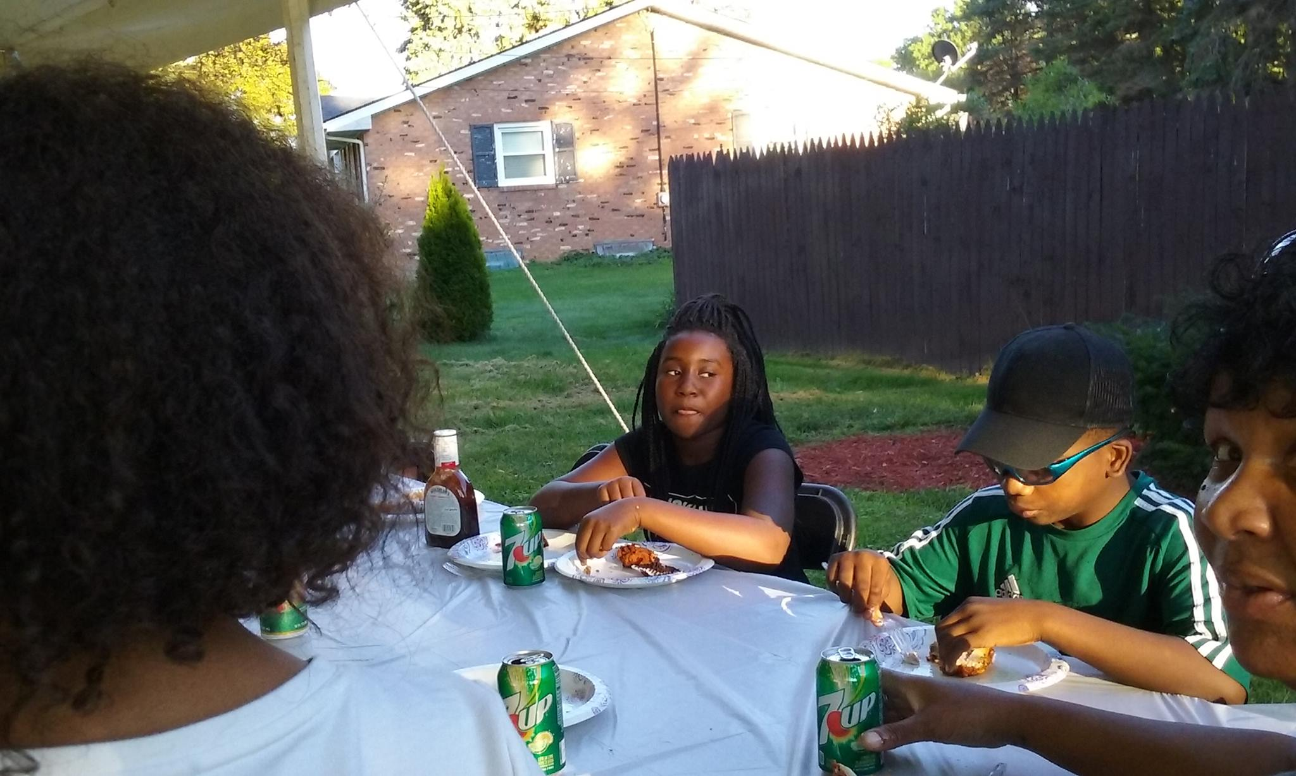

Often times these moments happened around the holidays and we chatted about everyday things, but most often tales of caution and of the old ways long gone were shared…this was/is the modern day meeting place of the Black community.

I am using this concept to surface our default and intentional self-care practices and stories of our own resilience.

Each person will have **5 minutes** to share a story of their own resilience.

# What, So What, Now What? Activity

We will use the ***What, So What, Now What?*** activity to help us further our understanding and to harvest the wisdom in the room.

**What** is surprising about what you heard in the stories?

|  |
| --- |
|  |

**So What** does this mean in regards to you taking care of yourself?

|  |
| --- |
|  |

**Now What,** as Black women…what type of self-care is needed?

|  |
| --- |
|  |

# I am Present, I SEE You, We ARE HERE!

Below is an open source chant taken from **Ancestral Resistance: Offerings + Practices**.

Starting in a circle

* Take one deep breath
* Start shaking your legs and arms
* Shake the rest of your body, releasing and generating flow of blood and oxygen
* Put your hands together and rub them and say…I am Present (3 times)
* Shift to snapping your fingers and seeing each other around the circle and say…I SEE You (3 times around the circle)
* Shift to tapping your knees and running in place and set collective intention of why or what you all are doing
* Start slow and increase momentum and sound
* Keep eye contact with one another and say…

**We are Here!!!! (3 times)**

The fourth time – **increase the volume and speed** of tapping your knees and running in place and raise waving hands to the skies saying our intention…

**We are HERE…Healing Ourselves & The World!!!**

Keep hands to the skies, look up, take deep breaths, hands stretched up and feet rooted into the ground, **your body is resilient, healing and powerful**.

Relax and be gentle with yourself and each other…

# (Re)Claiming Our Legacy of Magic

In preparation for the creation of your own unique plethora of practices, I will share my journey of (re)membering and (re)claiming my magic in creating my own practice (aka…My **Medicine Bag**) – broken down by **Mind, Body, and Spirit**

Before we get started, there are a few items I’d like to state upfront – these are NOT the Truth (with a capital T) but truths, in that…your ears will know the truth when they hear it. My ears heard these things and perked up!!

* Everything we need…we already have within us
* The Mind, Body and Spirit are hardwired together; you have to attend to all 3 and Spirit will be the common thread through it all
* Once the process of healing and creating a unique self-care plan begins…areas of resistance WILL pop up…don’t sweat the small stuff and keep it moving
* There will be 4 Gates that show up once you start the work – **breathe**…:
  + Doubt
  + Fear
  + Delusion
  + Suspicion
* The fastest way to change resistance is through the body – ie, focusing on our breath; creating a physical practice
* We carry historical, as well, as current trauma in our body/DNA – be gentle with yourself during this process
* Self-care is **NOT** a luxury for only the rich – CLAIM your shit!
* There is **NO** one way to this – so don’t get stuck on perfection…each person’s path will be unique to them…again, don’t get stuck on comparing the journey – ENJOY yours!!!
* The oppressor despises “joyful” action – do this, and do it often!
* Our primary objective in this Re-Evolution is to **SHINE** and **THRIVE**!
* You cannot be wise if you’re undisciplined – practice will require discipline and the by-product will be that you become WISE!

This work is about becoming self-aware and honing into our intuition (which lies a bit deeper than a “gut” feeling) and tending to our Energy exchange with other elements, such as, people, our environment, systems of oppression, etc.

Below is an energy self-reflection tool created by *The Energy Project*

**Energy management** is the capacity to work, it comes from four main wellsprings in human beings: the physical body, emotions, mind, and spirit.

“We're at our best when we move between expending energy and intermittently renewing our four core energy needs: physical, emotional, mental, and spiritual. When you're intent on supplying fuel in each dimension of energy, you're creating happier people that will affect your organization’s success.”

*The Energy Project*

**Mind**

**The mind is a terrible thing to waste.**

**~some commercial, somewhere…haha!**

My Iya, Luisah Teish, said to me once, “Baby you just be throwing those spells and curses – watch your words.”

For me this was in direct response to me entertaining the internal voices and not realizing that my **thoughts and words** leave an imprint on Universal Law that **MUST** be made true for “me” – emphasis on the “me”.

If I say that I am broke…Universal Law will give me situations to make this statement true. If I say things are difficult…Universal Law will give me situations to make this statement true. If I say, I want to travel…Universal Law will give me opportunities to travel. If I say, I am Divine and loved…Universal Law will give me examples expressing that this is true…see how that works?

Thus, our thoughts, especially the internal ones are **key** when we are seeking to heal and align with our Source/Higher Power.

In order to get my mind right, and to keep it that way…I **read a lot**. I ask Spirit to guide me to whatever it is I need to be reading and BAM…the items manifest!

**Meditation** is another method to quiet the mind. When the mind moves, the body wants to move in response…when we quiet the mind, we are also allowing the body to rest. There are all types of meditating techniques and I personally prefer walking meditation as I can easily get lost (or **placed in a trance state**) by following the lines in the sidewalk while listening to instrumental music.

I also endeavor to find things that make me happy! I’ve stopped watching TV altogether (yes, it really is a programming device) and I limit my internet interactions to specific times of the day. By staying in a happy state of mind…Universal Law sends more of whatever the thing is that is making me happy – working in tandem with the Universal Force helps to free my mind…and me!

**Body**

**“May You be with the Force, not May the Force be with you!”**

**~ Norma Wong, Art of War Retreat, 2018**

A few points to note about the body work required.

* Trauma lives/sits in our bodies
* Our bodies need space – breathing assists with this
* We interrupt the “Gates” by moving our bodies

In caring for our bodies, grounding is necessary. There are various ways to achieve that:

* Grounding (see handouts, I Feel Your Pain, by Nikki Elliot, pgs 122-126)
  + Earth
  + Air
  + Water
  + Fire
* Earthing – grounding through direct contact with the earth. Our bodies are energy and the planet is a ground or conduit of exchange for us. As we make direct contact with the earth, we exchange our negatively charged energy with the earth’s positively charged energy and thus, we ground. That’s why it is important for humans to connect, directly with **nature OFTEN**!
  + Video: Earthing video (**9 mins.**): <https://www.youtube.com/watch?v=KVUntbzmHkg>
* Tai Chi – one of my daily practices that incorporates meditation, breathing and movement into one, is Tai Chi. It allows me at least 45 mins. to just breathe deeply from the diaphragm, in a relatively “safe” space; the rest of the day I am monitoring my breath as it goes shallow or to “fright” breath when I am back out in the world.

**Self Defense:**

As Black women we are often targeted and don’t necessarily feel safe – I would suggest a self-defense class…and yes, my tai chi class fulfills this need as well. Though I don’t know how to spar with someone, I do know that if I put enough force behind any of the moves – I can defend myself enough to at least get out of harm’s way.

**Spirit**

**“The most important relationship you will ever have is with Source/Spirit”**

**~ Abraham-Hicks**

When beginning your work with Spirit/Source…

Are you ready for you? Michael Beckwith (**1 min.**) <https://www.facebook.com/Michael.B.Beckwith/videos/10155931784779785/>

In developing our daily self-care practices, it is necessary for us to reconnect with Source and see humanity in its original state.

Spirit/Source/Higher Power, will be the connecting thread throughout everyone’s self-care plan…it is just what it is and happens whether you are aware of it or not.

Our Inner Self is constantly communicating with us and directing us, toward our Higher Purpose. This is why many folks meditate…to become quiet enough to “hear” this communication.

What I have learned is that I can “**ask**” Spirit to speak to me in a way I will get/recognize the communication.

I also read, watch videos and participate in retreats that assist me in deepening my understanding of the things that “resonate” with me.

For example, I never embraced the bible, yet, I totally could relate to the text in A Course in Miracles (ACIM)…which translates what is being convened in the bible, but in a different way. So you will have to “feel” the way for **you**…again, your ears will know the truth for **you**, when they hear it.

Norma Wong, The Renegade Monk, at the AOW retreat I attended stated the following when speaking to us about Spirit…

* “The Resistance is an important part of the Universal Plan – and self-care is a key ingredient to this.
* If you are creating and you’re happy…that’s a good thing.
* Joyful action irritates the oppressor. We must tend to community to Create Together
* We must know what we LOVE, if we only know what we hate…we have a problem”

**Spiritual Economics:**

Lisa Nichols – The Difference Between Abundance & Wealth (**5 mins.**): <https://www.youtube.com/watch?v=BLuPwPz-QIQ>

Lisa Nichols – Serving From Your Overflow (**3:35 mins**): https://www.youtube.com/watch?v=lSfU5V5v_rE

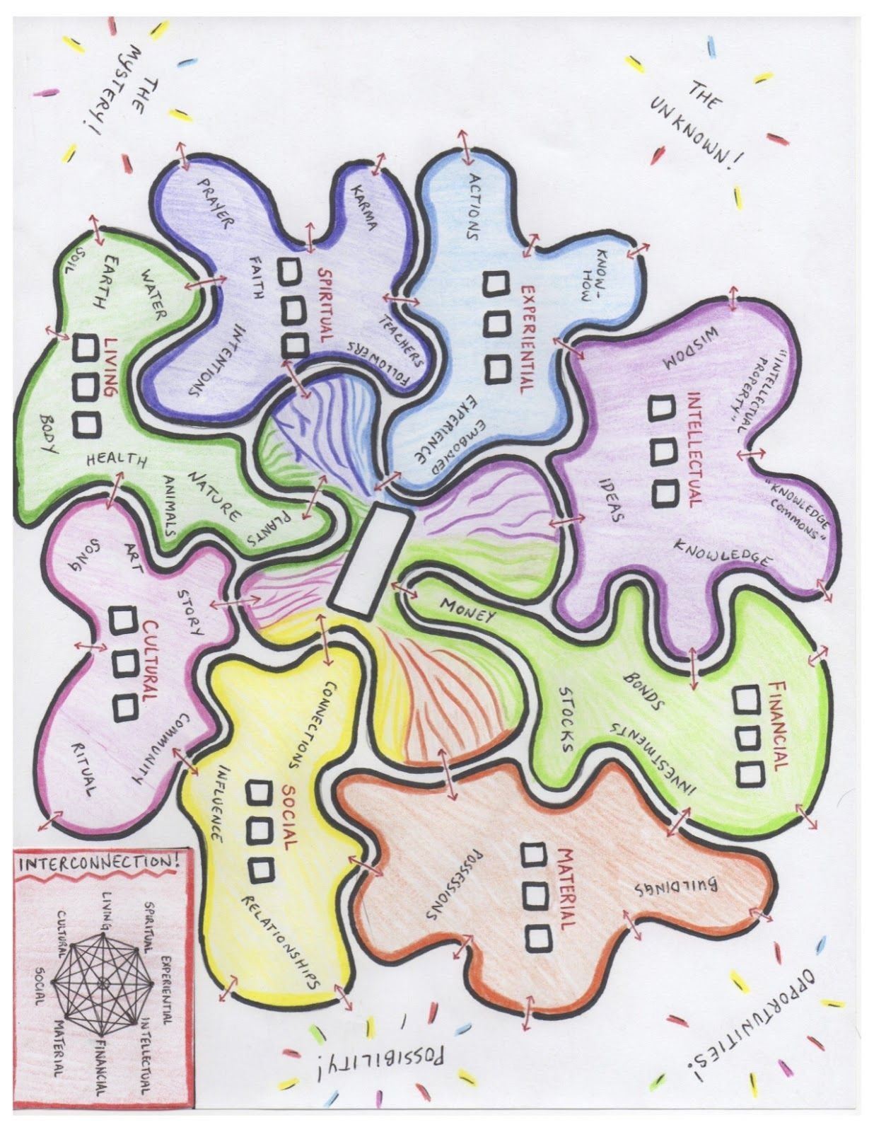

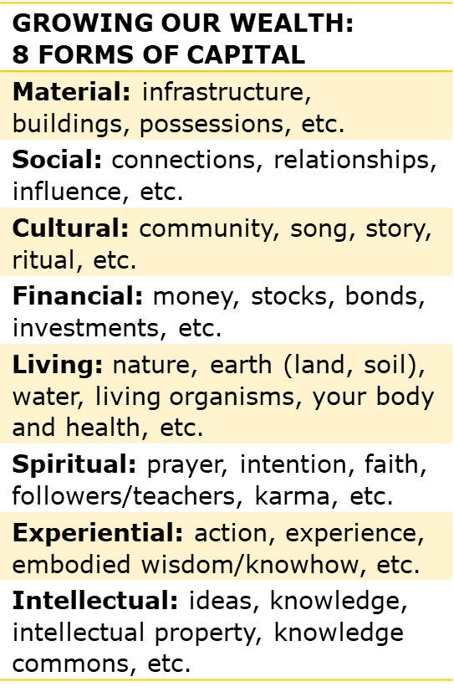

**Boundaries:**

Sarah Jakes Roberts – Boundaries video (**1 mins.**): <https://www.facebook.com/SarahJakesRoberts/videos/1305951669551505/>

It is up to YOU to set and to maintain your boundaries – here lies your Power.

**Energy Self-Reflection**

*Mark (X) the statements below that are true for you.*

|  |  |
| --- | --- |
| **BODY** | |
|  | I don’t regularly get at least seven to eight hours of sleep, and I often wake up feeling tired. |
|  | I frequently skip breakfast, or I settle for something that isn’t nutritious. |
|  | I don’t work out enough (meaning cardiovascular training at least three times a week and strength training at least once a week). |
|  | I don’t take regular breaks during the day to truly renew and recharge, or I often eat lunch at my desk, if I eat it at all. |
| **EMOTIONS** | |
|  | I frequently find myself feeling irritable, impatient, or anxious at work, especially when work is demanding. |
|  | I don’t have enough time with my family and loved ones, and when I’m with them, I’m not always really with them. |
|  | I have too little time for the activities that I most deeply enjoy. |
|  | I don’t stop frequently enough to express my appreciation to others or to savor my accomplishments and blessings. |
| **MIND** | |
|  | I have difficulty focusing on one thing at a time, and I am easily distracted during the day, especially by e-mail. |
|  | I spend much of my day reacting to immediate crises and demands rather than focusing on activities with longer-term value and high leverage. |
|  | I don’t take enough time for reflection, strategizing, and creative thinking. |
|  | I work in the evenings or on weekends, and I almost never take an e-mail–free vacation. |
| **SPIRITUAL** | |
|  | I don’t spend enough time at work doing what I do best and enjoy most. |
|  | There are significant gaps between what I say is most important to me in my life and how I actually allocate my time and energy. |
|  | My decisions at work are more often influenced by external demands than by a strong, clear sense of my own purpose. |
|  | I don’t invest enough time and energy in making a positive difference to others or to the world. |

**Energy Self-Reflection**

*Mark (X) the statements below that are true for you.*

|  |  |
| --- | --- |
| **SCORING** | |
| How is your overall energy? | Total number of statements checked: |
| *Guide to scores:* | *0–3: Excellent energy management skills*  *4–6: Reasonable energy management skills*  *7–10: Significant energy management deficits*  *11–16: A full-fledged energy management crisis* |
| **WHAT DO YOU NEED TO WORK ON?** | |
| Number of checks in each category: | Body: |
|  | Emotion: |
|  | Mind: |
|  | Spirit: |
| *Guide to scores:* | *0: Excellent energy management skills*  *1: Strong energy management skills*  *2: Significant deficits*  *3: Poor energy management skills*  *4: A full-fledged energy crisis* |

**My Priority Energy Area(s):**

(taken from The Energy Project - <https://theenergyproject.com/> )

# Developing Your Daily Practice

**Three things I will do differently, to encourage the creation of my daily self-care practice:**

**1.**

**2.**

**3.**

**NOW, Pick just ONE to commit to… ☺**

# Evening Ritual/Evening Flow Chant

Breaths of affirmation to acknowledge and release the day.

Place your hands over your belly (or any part calling to you) and become present with your evening rhythms, sounds and your body.

Breathe in over that area with a slow calming breath.

Inhale for a count of three (3) and release.

Say to yourself or out loud

I acknowledge this area of my being with gratitude for the day

I acknowledge this area of my being with love and light.

I acknowledge this are of my being with strength.

I acknowledge this area and the emotions that it has carried throughout the day.

I thank my being for existing in this moment in time.

I thank my being for the movement of the day.

I thank my being for receiving wisdom and light from the land, water, and my ancestors.

I thank my being for Life

Wrap your arms around yourself and give a huge, loving and affirming hug to yourself and to those around.

*The manual and resources will be on the **HIVE** Resource page.