**Welcome to the STRONG Nonprofits East Contra Costa Program!**

We are looking forward to beginning this **16-month** journey of team-based organizational sustainability to enhance resilience with you and your teams based in East Contra Costa. Now more than ever, we are excited to come together with you in support of addressing and eradicating poverty in your communities.

In the months ahead, we hope you begin to see **STRONG** as a home for you and the important work you are doing, one that respects, sustains, and nourishes you. We anticipate that the program will be creative, challenging, and fulfilling, and that you will walk away with relationships that become a “lifeline” for many years to come.

We are eager to get this group of amazing individuals together and can’t wait to meet all of you in person. It is our hope that each of you get much needed support and rejuvenation over our time together and that you arrive at our first retreat ready to build!

**As a reminder**, you are required to attend all program sessions, so please calendar these dates as soon as possible.

Warmly,

Your STRONG Nonprofits Team  
Maro, Jeanne, Byron and Spring

Disclaimer

All material is provided without any warranty whatsoever, including, but not limited to, the implied warranties of merchantability or fitness for a particular purpose. Any names of people or companies listed in this book or in its companion computer files are fictitious unless otherwise noted.

Copyright

© 2013 CompassPoint Nonprofit Services unless otherwise indicated. All rights reserved. This publication, including any companion computer disk, or any component part thereof, may not be reproduced or transmitted in any form or by any means, electronic or mechanical, including photocopying, recording, storage in an information retrieval system, or otherwise, without the prior written permission CompassPoint, 500 12th St, Ste 320, Oakland, CA 94607, 415-541-9000 or the author.

|  |
| --- |
| **STRONG Nonprofits KICK-OFF RETREAT**  **June 22 – June 23, 2017**  **9:00 am to 4:30 pm**  **Brentwood Community Center 35 Oak Street Brentwood, CA 925.516.5334** |

**SAVE THE DATES – ACTION REQUIRED!**

Please take a moment to mark your calendars for the following retreat dates. If you have questions, please contact Spring Opara, at 510.318.3738 or email at [springo@compasspoint.org](mailto:springo@compasspoint.org), and she will get back to you as soon as possible.

**Retreat Dates**

*Note all retreats will be held at the Brentwood Community Center

|  |  |
| --- | --- |
| **Retreat #2:** August 18, 2017 | **Retreat #3:** October 13, 2017 |
| **Retreat #4:** December 8, 2017 | **Retreat #5:** February 16, 2018 |

**STRONG Nonprofit Program Components**

**Cohort Seminars and Peer Learning**  
The program includes five in-person sessions centered on issues of organizational sustainability within leadership, management, and strategy. Seminars will also include frameworks for strategic decision-making and planning, opportunities for peer learning, and team working sessions that translate new skills and knowledge into action.

**Organizational Assessment and Individual Strengths Assessment**  
Selected organizations will complete the **My Healthy Organization (MHO)** assessment. Each individual leader will also have the opportunity to take the StrengthsFinder 2.0 assessment to gain insight into their individual strengths. Learnings from these assessments will inform the development of organizational sustainability goals and implementation planning efforts.

**Organizational Coaching**  
Each organization will work with a CompassPoint coach/consultant who will support the development of a sustainability plan and provide technical support and suggestions to help leaders address challenges they might be facing in the implementation process.

**Homework**Between each seminar, participants—with support from CompassPoint consultants—will be given homework to continue analysis and development of their sustainability plans; guide leaders in bringing program content and learnings back to staff and board; and vet proposed decisions with others within the organization to get feedback, increase ownership, and foster alignment.

**Resources and Technical Support**Participants will have access to CompassPoint’s resource library of publications, training material, webinars, templates, and tools. These resources will be used to support participants’ rollout of sustainability plans with staff and board.

**What is Expected of Participants?**

* Attend and actively participate in all **in-person seminars**, a total of six full days.
* **Participate as a team**—the executive director and one or two colleagues from the organization are required to participate together over the duration of the program. Participants may not substitute team members once the program begins.
* Spend at least **five hours between sessions** working with your team and CompassPoint consultant on your sustainability planning process.
* **Bring an open mind**, be open to share your leadership story, your organizational aspirations and challenges, as well as your hopes and dreams for the work you do.
* Engage in a process to get feedback from the CompassPoint team, colleagues, and peers.
* Complete the online **StrengthsFinder 2.0 assessment** (approximately 30-45 minutes) and engage in an hour-long conference call to debrief the results.

**Optional:**

* Participate in the **My Healthy Organization** assessment process and engage in an hour-long call to debrief the results.

**There is no fee to participate.** The program is fully funded by grants from the **East Contra Costa STRONG Nonprofits Project** collaborative.

**COMMUNICATION AGREEMENTS**

* **Confidentiality** is often defined as “what’s said in the room stays in the room” and we agree not to discuss what happens here in a way that would identify any individual or organization. There is another dimension to confidentiality that includes “asking permission” to share or discuss any statement another person makes of a personal nature. It helps to remember that the story belongs to the teller, not the listener.
* **Move-up Participation**. Honor different beliefs and encourage empowerment by making a space for all voices, experiences and ideas to be heard and shared. Talking does not equal participation. Generous listening is a form of participating. If you speak a lot, try listening more. And it you tend to sit back and listen, consider speaking up more.
* **Intent is different than impact**, and both are important. It is also important to own our ability to have a negative impact in another person’s life despite our best intention. In generous listening, if we assume positive intent rather than judging or blaming, we can respond, rather than reacting or attacking when a negative impact occurs.
* **It’s okay to disagree**. Avoid attacking, discounting or judging the beliefs and views of yourself or others – verbally or non-verbally. Instead, welcome disagreements as an opportunity to expand your world. Ask questions to understand other people’s perspectives.

**LEARNING AGREEMENTS**

* **Embrace polarities**. Avoid binaries and embrace wicked questions (i.e. paradoxical truths), such as “How can we be both BOLD and humble in our asking?”
* **Real play, not role play**. Let’s try on ways of being, and ways of doing here in this room.
* **Name elephants**. Be intentional about speaking the unspeakable; foster a culture of candor inside and outside your organization.
* **Be open to new ideas and perspectives**, and be open to having your current ideas and perspectives challenged.
* **Embrace inquiry**. Ask difficult, reflective questions as a matter of course.

**The CompassPoint STRONG Nonprofits Program   
for East Contra Costa County**

# **SESSION ONE: Thursday, June 22, 2017**

9:00 – 9:30 Coffee, Tea, and Continental Breakfast

9:30 – 10:00 Welcome, Introductions

10:00 – 10:15 Group Agreements

10:15 – 10:45 Program Overview

10:45 – 11:00 Break

11:00 – 12:00 Place, Context, Aspiration Setting

12:00 – 1:00 Lunch

1:00 – 1:45 What is Sustainability?

1:45 – 2:45 What is Core?

2:45 – 3:00 Break

3:00 – 4:00 Reflected Best Organization

4:00 – 4:30 Closing Reflections

4:30 Adjourn

**Notes**

**Identity and Purpose: What is Core?**



“**Who are we now**?” is a query that keeps us noticing how we are creating ourselves—not through words and position papers, but through our actions and reactions from moment to moment. All living systems spin themselves into existence because of what they choose to notice and how they choose to respond. This is also true of human organizations, so we need to acknowledge that we are constantly creating the organization through our responses.

To monitor our own evolution, we need to ask this question regularly. Without such monitoring, we may be shocked to realize who we've become while we weren't watching.

*– from “Bringing Life to Organizational Change”  
by Margaret J. Wheatley & Myron Kellner-Rogers*

**What is Sustainability?**

Sustainability is a word we hear regularly in the nonprofit sector, often as if it’s a golden panacea, a magical place in which our revenue and resource needs will simply regenerate and enable us to focus “all” of our efforts on our mission-centered work. It is not uncommon to still come across this thinking – including funders and sometimes misguided board members who ask how we intend to make our work sustainable “when the grant runs out.”

The reality is that if by sustainable we mean an ongoing, steady existence to our work, then we as a sector have largely managed to achieve that – in California nonprofits are now the fourth largest industry in the state, generating 15% of our State GDP.[1] Nonprofit organizations are deeply embedded into our communities and as a whole are likely here to stay – and many of these organizations subsist successfully for decades on grants and other forms of contributed income.  
  
But although the sector persists, individual organizations clearly ebb and flow, start up and shut down. From an organizational perspective, then, what do we actually mean by sustainability?

**What’s possible when we align ourselves in a personally sustainable way?**

* We can be more creative
* We can take risks more comfortably
* We are more energized and able to weather challenges
* Moral is higher
* Teamwork is stronger

**WE ARE MORE PRODUCTIVE!**

Most nonprofit organizations are here to do work that spans generations, whether it’s a focus on shifting systems and structures that continue to oppress people, providing a platform for advocacy and full engagement in our democracy, or sustaining safety net systems for people struggling with poverty and its affects. It’s the compelling impact of this very work that drives the revenue and resources that we seek to sustain over time – and, necessarily, in these kinds of long-term efforts both our understanding of the work and the resources available to support them shift over time.

What would it look like if we focused on the elements of sustainability in a more holistic way? One way of thinking about sustainability is when *we generate more than we consume*.

There is a clear parallel here to organizational finances – where this shows up as surplus or profit in a given year. Regular surpluses *are* an important component of organizational sustainability, but what might it mean if *all* of our resources – human, financial, organizational and otherwise – were aligned in a way that is designed to generate more than what it takes in? What happens when we stop thinking of organizational sustainability solely in the context of renewable funding and focus on fueling our overall efforts in an aligned – and energizing – way?

Extraordinarily efficient in generating high rates of propagation, but the degrees of variation are far less than for those in sexual reproduction. Cloning, therefore, is far less likely to generate innovations for finding and thriving in new environments. The secret of evolution is variation, which in organizational terms could be called distributed or collective intelligence. Likewise, adaptive leadership on economic policy would want to diversify an economy so that people are less dependent on one company or industry for sustenance. For an organization, adaptive leadership would build a culture that values diverse views and relies less on central planning and the genius of the few at the top, where the odds of adaptive success go down. This is especially true for global businesses operating in many local microenvironments.

**What is Core?**

A dictionary definition of core names it as the “central, innermost, or most essential part of anything.” In his work, researcher and management consultant Jim Collins discusses an organization’s Core Ideology in the terms of deepening our understanding of it, not designing or creating it:

“You do not create or set core ideology. You discover core ideology. You do not deduce it by looking at the external environment. You understand it by looking inside. Ideology has to be authentic. You cannot fake it. Discovering core ideology is not an intellectual exercise. Do not ask, What core values should we hold? Ask instead, What core values do we truly and passionately hold? You should not confuse values that you think the organization ought to have – but does not – with authentic core values. To do so would create cynicism throughout the organization. (‘Who're they trying to kid? We all know that isn't a core value around here!’) Aspirations are more appropriate as part of your envisioned future or as part of your strategy, not as part of the core ideology. However, authentic core values that have weakened over time can be considered a legitimate part of the core ideology – as long as you acknowledge to the organization that you must work hard to revive them.

Core ideology needs to be meaningful and inspirational only to people inside the organization; it need not be exciting to outsiders. Why not? Because it is the people inside the organization who need to commit to the organizational ideology over the long term… You cannot impose new core values or purpose on people. Nor are core values and purpose things people can buy into. Executives often ask, How do we get people to share our core ideology? You don't. You can't. Instead, find people who are predisposed to share your core values and purpose; attract and retain those people; and let those who do not share your core values go elsewhere.’[2]

The question of core, then, is one of exploration and understanding, not of prescription and commanding. The question is essentially a human one easily applied to organizational form – what is it that we are uniquely designed to be and how do we grow into its full expression?

It’s the seeds of a plant that determine its ultimate characteristics. The seed of a redwood tree is unimaginably small but within it is an essential purpose to become what it must – one of the largest most enduring trees on the planet.

So what does this mean and why does it really matter from an organizational context? As we become deeply curious about what’s at our core as an organization, and work diligently to align ourselves with that, it becomes a true guide in our ongoing development.

Regarding organizational size, for example, it is not necessarily simply a question of if, when, and how to grow. The more compelling, and challenging, question about organizational size is – what size do we need to be in order to fully express what’s embedded in our core?

**EXERCISE: Reflected Best Organization**

1. Think of a time when your organization was at its best. Jot down as many details as possible. What happened? Who was there? Why does that particular experience   
   come to mind?

*Share with your partner and reflect together:*

**What’s Your Organization’s Core?**

* Unique approaches to the work
* Organizational values and principles
* Positive attributes of organizational culture
* Ingrained talents and strengths
* What were the organizational strengths brought to bear?
* What were the circumstances that made the success possible?

1. Share your reflection with your partner and discuss what the two stories might tell you about what’s “core” for your organization.

**REFLECTION: Exploring What’s Core**

How might we define what’s core   
to *who we are* as an organization?

**Notes**

**The CompassPoint STRONG Nonprofits Program   
for East Contra Costa County**

# **SESSION TWO: Friday, June 23, 2017**

9:00 – 9:30 Coffee, Tea, and Continental Breakfast

9:30 – 9:45 Welcome, Reflections

9:45 – 10:15 Sustainability & Dual Bottom Line

10:15 – 10:30 Break

10:30 – 12:00 Revenue Model

12:00 – 1:00 Lunch

1:00 – 1:45 Strengths Based Leadership

1:45 – 2:45 Leading Others: Building Teams

2:45 – 3:00 Break

3:00 – 4:00 Introduction to StrengthsFinder

4:00 – 4:30 Closing Reflections

4:30 Adjourn

**What is Nonprofit Sustainability?***-- excerpted from The Sustainability Mindset by Jeanne Bell and Steve Zimmerman*

“Sustainability encompasses both *financial sustainability* (the ability to generate resources to meet the needs of the present without jeopardizing the future) and *programmatic sustainability* (the ability to develop, mature, and cycle out programs to be responsive to constituencies over time).”

This definition does notencompass two separate, complementary ideas. Rather, the two ideas are of one piece and are not independent of one another over time. Great organizations develop, mature, and innovate their mission-specific programs in concert with the continuous development, maturation, and innovation of their fund development programs. Leaders who deeply understand this are able to guide their organizations to achieve deep impact and modest profitability.

Mission and resources cannot be separated in any useful or logical manner. Achieving great results requires great resources—time, money, partnerships, and community will—all of which must be intentionally and continuously cultivated. In fact, this notion of continuous is central to our point of view on sustainability.

While the matrix map (more on this later) process of assessing the impact and net financial return of each program in an organization’s business model engages an organization’s leadership in an intensive inquiry over several months, sustainability is an orientation, not a destination. It is not a one-time thing, not an episodic thing, not a senior management thing or a board of directors’ thing. It’s really a mindset and way of organizational being. The way of thinking about two bottom lines in a holistic way, the sharp financial analysis, and the co-created language around impact all live on well past the creation of the matrix map. When we do this work well, they become inextricably woven into the fabric and culture of the organization.

**Dual Bottom Line**

The dual bottom line provides a framework for thinking about the portfolio of activities in a nonprofit organization and assessing each activity based on both its mission impact and financial return.

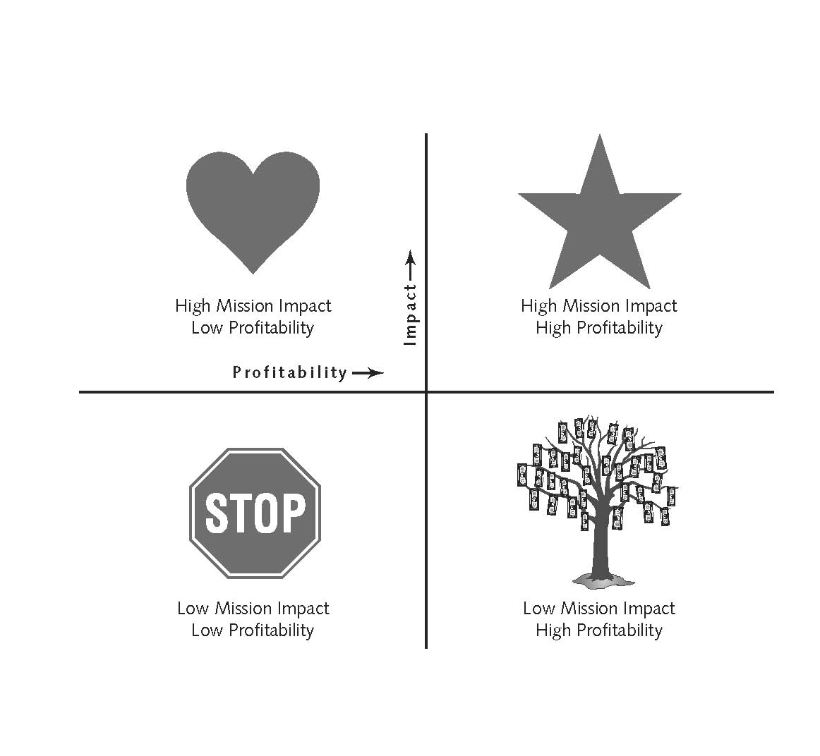

At any given moment, a nonprofit may have a portfolio of activities that are spread across the four quadrants shown in the figure. Locating activities in these quadrants through a systematic assessment of data – what we call creating a Matrix Map – will suggest a clear set of decisions that leaders need to make in order to foster the business model’s overall strength.

**Notes:**

**Identifying Your Revenue Model**

As nonprofits we have access to several different streams of funding and while each of those streams offer us different benefits, each also requires us to develop different management structures and relationships. In years past, “revenue diversity” has often been lauded as a critical element of nonprofit financial management and fiscal health. However, as the sector matures, we are understanding more deeply the programmatic and infrastructure implications of different revenue strategies. Research by The Bridgespan Group, among others, has demonstrated that many organizations successfully grow through intentional investment in a dominant type of revenue that is aligned with its work and intended impact (and focus efforts on diversifying among several sources). It’s good to have one primary income type that is reliable and repeatable and a secondary unrestricted income source. Even having 8% of your income from annual giving can ease cash flow throughout the year—8% is one month of operating expense!

With this in mind, the revenue question becomes not so much about how to diversify but about how to maximize the revenue streams that are most aligned with the organization’s goals and values. In articulating and nurturing the funding model for an organization, it can be particularly helpful to think about the people behind the funding streams:

* **Who decides?** Within your principal source of funding, who are the particular set of people who dictate the flow of funds? What does that mean for the relationships and systems you need to attend to?

Donors do *not* give to your organization. They give *through* your organization to achieve their own desires…  
to fulfill their own aspirations…  
to live out their own values. —Simone Joyaux

* **What are their motivations?** Thinking of these people specifically, what do they want to achieve – for themselves and/or their communities – by giving to your organization? How do they think about and assess the value that your organization delivers?

**Nonprofit Revenue Model for:** ____________________________________________________________________________________________

|  |  |  |  |  |  |
| --- | --- | --- | --- | --- | --- |
| 1. Intended Impact/Organizational Goals *Impacts answer the question, “We will know we are successful when…” They include observable indicators of the specific conditions we aim to resolve and help us orient our work toward contributing to the change we seek in the world.* | | | | | |
| 2. Primary Revenue Stream: | | 3. Stability Rating | 4. Relationship Requirements | 5. Infrastructure Requirements | 6. Alignment to Impact/Organizational Goals |
| *The dominant type of revenue that supports our work (e.g. earned income, government contracts, foundation grants, individual donors, investment income, event revenue, etc.).* | | Flexible: Y/N  (we can use this stream at our discretion to maximize our impact)  Repeatable: Y/N  (we can reasonably rely on this stream as an ongoing source of annual revenue)  Surplus-Generating: Y/N  (when measured against direct expenses) | * *Who are the people behind this revenue stream, and what are their motivations for giving to our work?* * *What are the distinctive qualities of the person-to-person relationships that draw these people to and keep them connected with the organization?* | * *What are the critical resources that are required to nurture this revenue stream?*    + People (core competencies),   + Process (systems), and   + Practice (cultural norms). | * *How do the motivations and intentions of the people behind this revenue stream align with our intended impact?* * *How does this revenue stream align with – or even amplify – our organizational values?* |
| % of Total Annual Revenuefrom this stream | |
| Current | Optimal |
| *% of total* | *% of total* |
| 7. Secondary Rev. Stream: | | 8. Stability Rating | 9. Relationship Requirements | 10. Infrastructure Requirements | 11. Alignment to Impact/Organizational Goals |
| *The secondary type of revenue that supports our work. Ideally the secondary type helps  to offset the vulnerabilities or limitations of the dominant type.* | | Flexible: Y/N  (we can use this stream at our discretion to maximize our impact)  Repeatable: Y/N  (we can reasonably rely on this stream as an ongoing source of annual revenue)  Surplus-Generating: Y/N  (when measured against direct expenses) | * *Who are the people behind this revenue stream?* * *What are their motivations for giving to our work?* * *What are the distinctive qualities of the person-to-person relationships that draw these people to and keep them connected with the organization?* | * *What are the critical resources that are required to nurture this revenue stream?*    + People (core competencies),   + Process (systems), and   + Practice (cultural norms). | * *How do the motivations and intentions of the people behind this revenue stream align with our intended impact?* * *How does this revenue stream align with – or even amplify – our organizational values?* |
| % of Total Annual Revenuefrom this stream | |
| Current | Optimal |
| *% of total* | *% of total* |
| 12. Priorities to Strengthen the Model: | | | | | |
| What in our model is working well?  What specific investments do we need to make in people, process, or practice in order to strengthen this model?  How will we get there? | | | | | |

**EXAMPLE Nonprofit Revenue Model for:** Domestic Violence Intervention & Prevention Agency

|  |  |  |  |  |  |
| --- | --- | --- | --- | --- | --- |
| Intended Impact/Organizational Goals | | *There is a holistic, collaborative, community response to resolve incidents of intimate partner violence that recognizes and values the experience, knowledge, feelings and strengths of the people involved.* | | | |
| Primary Revenue Stream: | | Stability Rating | Relationship Requirements | Infrastructure Requirements | Alignment to Impact/Organizational Goals |
| Government contracts with cities throughout the county, as well as state and federal funds. | | $ Amount: $1.8M  # of Sources: 28  Flexible: NOT VERY  Repeatable: VERY  Surplus-Generating: NO | ­   * The people behind this revenue stream include:   + Elected officials, governing bodies (e.g. city council)   + Staff in several city and county departments   + Community-based oversight commissions * The qualities of relationships with these people require:   + Attention to constituent and political priorities   + Fairness, transparency, and accountability * The people and systems needed to nurture these relationships include:   + Politically astute/well-connected staff and board   + Orientation to accountability and transparency | ­   * People (core competencies)   + Politically astute/well-connected staff and board   + Detailed oriented, accountability focused staff * Process (systems)   + Regular attendance at and engagement with local political systems, commissions, and processes   + Strong data management systems for managing service delivery data and financial tracking * Practice (cultural norms)   + Values of accountability, transparency, public good   + Data-driven decision making | We believe that the problem of intimate partner violence is best addressed by the community as a whole. Therefore, we believe that public resources should be directed to help support the resolution of the issue. We value the democratic process as a way to advocate for community-driven resource allocation and as a way to hold our elected officials and other public employees (including police, educators, and social workers) accountable to the needs of the community. |
| % of Total Annual Revenue: | |
| Current | Optimal |
| 90% | 80% |
| Secondary Revenue Stream: | | Stability Rating | Right Relationship Requirements | Infrastructure Requirements | Alignment to Impact/Organizational Goals |
| Individual donors who have been touched by the issue of domestic violence. | | $ Amount*:* $113K  # of Sources*:* 500  Flexible: VERY  Repeatable: VERY  Surplus-Generating: YES | * The people behind this revenue stream include:   + Community members who know our work  (especially lawyers and mental health professionals)   + Individuals who have been personally affected by DV * The qualities of relationships with these people require:   + Empathy and a willingness to share our vision | * People (core competencies)   + Deep, personal, heartfelt passion for the work   + Powerful communication skills; ability to articulate our vision and influence people’s thinking   + Ability to connect with others in meaningful ways * Process (systems)   + Ongoing opportunities for meeting people interested in our cause and making new connections   + Strong donor management systems * Practice (cultural norms)   + System-wide comfort with talking about money | We believe that the problem of intimate partner violence is best addressed by the community as a whole. We know that many people from all walks of life have been affected by domestic violence. When people invest time and money in our work, we build connections among­ passionate advocates who will be a critical part of raising awareness of the issue and in creating and driving community-based solutions. |
| % of Total Annual Revenue: | |
| Current | Optimal |
| 5% | 15% |
| Priorities to Strengthen the Model: | | | | | |
| What specific investments do we need to make in people, process, or practice in order to strengthen this model?   * Two more board members who are connected with local politics and/or public agencies. * Strengthen our staff’s understanding of, and commitment to, grassroots fundraising efforts. * CRM software that will allow us to leverage our knowledge about and build upon our existing donor base.   How will we get there?   * The Governance Committee will lead a process in which we focus our board recruitment efforts this year on strong, generative thinkers who are politically minded and connected. * The Executive Director will lead a training with staff and board on developing a “culture of philanthropy” and begin to set clear goals for shifting our practices in fundraising. * We will research and choose a CRM software and seek capacity-building funds to help purchase and/or customize it to our needs. | | | | | |

**Notes**

**EXERCISE: Revenue Stream Analysis**

**Type of Revenue: ____________________________________________________**

□ Primary Stream □ Secondary Stream □ Other/Unknown

$$ of Current Annual Revenue: ____________ % of Current Annual Revenue: _____________

Type: □ Earned □ Contributed Unrestricted □ Contributed Restricted

Source: □ Individuals □ Governments □ Organizational □ Other _________________

**STABILITY RATING (rate 1-4 on each)**

**____ Flexibility:** How flexible is this revenue stream? On average, how easily can we use it at our discretion to maximize our impact? If we change our mind about program design or a particular strategy, do we need to “run it by” these funders first?

1 = not at all flexible; most sources in this stream monitor precisely how their funds are spent

2 = not very flexible; most sources in this stream are only interested in funding a particular program or activity, but might be open to potential shifts in our program direction

3 = somewhat flexible; most sources in this stream might be interested in funding a particular program or activity, but we have a fair amount of discretion in how we use it toward those ends

4 = very flexible; we have significant discretion as to how to use these funds to further our work

**____ Repeatability:** Is this a revenue stream that we can expect to count on as a regular stream of annual revenue? Are we relatively certain that we will continue to have consistent access to this type of revenue for the foreseeable future?

1 = not at all repeatable; this revenue stream is very sporadic and unpredictable – a “windfall”

2 = not very repeatable; this revenue stream is currently somewhat unsteady but has the potential to be more regular for our organization

3 = somewhat repeatable; we have developed a pattern of securing this revenue stream and have some multi-year commitments

4 = very repeatable; we have established a strong history with this revenue stream and have many multi-year commitments

**SURPLUS-GENERATING: YES / NO**

Do we consistently generate surplus from this revenue stream? To do so it must be both:

Y / N Unrestricted (contributed or earned), and

Y / N Profitable: the full cost of the activities supported by this revenue stream (including the systems and staffing required to manage it) is consistently less than the revenue they generate

If this revenue stream represents unrestricted funds (earned or contributed), what might it take to potentially generate or increase the surplus from this stream?

**RELATIONSHIP AND INFRASTRCUTURE REQUIREMENTS**

**Who decides?** Within this revenue stream, who are the particular set of people who dictate the flow of funds?

**What are their motivations?** Thinking of the people behind these funds specifically, what do they want to achieve – for themselves and/or their organizations or communities – by giving to your organization? How do they think about and assess the value that your organization delivers?

**What are the implications?** Given the needs and motivations of the decision-makers, as well as the nature of managing this type of funding stream, what are some of the implications of the relationships and systems you may need to tend to? What is strong? What needs attention?

**Notes:**

**EXERCISE: Revenue Stream Analysis**

**Type of Revenue: ____________________________________________________**

□ Primary Stream □ Secondary Stream □ Other/Unknown

$$ of Current Annual Revenue: ____________ % of Current Annual Revenue: _____________

Type: □ Earned □ Contributed Unrestricted □ Contributed Restricted

Source: □ Individuals □ Governments □ Organizational □ Other _________________

**STABILITY RATING (rate 1-4 on each)**

**____ Flexibility:** How flexible is this revenue stream? On average, how easily can we use it at our discretion to maximize our impact? If we change our mind about program design or a particular strategy, do we need to “run it by” these funders first?

1 = not at all flexible; most sources in this stream monitor precisely how their funds are spent

2 = not very flexible; most sources in this stream are only interested in funding a particular program or activity, but might be open to potential shifts in our program direction

3 = somewhat flexible; most sources in this stream might be interested in funding a particular program or activity, but we have a fair amount of discretion in how we use it toward those ends

4 = very flexible; we have significant discretion as to how to use these funds to further our work

**____ Repeatability:** Is this a revenue stream that we can expect to count on as a regular stream of annual revenue? Are we relatively certain that we will continue to have consistent access to this type of revenue for the foreseeable future?

1 = not at all repeatable; this revenue stream is very sporadic and unpredictable – a “windfall”

2 = not very repeatable; this revenue stream is currently somewhat unsteady but has the potential to be more regular for our organization

3 = somewhat repeatable; we have developed a pattern of securing this revenue stream and have some multi-year commitments

4 = very repeatable; we have established a strong history with this revenue stream and have many multi-year commitments

**SURPLUS-GENERATING: YES / NO**

Do we consistently generate surplus from this revenue stream? To do so it must be both:

Y / N Unrestricted (contributed or earned), and

Y / N Profitable: the full cost of the activities supported by this revenue stream (including the systems and staffing required to manage it) is consistently less than the revenue they generate

If this revenue stream represents unrestricted funds (earned or contributed), what might it take to potentially generate or increase the surplus from this stream?

**RELATIONSHIP AND INFRASTRCUTURE REQUIREMENTS**

**Who decides?** Within this revenue stream, who are the particular set of people who dictate the flow of funds?

**What are their motivations?** Thinking of the people behind these funds specifically, what do they want to achieve – for themselves and/or their organizations or communities – by giving to your organization? How do they think about and assess the value that your organization delivers?

**What are the implications?** Given the needs and motivations of the decision-makers, as well as the nature of managing this type of funding stream, what are some of the implications of the relationships and systems you may need to tend to? What is strong? What needs attention?

**Notes:**

**REFLECTION: Revenue Model Analysis**

****Reviewing your trend analysis pre-work, along with the work you’ve done above, consider:

* How can we build upon our strengths to take advantage of the internal or external factors that are driving increased revenue trends?
* Where do we need continued infrastructure investment to support and further develop our capacity to effectively manage and build upon those streams?
* What themes can we identify related to either the internal factors (our organizational capacity to manage particular streams) and/or external factors (changes in policies, funders’ priorities, partnership opportunities) that are influencing revenue trends? What do we need to tend to as an organization to address these themes?

**Notes:**

**Strengths Based Leadership**

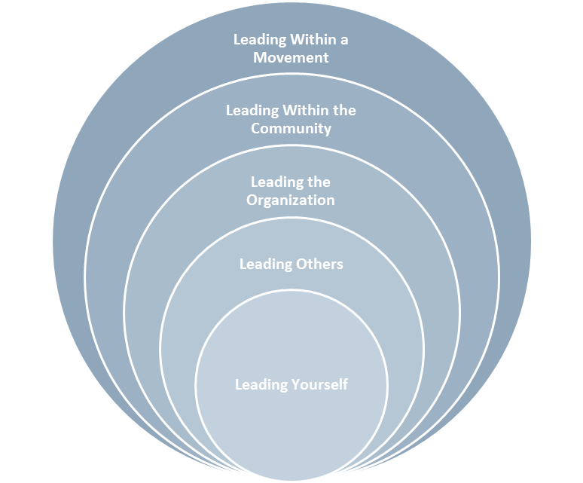

CompassPoint: Using Strengths for Personal, Staff and Team Development

**STRENGTHS-BASED LEADERSHP**

Strengths are the result of maximized talents. Specifically, a strength is mastery created when one’s most powerful talents are refined with practice and combined with acquired relevant skills and knowledge. They can be expressed in different ways, for example:

* Activities – tasks that make you engaged and energized
* Relationships – what you do for others, how you feel valued and competent
* Learning – specific ways you learn for optimal experience

The strengths-based development process encourages individuals to build strengths by acquiring skills (i.e., basic abilities) and knowledge (i.e., what you know, including facts and meaning-making from experiences) that can complement your greatest talents in application to specific tasks.

**A strength is composed of:**

* Skills: your basic abilities to perform the fundamental steps of a task, such as your basic ability to move through the fundamental steps of operating a computer. Skills do not naturally exist within us; they must be acquired through formal or informal training and practice.
* Knowledge: simply what you know, such as your awareness of facts and your grasp of the rules of a game. Knowledge does not naturally exist within us; it must be acquired through formal or informal education.
* Talents: the ways in which you naturally think, feel, and behave, such as the inner drive to compete, sensitivity to the needs of others, and the tendency to be outgoing at social gatherings. Although talents must come into existence naturally and cannot be acquired like skills and knowledge, we each have unique talents within us.

Talents are manifested in life experiences characterized by:

* Yearnings: the things we want to do more of in life because we enjoy them so much!
* Rapid learning: a specific talent is there when learning something new is easy to comprehend and master.
* Satisfactions: We get a feeling of reward, success, accomplishment or other ways that tap into what motivates us
* Timelessness: work and activities are "in the flow" when we lose track of time engaging in them.

**TALENT**

**X**

**(Skill + Knowledge)  
=  
STRENGTH**

These trait-like “raw materials” are believed to be the products of normal healthy development and successful experiences over childhood and adolescence.

The purpose of a strengths-based approach to leadership development is to facilitate personal development and growth. It can be used as a springboard for discussion with managers, friends, colleagues and advisers, and as a tool for self-awareness. Accordingly, feedback about talents and strengths development often forms the basis of further exploration that help individuals capitalize on their greatest talents and apply them to new challenges.

**About the Research**

Gallup studied more than one million work teams, conducted more than 20,000 in-depth interviews with leaders, and drew on 50 years of Gallup Polls to understand what improves the effectiveness and performance of individuals, teams and organizations. Millions of employees and students worldwide have participated in this research. These studies indicate that people who have the opportunity to focus on their strengths every day are *six times* as likely to be engaged in their jobs and more than *three times* as likely to report having an excellent quality of life in general.

“What would happen if we studied what was right with people?” - Donald Clifton

This has significant implications for organizational leadership and management. Consider this data from the research:

|  |  |
| --- | --- |
| **If your manager primarily:** | **The chances of you being actively disengaged are:** |
| * Ignores you | * 40% |
| * Focuses on your weaknesses | * 22% |
| * Focuses on your strengths | * 1% |

Traditionally, performance management and leadership development efforts and initiatives have focused on developing people in areas where they do not have natural talent or strengths. Strengths-based leadership, in contrast, is a counter approach to the overly negative orientation of mainstream culture which is deficit based and focuses on an individual’s areas of lacking and weakness.

**Strengths-based leadership is more effective on multiple levels:**

Personal/individual success: A strengths-based leadership approach yields greater fulfillment and satisfaction and increased achievement and happiness. We are more likely to succeed, be personally engaged at work, and satisfied in life if we maximize our strengths.

*“The strengths philosophy is the assertion that individuals are able to gain far more when they expend effort to build on their greatest talents than when they spend a comparable amount of effort to remediate their weaknesses.”*

Organizational success: A strengths-based leadership approach can result in higher employee engagement and productivity and improved organizational results.

*“In the workplace, when an organization's leadership fails to focus on an individual's strengths, the odds of an employee being engaged are a dismal 1 in 11 (9%). But when an organization's leadership focuses on the strengths of its employees, the odds soar to almost 3 in 4 (73%). When leaders focus on and invest in their employees' strengths, the odds of each person being engaged goes up eightfold.”*

Team success: A strengths-based leadership approach posits that, while no individual is strong at everything, ideally the best teams are well rounded with individuals who collectively possess the range of strengths required to achieve the team’s purpose.

**Brief Descriptions of the 34 Themes of Talent Measured by the Clifton StrengthsFinder**

**Achiever**

People especially talented in the Achiever theme have a great deal of stamina and work hard. They take great satisfaction from being busy and productive.

**Activator**

People especially talented in the Activator theme can make things happen by turning thoughts into action. They are often impatient.

**Adaptability**

People especially talented in the Adaptability theme prefer to "go with the flow."

They tend to be "now" people who take things as they come and discover the future one day at a time.

**Analytical**

People especially talented in the Analytical theme search for reasons and causes.

They have the ability to think about all the factors that might affect a situation.

**Arranger**

People especially talented in the Arranger theme can organize, but they also have a flexibility that complements this ability. They like to figure out how all of the pieces and resources can be arranged for maximum productivity.

**Belief**

People especially talented in the Belief theme have certain core values that are unchanging. Out of these values emerges a defined purpose for their life.

**Command**

People especially talented in the Command theme have presence. They can take control of a situation and make decisions.

**Communication**

People especially talented in the Communication theme generally find it easy to put their thoughts into words. They are good conversationalists and presenters.

**Competition**

People especially talented in the Competition theme measure their progress against the performance of others. They strive to win first place and revel in contests.

**Connectedness**

People especially talented in the Connectedness theme have faith in the links between all things. They believe there are few coincidences and that almost every event has a reason.

**Consistency**

People especially talented in the Consistency theme are keenly aware of the need to treat people the same. They try to treat everyone in the world with consistency by setting up clear rules and adhering to them.

**Context**

People especially talented in the Context theme enjoy thinking about the past.

They understand the present by researching its history.

**Deliberative**

People especially talented in the Deliberative theme are best described by the serious care they take in making decisions or choices. They anticipate the obstacles.

**Developer**

People especially talented in the Developer theme recognize and cultivate the potential in others. They spot the signs of each small improvement and derive satisfaction from these improvements.

**Discipline**

People especially talented in the Discipline theme enjoy routine and structure.

Their world is best described by the order they create.

**Empathy**

People especially talented in the Empathy theme can sense the feelings of other people by imagining themselves in others' lives or others' situations.

**Focus**

People especially talented in the Focus theme can take a direction, follow through, and make the corrections necessary to stay on track. They prioritize, then act.

**Futuristic**

People especially talented in the Futuristic theme are inspired by the future and what could be. They inspire others with their visions of the future.

**Harmony**

People especially talented in the Harmony theme look for consensus. They don’t enjoy conflict; rather, they seek areas of agreement.

**Ideation**

People especially talented in the Ideation theme are fascinated by ideas. They are able to find connections between seemingly disparate phenomena.

**Includer**

People especially talented in the Includer theme are accepting of others. They show awareness of those who feel left out, and make an effort to include them.

**Individualization**

People especially talented in the Individualization theme are intrigued with the unique qualities of each person. They have a gift for figuring out how people who are different can work together productively.

**Input**

People especially talented in the Input theme have a craving to know more. Often they like to collect and archive all kinds of information.

**Intellection**

People especially talented in the Intellection theme are characterized by their intellectual activity. They are introspective and appreciate intellectual discussions.

**Learner**

People especially talented in the Learner theme have a great desire to learn and want to continuously improve. In particular, the process of learning, rather than the outcome, excites them.

**Maximizer**

People especially talented in the Maximizer theme focus on strengths as a way to stimulate personal and group excellence. They seek to transform something strong into something superb.

**Positivity**

People especially talented in the Positivity theme have an enthusiasm that is contagious. They are upbeat and can get others excited about what they are going to do.

**Relator**

People especially talented in the Relator theme enjoy close relationships with others. They find deep satisfaction in working hard with friends to achieve a goal.

**Responsibility**

People especially talented in the Responsibility theme take psychological ownership of what they say they will do. They are committed to stable values such as honesty and loyalty.

**Restorative**

People especially talented in the Restorative theme are adept at dealing with problems. They are good at figuring out what is wrong and resolving it.

**Self-Assurance**

People especially talented in the Self-Assurance theme feel confident in their ability to manage their own lives. They possess an inner compass that gives them confidence that their decisions are right.

**Significance**

People especially talented in the Significance theme want to be very important in the eyes of others. They are independent and want to be recognized.

**Strategic**

People especially talented in the Strategic theme create alternative ways to proceed. Faced with any given scenario, they can quickly spot the relevant patterns and issues.

**Woo**

People especially talented in the Woo theme love the challenge of meeting new people and winning them over. They derive satisfaction from breaking the ice and making a connection with another person.

Copyright © 2005, 2007 The Gallup Organization, Princeton, NJ. All rights reserved.

1. “Causes Count: The Economic Power of California’s Nonprofit Sector,” CalNonprofits, 2014. http://calnonprofits.org/causes-count
2. “Building Your Company’s Vision,” Collins & Porras, Harvard Business Review, 1996.