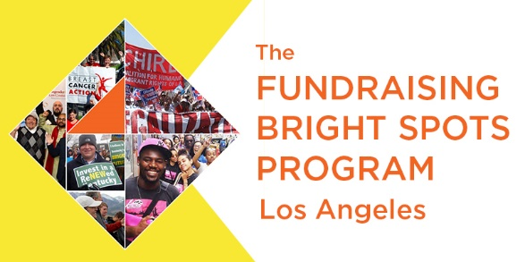

**Session One: February 14, 2018**

**Getting Grounded in Fundraising Bright Spots**

Disclaimer

All material is provided without any warranty whatsoever, including, but not limited to, the implied warranties of merchantability or fitness for a particular purpose. Any names of people or companies listed in this book or in its companion computer files are fictitious unless otherwise noted.

Copyright

© 2013 CompassPoint Nonprofit Services unless otherwise indicated. All rights reserved. This publication, including any companion computer disk, or any component part thereof, may not be reproduced or transmitted in any form or by any means, electronic or mechanical, including photocopying, recording, storage in an information retrieval system, or otherwise, without the prior written permission CompassPoint, 500 12th St, Ste 320, Oakland, CA 94607, 415-541-9000 or the author.

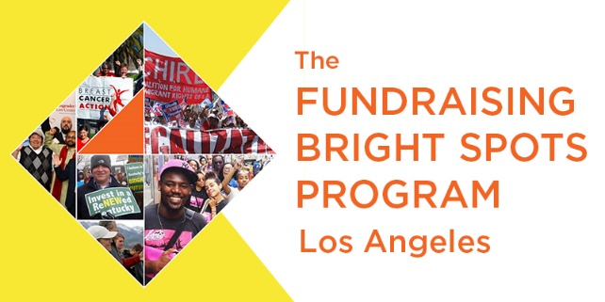**Welcome, Fundraising Bright Spots Learning Community**!

We are looking forward to beginning this journey of team-based organizational sustainability with your learning pair and your organization. Now more than ever, we are excited to come together and create new fund development actions that move our organizations past ‘best practices’ to ‘new practices’.

Tap into this community to break any silos or isolation of development in your organization, it’s not often that you can be with other leaders to think and imagine and try new ways of approaching fundraising. We invite you to make this community a home that sustains and nurtures you work and other participants.

Creating a learning community requires each of us to be responsible for our learning, and to share what we know, what we don’t know and what we are curious about, in order to deepen the conversations. It also requires building a collective space of respect for different experiences and attuning our listening for bright spots in each other. There may be a special role that you can offer to make the learning community gel or become energized. Please let us know!

Warmly,

Your Bright Spots Program Team  
Belinda, Steve and Spring

**R**elationships

**R**esilience

**R**esources

To develop tools  
 and new ways of thinking   
about generating, navigating,   
and managing resources  
for sustainability

To build trust,   
break down silos,   
and deepen collaboration   
skills and practices.

To cultivate ways of giving, asking and building support that do not diminish people, or reinforce social inequities.

To share practices for self-care and rejuvenation.

**ABOUT THE BRIGHT SPOTS PROGRAM TEAM**

**Steve Lew** is a senior project director at CompassPoint. He helps positional and emerging leaders increase their effectiveness in fundraising, governance, leadership, strategy, and multicultural group development. Steve was CompassPoint’s development director and a senior manager for several years, and previously served as executive director and development director in HIV and cultural arts nonprofits in San Francisco. Steve’s work at CompassPoint has been deeply connected to building the strength of organizations, leaders, and networks in communities of color. He has co-designed and led the Fundraising Academy for Communities of Color and the Next Generation Leaders of Color Program and has been a fundraising and leadership coach for many of these participants for over a decade. He deeply appreciates nonprofit leaders who are on a path to align their personal values, practices, and impact more closely to the change they are working toward in their organizations. Contact Steve: [SteveL@compasspoint.org](mailto:SteveL@compasspoint.org)

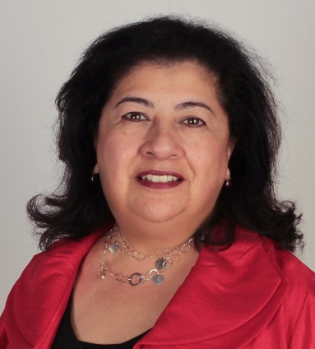**Belinda Madrid Teitel** taps into a range of experience in service to CNM clients. As an executive coach, capacity building consultant, and trainer, Belinda has experience in fundraising, effective boards, leadership, organizational development, and strategic planning. Over the past 15 years, Belinda has worked with hundreds of organizations of all types and sizes. Prior to her consulting work, she served as Regional Director for Earth Share California, a nonprofit federation of 90 premier environmental organizations. Belinda launched her career in banking and finance and has extensive ties with the nonprofit and business sectors. She is a certified Governance Trainer for BoardSource, a Professional Certified Coach with the International Coach Federation, and she serves on the boards of the Greater Los Angeles Chapter of Association of Fundraising Professionals, and Girls on the Run, Los Angeles. Contact Belinda: [bmteitel@cnmsocal.org](mailto:bmteitel@cnmsocal.org)

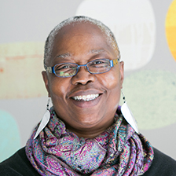**Spring Opara** is a project director for CompassPoint, and a certified professional coach. She is responsible for creatively providing project management support by designing systems and protocols to manage the implementation and execution of Cohort Leadership Programs (CLP). Spring has worked for several nonprofits in the Bay Area including WestEd, The Toigo Foundation, The Dental Health Foundation, and The Link to Children (TLC), all of which have allowed her to develop a plethora of skills and opportunities to support work that has a positive impact in her community. Spring served five years in the U.S. Air Force, where she received numerous medals. She was honorably discharged in 1984 with the rank of E/5, SSgt. Spring is a published writer of both fictional short stories and poems. She was the Women’s Initiative Simple Steps to Success 2010 valedictorian and, in her spare time, works to empower women by facilitating workshops on how to grow your own business. Contact Spring: [springo@compasspoint.org](mailto:springo@compasspoint.org)

|  |
| --- |
| **Fundraising Bright Spots Learning Community**  **KICK-OFF Gathering**  **February 14, 2018**  **9:00 am to 4:30 pm**  **Center for Nonprofit Management** 1000 North Alameda Street Suite A Los Angeles, CA 90012 |

**SAVE THE DATES – ACTION REQUIRED!**

If you have not done this, please take a moment to mark your calendars for the next four sessions.

**Session Dates**

*Note all sessions will be held at the **Suite A** location will begin at 9:00 am, end at 5 pm.

|  |  |
| --- | --- |
| **Session #2:** March 14, 2018 | **Session #3:** May 9, 2018 |
| **Session #4:** June 19, 2018 | **Session #5:** September 13, 2018 |

All materials and work completed in the sessions will be posted on the **Bright Spots Resource Page**: <https://www.compasspoint.org/bright-spots-los-angeles-resources>

**ABOUT THE PROGRAM**

**The Fundraising Bright Spots Program: Making Fundraising Work for You**

This 8 month long intensive, will support your organization's **exploration, development, and implementation of a shared leadership approach to fundraising** that aligns to and builds on your organizational values, strengths, and identity. Research from our latest report, *Fundraising Bright Spots*, shines a light on how organizations that run successful individual donor programs thrive by taking on fundraising in a way that is:

* Core to the **organization’s identity**
* **Distributed broadly** across staff, board and volunteers
* Based on **authentic relationships** with donors
* Characterized by **persistence, discipline, and intentionality**

But how can these values play out for your organization when it comes to developing your own fundraising strategy? In this program, we’ll help you activate practices from successful grassroots fundraising models and individual donor programs highlighted in the Fundraising Bright Spots report and the Grassroots Fundraising Journal. You’ll get the **content, expert guidance, and support** you need to spark deep shifts in how you think about fundraising, and ignite a new **plan of action** that can sustain your organization’s social justice agenda now and for years to come.

**HOMEWORK**

Between each seminar, your team will have homework to continue analysis and development of your plan; guide you in bringing program content and learning back to staff and board; and vet proposed decisions with others within your organization to get feedback, increase ownership, and foster alignment.

**COACHING & PROGRAM ADVICE**

Your coach is a resource for how you utilize the program and create changes in your work and the organization. One of the biggest missed opportunities is when people leave a session with lots of ideas, yet cannot find the time, support or resources to enact them. Having a thirty to sixty minute call with your coach in between group sessions is a way for your team to stay connected to the Bright Spots program learning and the actions you and your partner hold important.

**Coaches are:**

**Angela Johnson Peters:** <https://www.linkedin.com/in/angelajohnsonpeters/>

**Janet McIntyre:** <https://roadmapconsulting.org/consultants/janet-mcintyre-consultant/>

**Kebo Drew:** <https://www.qwocmap.org/KeboDrew.html>

**Steve Lew & Belinda Madrid Teitel**

**LEARNING OBJECTIVES**

**Skills/Knowledge:**

* Clarify your organizational business model, identifying and creating relationship building that is aligned to income types.
* Achieve greater clarity around which fundraising strategies you are pursuing and why
* Make meaning of donor data to guide your fundraising

**Systems:**

* Improve or implement fundraising systems by working to:
  + Clarify data collection strategies
  + Institute practices and habits that will contribute to better understanding of organizational fundraising data
  + Integrate development principles grounded in current field knowledge
* Create a documented plan to distribute fundraising activities throughout the organization
  + Clarify each person's role

**Culture:**

* Identify how fundraising lives both inside and outside the organization
* Understand how fundraising can build power in your community, movement, and in the organization
* Be able to name organizational culture shifts required to support your plan

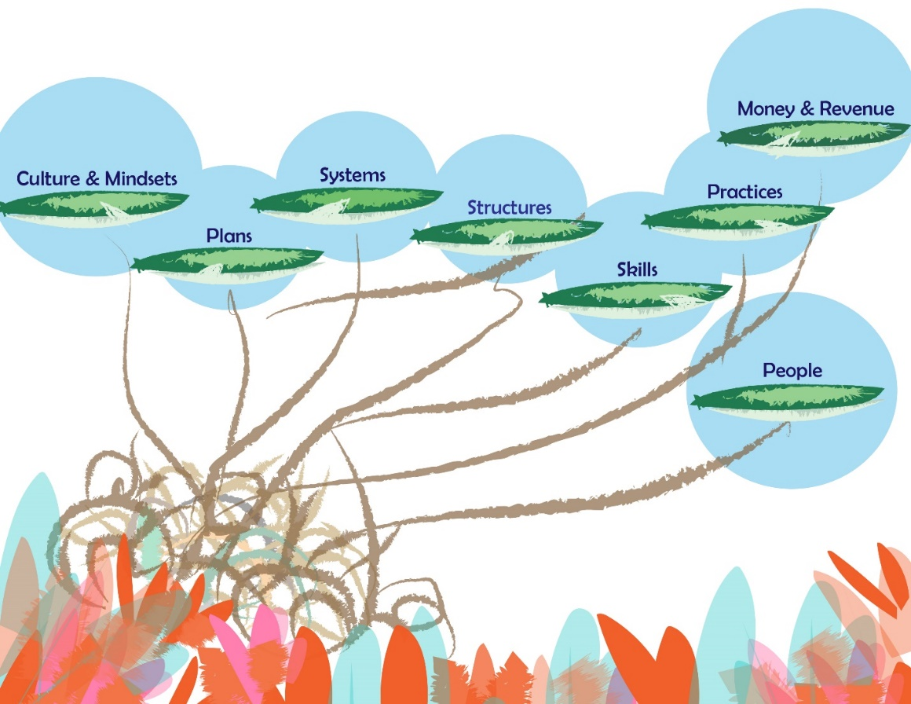

***What’s 1 thing you LOVE about development and fundraising?***

***What’s 1 Risk that you’ll need to take, in order to learn in this setting?***



**COMMUNICATION AGREEMENTS**

* **Confidentiality** is often defined as “what’s said in the room stays in the room” and we agree not to discuss what happens here in a way that would identify any individual or organization. There is another dimension to confidentiality that includes “asking permission” to share or discuss any statement another person makes of a personal nature. It helps to remember that the story belongs to the teller, not the listener.
* **Move-up Participation**. Contribute to conversations for your learning and for others. Create a space for all voices, experiences and ideas to be heard and shared. Talking does not equal participation. Generous listening is a form of participating. If you speak a lot, try listening more. And it you tend to sit back and listen, consider speaking up more.
* **Intent is different than impact**, and both are important. It is also important to own our ability to have a negative impact in another person’s life despite our best intention. In generous listening, if we assume positive intent rather than judging or blaming, we can respond, rather than reacting or attacking when a negative impact occurs.
* **It’s okay to disagree**. Avoid attacking, discounting or judging the beliefs and views of yourself or others – verbally or non-verbally. Instead, welcome disagreements as an opportunity to expand your world. Ask questions to understand other people’s perspectives.

**LEARNING AGREEMENTS**

* **Embrace polarities**. Avoid binaries and embrace wicked questions (i.e. paradoxical truths), such as “How can we be both BOLD and humble in our asking?”
* **Real play, not role play**. Let’s try on ways of being, and ways of doing here in this room.
* **Name elephants**. Be intentional about speaking the unspeakable; foster a culture of candor inside and outside your organization.
* **Be open to new ideas and perspectives**, and be open to having your current ideas and perspectives challenged.
* **Embrace inquiry**. Ask difficult, reflective questions as a matter of course.

Other agreements:

“*All communities are sites of collective imagination, social processes rather than mere locations for living and work*.” Manning Marable

# **SESSION ONE Wednesday February 14th**

# **Agenda**

8:30 – 9:00 Coffee, Tea, and Breakfast

9:15 – 10:25 Welcome, Mingle Magic, Community Learning Agreements

10:25 – 10:40 Break

10:40- 11:10 Introductions

11:10– 12:00 Mapping Your Current Fundraising Environment

11:40 – 12:00 Overview of Fundraising Bright Spots Research

12:00 – 12:30 Fundraising Self-Assessment

12:30 – 1:30 Lunch

1:30 – 2:30 Right Relationship/Right Revenue

2:30 – 4:20 Exploring Core Values, Try On New Values

3:15 – 3:30 Break

4:20 – 4:30 Coaching & Next Steps

4:35 – 5:00 Close/Adjourn

**SESSION ONE: GETTING GROUNDED & BRIGHT SPOTS PRINCIPLES**

**Today’s objectives:**

* Begin establish a learning community; learning about our individual and collective strengths and talents
* Create a baseline understanding of how fundraising happens in your organization
* Explore organizational beliefs & values related to fundraising and identify what is core to your organizations’ identity
* Begin to assess alignment of your fundraising activities to your current revenue model

**Mapping Your Current Fundraising System**

**Mapping Exercise**

This activity is foundational to the work your team will be doing together over the next six months. Having a clear understanding of the roles you activate for fundraising and development and the people who fulfill those roles is important before planning to make fundraising more widespread. It’s as important as your fundraising goals, strategies and, along with a database, the people and roles that comprise the current development system.

**Map It Out**

Draw a “map” of your current fundraising structure and environment. Do your best to document what is actually happening (versus what is aspirational or planned). As we move through this program together, your map will change as you analyze your system, adapt new ideas, and try things on.

1. Consider all the activities that occur during the year to raise money from individuals and institutions.

Create a list of those actions, organized around these categories: *Identifying prospective supporters; Cultivation of prospective supporters; Asking for new support and renewals; Recognition and Thanks; Stewardship.* List any events within these categories based on the function that the event is serving.

Example: a house party may be “asking for new support or renewals” an open house might be “identifying prospective supporters” a gala event may be “Asking” as well as “Stewardship.”

|  |  |
| --- | --- |
| **Category** | **List all activities in the year** |
| **Identifying potential supporters “prospects”** |  |
| **Cultivation** |  |
| **Category** | **List all activities in the year** |
| **Asking** |  |
| **Recognition** |  |
| **Stewardship** |  |

***On your own… Each person in pairs creates their own map to share and compare perspectives*.**

**Once you have named most or all of your activities in a year, map out who is doing what.**

1. Start with yourself by putting your name in a circle. Since you are coordinating and leading much of this work, put your circle in the middle.
2. Add additional circles for other staff who are also playing more central roles, which require more time and responsibilities in development. Be specific in listing what activities or actions they are expected to do related to the development categories.
3. Create as many circles with people (i.e. the board may actually be many small circles if different members are doing specific and different actions than others. Name each person if you can.
4. Remember to add the donors, volunteers, and clients/constituents, elected officials who have played special roles in any of the activities you listed.
5. Now look at your map. Notice who is named. Now ask yourself if each person actually made an effort in the activity or if they are there in name only ☹. Cross out those activities that did not happen.
6. Place a positive symbol or a star by the people who are getting most of their activities done. Consider them your “bright spots” in fundraising. Note next to their name: *What did you learn in the last month about how and why they were able to do what they did in fundraising?*

**Now map it out further…**

1. What supports these bright spots? What ‘system tools’ are used to fulfill the fundraising functions? Name things like your database, email server, social media platforms, gift recordkeeping, and other processes with a box around each tool. Connect names of the people who maintain the tools by drawing a line to their circle.
2. What Allies and Opinion Makers have helped with your fundraising? (Think advisory council members, elected officials and public agency employees, activists from coalitions who have helped out, etc.)
3. What else would you include that we haven’t thought of?

*Paired work*:

**Share your maps with each other-**

* *What did each of us emphasize differently?*
* *Who are the people if any that we see as bright spots?*
* *What areas are we really covering, and what areas are we really missing?*
* *What else do your maps tell you?*

You will come back to this again to envision a future fundraising map- for now, take a photo of each of your maps and send them to each other and **send a copy to Emily Smizer, EmilyS@compasspoint.org** for future reference.

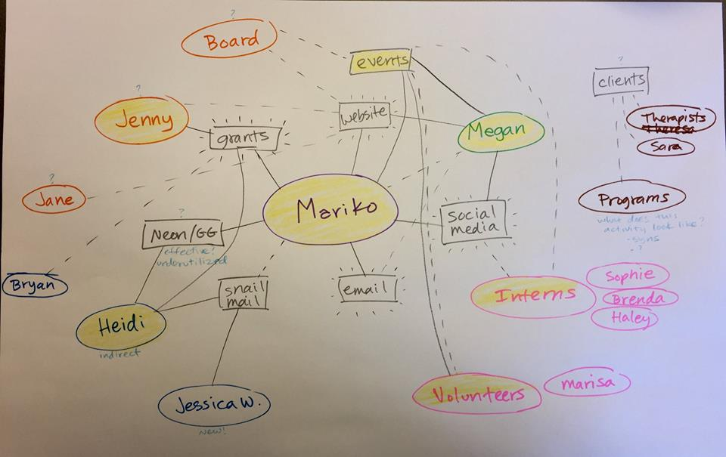

**Fundraising Bright Spots: Key Themes**

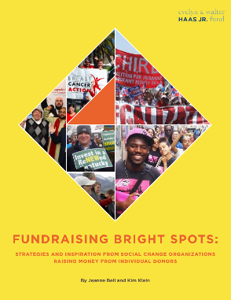**Fundraising is Core to the Organization’s Identity**

“Leaders and sharing power is the core of what we do. So this is about developing leadership that plays into fundraising” -Queer Women of Color Media Arts Project

**Fundraising is Distributed Broadly Across Staff, Board and Volunteers**

“We applied our learning from Bright Spots to achieve 70% staff participation in our most recent fundraising campaign in March 2017, which raised $187,000 in three weeks from 1,100 donors. It was our most successful org-wide fundraising campaign to date”. -Women’s Community Clinic

**Fundraising Succeeds Because of Authentic Relationships with Donors**

“I’ve seen and been in so many conversations where fundraisers indicate a fear of having honest conversations with donors. But I don’t think we can do this work effectively if we can’t have honest, respectful conversations, including strong disagreements as needed, with our donors” -Vu Le, Nonprofit AF

**Fundraising is characterized by Persistence, Discipline, and Intentionality**

“We don’t have a singular development plan. We have a system.” Jewish Voice for Peace

**Brightness Self-Assessment**

*First do an individual assessment, then compare with your teammate.*

|  |  |  |  |  |
| --- | --- | --- | --- | --- |
| **Fundraising is Core to the Organization’s Identity** | | | | |
| **Mindsets** | **Strongly Disagree** | **Disagree** | **Agree** | **Strongly Agree** |
| 1. The decision to raise money from individuals—as well as the approaches used to do so—are steeped in existing organizational & community values. | 1 | 2 | 3 | 4 |
| 1. Being genuine about who we are and what we stand for as an organization is core to fundraising success | 1 | 2 | 3 | 4 |
| 1. Fundraising is a form of organizing and power-building, not merely a strategy for financing the organization’s work. | 1 | 2 | 3 | 4 |
| **Fundraising is Distributed Broadly Across Staff, Board and Volunteers** | | | | |
| **Mindsets** | **Strongly Disagree** | **Disagree** | **Agree** | **Strongly Agree** |
| 1. Fundraising is not the purview of a select group of professionals, but a process, if well-supported, that anyone can engage in. | 1 | 2 | 3 | 4 |
| 1. Development directors are organizational leaders focused on skill building, work culture change, and systems development to support others in fundraising. | 1 | 2 | 3 | 4 |
| 1. The conversation about fundraising goals and progress belongs everywhere. It’s not contained in a single department or confined to a single team. | 1 | 2 | 3 | 4 |
| **Fundraising Succeeds Because of Authentic Relationships with Donors** | | | | |
| **Mindsets** | **Strongly Disagree** | **Disagree** | **Agree** | **Strongly Agree** |
| 1. “Donor” is only one aspect of the many relationships that committed supporters forge with our organization. | 1 | 2 | 3 | 4 |
| 1. Authentic relationships with donors are part of a larger organizational culture that values relational rather transactional interactions with everyone. | 1 | 2 | 3 | 4 |
| 1. High trust and accountability among staff and board members allow leaders to weather fundraising’s inevitable ups and downs together. | 1 | 2 | 3 | 4 |
| **Fundraising is Characterized by Persistence, Discipline, and Intentionality** | | | | |
| **Mindsets** | **Strongly Disagree** | **Disagree** | **Agree** | **Strongly Agree** |
| 1. More important than having a perfect system is working whatever system we have with a stance of rigor and continuous improvement. | 1 | 2 | 3 | 4 |
| 1. Development and communications are inextricably linked; compelling communications are a powerful way to acquire, engage, and retain donors. | 1 | 2 | 3 | 4 |
| 1. The use of data is not just about having a donor database. It’s also about surveying our donors; getting feedback from our fundraisers on what messages are resonating; and studying the performance of every fundraising campaign and event. | 1 | 2 | 3 | 4 |

**Assessment Notes:**

_____________________________________________________________________________

_____________________________________________________________________________

_____________________________________________________________________________

_____________________________________________________________________________

_____________________________________________________________________________

_____________________________________________________________________________

_____________________________________________________________________________

_____________________________________________________________________________

_____________________________________________________________________________

_____________________________________________________________________________

_____________________________________________________________________________

_____________________________________________________________________________

_____________________________________________________________________________

_____________________________________________________________________________

_____________________________________________________________________________

**Articulating Your Revenue Model**

A nonprofit revenue model is a framework for generating revenues that allows the organization to maximize its intended impact while also generating small surpluses that will feed the organization’s future efforts. Often, articulating the revenue model provides the leaders of the organization with focus and clarity as they pursue an optimal business model that allows the organization to thrive in achieving its intended impact.

As nonprofits, we have access to several different streams of funding, and while each of those streams offer us different benefits, each also requires us to develop different management structures and relationships. In years past, “revenue diversity” has often been lauded as a critical element of nonprofit financial management and fiscal health. However, as the sector matures, we are understanding more deeply the programmatic and infrastructure implications of different revenue strategies. Research by *The Bridgespan Group*, among others, has demonstrated that many organizations successfully grow through intentional investment in a dominant type of revenue that is aligned with its work and intended impact (and focus efforts on diversifying among several sources). It’s good to have one primary income type that is reliable and repeatable and a secondary unrestricted income source. Even having 8% of your income from annual giving can ease cash flow throughout the year—8% is one month of operating expense!

**EXAMPLES: REVENUE STREAMS**

* Foundation grants restricted
* Foundation grants unrestricted
* Corporate donations/sponsorships
* Tuition income
* Earned income, fees
* Membership income
* Individual contributions (unrestricted)
* Special event income

**Sources are within a stream, for example:**

Stream 🡪 Restricted foundation grants.  
Sources within that stream🡪 The California Endowment, Irvine Foundation, Ford Foundation

**Complete the Revenue Model Worksheet** (separate attachment, also found on the web resource page).

**RIGHT REVENUE**

The state of your revenue working in concert with your intended impact and values. Rather than focusing solely on the question of income diversification, the fundamental question is this:

***Do you have the right revenue to pursue your intended impact in a financially viable manner that is aligned with your organizational values****?*

1. Does the current revenue mix reliably produce a modest surplus?
2. Do we have a reliable source of unrestricted support?
3. Are our largest sources of income paying for work that we deem essential to our intended impact?
4. Are we relying on a funding stream that is changing substantially, and is that change beyond our control?
5. Are we relying on a funding stream that is misaligned with our organizational values?

**RIGHT RELATIONSHIP**

Just as important as the source of income are the people behind that source. As we articulate your funding model, it is equally important to assess the degree to which you are in right relationship with those that support your organization. The question is:

***Are the people supporting your organization aligned with your organizational values, identity, and goals?***

“Donors do *not* give to your organization. They give *through* your organization to achieve their own desires…to fulfill their own aspirations…to live out their own values.”—Simone Joyaux

“I think we should take the best elements of the donor-centric model, and evolve it into the community-centric model. I think donors want to be neither ATMs nor royalty to be catered to. I think that most would like to be equal partners in the work toward creating an awesome community that they are a part of. If the donor-centric model puts donors in the center, the Community-Centric model focuses on the community as the most important element of our work.” —*Vu Le*

**EXERCISE**

1. Who decides? Within your principal source of funding, who are the particular set of people who dictate the flow of funds? What does that mean for the relationships and systems you need to attend to?
2. What are their motivations? Thinking of these people specifically, what do they want to achieve – for themselves and/or their communities – by giving to your organization? How do they think about and assess the value that your organization delivers?
3. What are the power dynamics in the relationships? Thinking of these people specifically, what power dynamics are at play between you and them? Do they responsibly use their power or do they wield their power inappropriately and/or oppressively?

**Principles of Community-Centric Fundraising**

*Excerpted from Nonprofit AF by Vu Le*.

**Principle 1:** **Fundraising must be grounded in Race, Equity, and Social Justice.** The conversations around fundraising must move beyond diversifying donors and tapping into marginalized communities to give, toward sometimes uncomfortable discussions regarding race and wealth disparities, etc. Many of us are having these conversations with our boards, colleagues, even volunteers. Donors, however, have mainly been exempt from participating in these crucial conversations, which is a disservice to our donors, and to the sector:

* All fundraising professionals must be trained in anti-racism, systemic oppression, equity, wealth disparity, intersectionality, and other areas important to social justice
* Where we can, we encourage donors to think about the above topics, and their roles and privileges within these areas, understanding that people are on different points on various continua.
* We invest in fundraisers who come from the communities that we serve.
* Larger organizations must be cognizant of their roles and minimize inequitable practices like [Trickle-Down Community Engagement](http://nonprofitaf.com/2015/01/are-you-or-your-org-guilty-of-trickle-down-community-engagement/), where they absorb the majority of the funding and donations and filter down small amounts to organizations led by marginalized communities who do the significant community engagement work.

**Principle 3:** **Nonprofits are generous with and mutually supportive of one another**: Nonprofits see and treat one another not as competitors (for the most part), but as critical partners with the common mission of strengthening the community.

* We do not let fear, scarcity mindset, or survival tendencies drive our decisions and actions when relating to other organizations
* We collaborate with organizations whose missions are interconnected with ours and support them to ensure they are also strong
* We introduce our donors to other nonprofits as appropriate
* We share grant opportunities and funder relationships as appropriate
* We give credit to other nonprofits publicly
* We generously share resources, ideas, and promising practices in fundraising and other areas

**Principle 4: All elements that strengthen community are equally valued and appreciated**: We respect, appreciate, recognize, and build relationship with our donors, and we use those same principles with others in the sector, including staff, board members, volunteers, and clients:

* Our staff play a critical role in building a strong and just community. We compensate them fairly, invest in their growth, and appreciate them as much as we appreciate donors.
* Our boards play critical roles in this work. We appreciate our board members as much as we appreciate our other donors.
* Our volunteers provide valuable skills and work and help to strength our community. We appreciate our volunteers as much as we appreciate donors.
* We see our clients not just as recipients of our services but vital contributors to the community. We appreciate our clients as much as we appreciate donors.

**Principle 6: We respect our donors’ integrity and treat donors as partners, which means occasionally pushing back**: I’ve seen and been in so many conversations where fundraisers indicate a fear of having honest conversations with donors. But I don’t think we can do this work effectively if we can’t have honest, respectful conversations, including strong disagreements as needed, with our donors:

* We provide opportunities for donors to further their understanding of the complexity of this work
* We respectfully and firmly push back when donors do or say things that may be detrimental to our work or to the community we are serving
* We are honest and transparent with our donors about the resources that it takes to comply with their wishes and to maintain relationships, and push back when that becomes excessive
* We do not adhere to donors’ wishes if it ever comes at the expense of our clients and community

Note: Vu Le offered **three other principles**, which are found the blog post here: <http://nonprofitaf.com/2017/05/9-principles-of-community-centric-fundraising/>

**Instructions for Discussion**

We are inviting you to explore how you and your group resonates with a four of the nine principles and behaviors described in Vu Le’s article : *9 Principles of Community Centric Fundraising*

1. **Take 15 minutes on your own to review each of the Principles…**

* Is there a principle described that your organization embraces in its beliefs and actions? Underline the bullet points in that principle that your group practices, and add any other examples of what your group does in this principle.
* Identify a principle in the article that is very different, not at all aligned with how your group works. Circle the bullet point practices that ***you want*** to make a reality, put question marks next to the ones that you ***disagree with***, or are uncomfortable with.

1. **In your pairs: What is “core”?**

* In you pairs, share any of the practices and principles that seem core to your work, or new practices you’re excited about. What actual practices are happening in your organization that make this a core principle? What group values are connected to this principle?

__________________________________________________________________________________________________________________________________________________________________________________________________________________________________________________________________________________________________________________________________________________________________________________________________________________________________________________________________________________________________________________________________________________________________________________________________________________________________

1. **What is NOT Core? What COULD be?**

Explore together what is NOT core to your group, and what you’d like to “try on,” experiment with, or truly aspire towards.

__________________________________________________________________________________________________________________________________________________________________________________________________________________________________________________________________________________________________________________________________________________________________________________________________________________________________________________________________________________________________________________________________________________________________________________________________________________________________

1. **What are you curious about that you will want to learn in this community? Name any questions you have, that you want to explore through this program.**

______________________________________________________________________________________________________________________________________________________________________________________________________________________________________________________________________________________________________________________________________________________________________________________________________________________________________________________________________________________________________________________________________________________________________________________________________________________________________________________________

**Bright Spot Examples of Core Identity**

Traditionally, fundraising has been viewed as a supporting activity, an overhead cost, or as a means to a programmatic end. That’s not the case for the Bright Spots. For them, fundraising is part and parcel of organizational identity.

**Who they are and what they believe specifically informs how they approach fundraising from individuals.** Many of the Bright Spots identify as social justice movement-building organizations. For them, giving money is integral to being part of a movement. They involve their donors and members in fundraising as part of a broad array of engagement strategies such as strategic agenda setting, issue education, and political action.

**Fundraising the RISE way:** Respect, Inspire, Support, Empower

We RESPECT our donors and their commitments to RISE—their invested time, money, energy, and emotion—because our donors are activists, invaluable to our mission of ending violence and creating peace.

We strive to INSPIRE our donors with meaningful content sharing about RISE, our clients, and the movement to end gender-based violence.

We SUPPORT donors in getting involved in ways that are exciting and meaningful for them, and thank them with authentic appreciation.

We EMPOWER donors to be ambassadors to their communities, bringing our message and mission.

Bright Spots organizations could easily articulate how fundraising from individuals is inspired by and reflective of their organizational values. Their work reminds us that fundraising identity can’t be tacked on, hired, or manufactured to meet a budget shortfall; it is embedded in organizational identity…

* ***Unconditional acceptance, self-determination, and individualization***
* ***Member engagement is leadership development***
* ***Our work is building power and building the base***
* ***Think Before You Pink***

**Optional Homework to Create a Core Identity Statement**

Think of a time when your groups’ fundraising AND message AND program fit together ‘just right’. Describe the details to each other.

What were you doing, what were others doing well. What did that strength look like, feel like?

1. What words do you use to describe what is “core” in your organization’s identity.

Consider:

* **What is your organization’s unique approach(es) to the work?**
* **Organizational values and principles?**
* **Positive attributes of organizational culture?**

1. In teams, write one to three brief phrases that describe your core organizational identity.

*Guiding principles, values, and tenets that undergird everything that your organization does and that fundraising should generate from.*

_________________________________________________________________________

_________________________________________________________________________

_________________________________________________________________________

_________________________________________________________________________

_________________________________________________________________________

_________________________________________________________________________

_________________________________________________________________________

_________________________________________________________________________

_________________________________________________________________________

_________________________________________________________________________

**HOMEWORK**

**Before Session 2**, each team should complete the following homework:

* Debrief this session with your partner, clarify any role, surface any agreements for how you can participate, and bring back ideas and new actions.
* Re-visit your revenue worksheet and determine what action or decision making is needed, if anything.
* Refine your *What Is Core* statement.
* Schedule your first session with your coach.

**How are you leaving today?**

**What will you share with others in your organization?**

**Notes**

**Fundraising Bright Spots Program – Los Angeles   
2018 Participants List**

|  |  |  |
| --- | --- | --- |
| **Center for the Pacific Asian Family** 3424 Wilshire Blvd., Suite 1000 Los Angeles, CA 90010 [www.NurturingChange.org](http://www.NurturingChange.org)  **Debra Suh, Executive Director** [debra.suh@cpaf.info](mailto:debra.suh@cpaf.info)  **Michelle Esperanza, Dev. & External Relations Dir.** [michellee@cpaf.info](mailto:michellee@cpaf.info)  **Bright Spots Coach:**  Steve Lew, [stevel@compasspoint.org](mailto:stevel@compasspoint.org) |  | **Leadership for Urban Renewal Network (LURN)** 553 S. Clarence Street Los Angeles, CA 90033 [www.lurnetwork.org](http://www.lurnetwork.org)  **Rudy Espinoza, Executive Director** [rudy@lurnetwork.org](mailto:rudy@lurnetwork.org)  **Azusena Espinoza, Director of Programs & Operations** [rudy@lurnetwork.org](mailto:rudy@lurnetwork.org)  **Bright Spots Coach:** Belinda Madrid Teitel, [bmteitel@cnmsocal.org](mailto:bmteitel@cnmsocal.org) |
| **CollegeSpring** 800 S. Figueroa Street, Suite 760 Los Angeles, CA 90017 [www.colleagespring.org](http://www.colleagespring.org)  **Krystal O’Leary-Flores, S. Cal. Executive Director** [kflores@collegespring.org](mailto:kflores@collegespring.org)  **Amy Sims, Programs & Development Manager** [asims@collegespring.org](mailto:asims@collegespring.org)  **Bright Spots Coach:**  Angela Johnson-Peters, [artsguru@sbcglobal.net](mailto:artsguru@sbcglobal.net) |  | **Self Help Graphics & Art** 1300 E. 1st Street Los Angeles, CA 90033 <https://www.selfhelpgraphics.com/>  **Betty Avila, Co-Dir. Advancement & Admin.** [betty.avila@selfhelpgraphics.com](mailto:betty.avila@selfhelpgraphics.com)  **Stephanie Mercado, Development Associate** [stephanie.mercado@selfhelpgraphics.com](mailto:stephanie.mercado@selfhelpgraphics.com)  **Bright Spots Coach:** Belinda Madrid Teitel, [bmteitel@cnmsocal.org](mailto:bmteitel@cnmsocal.org) |
| **El Monte Promise Foundation** 10900 Mulhall Street El Monte, CA 91731 [www.promisenow.org](http://www.promisenow.org)  **Christina Davila, Project Manager** [c.davila@promisenow.org](mailto:c.davila@promisenow.org)  **Kristan Venegas** [kristan.venegas@gmail.com](mailto:kristan.venegas@gmail.com)  **Bright Spots Coach:** Belinda Madrid Teitel, [bmteitel@cnmsocal.org](mailto:bmteitel@cnmsocal.org) |  | **South Asian Network** 18173 Pioneer Blvd., Suite I Artesia, CA 90701 [www.sansocal.org](http://www.sansocal.org)  **Shikha Bhatnagar, Executive Director** [shikha@southasiannetwork.org](mailto:shikha@southasiannetwork.org)  **Saima Husain, Deputy Director** [saima@sansocal.org](mailto:saima@sansocal.org)  **Bright Spots Coach:** Steve Lew, [stevel@compasspoint.org](mailto:stevel@compasspoint.org) |
| **Empowering Pacific Islander Communities (EPIC)** 1137 Wilshire Blvd Los Angeles, CA 90017 [www.empoweredpi.org](http://www.empoweredpi.org)  **Tavae Samuelu, Executive Director** [tsamuelu@empoweredpi.org](mailto:tsamuelu@empoweredpi.org)  **Natasha Saelua, Board Member** [nsaelua@empoweredpi.org](mailto:nsaelua@empoweredpi.org)  **Bright Spots Coach:** Kebo Drew, [events@qwocmap.org](mailto:events@qwocmap.org) |  | **The Unusual Suspects Theatre Co.** 3719 Verdugo Road Los Angeles, CA 90065 <http://theunusualsuspects.org/>  **Melissa Denton, Executive Director** [melissa@theunusualsuspects.org](mailto:melissa@theunusualsuspects.org)  **Meisha Rainman, Development Director** [meisha@theunusualsuspects.org](mailto:meisha@theunusualsuspects.org)  **Bright Spots Coach:** Janet McIntyre, [janetnami@gmail.com](mailto:janetnami@gmail.com) |
| **Get Lit – Words Ignite** 672 S. La Fayette Park Place, Suite 10 Los Angeles, CA 90057 [www.getlit.org](http://www.getlit.org)  **Colleen, Hamilton-Lecky, Development Volunteer** [colleenrhl@gmail.com](mailto:colleenrhl@gmail.com)  **Monique Mitchell** [monique@getlit.org](mailto:monique@getlit.org)  **Bright Spots Coach:** Angela Johnson-Peters, [artsguru@sbcglobal.net](mailto:artsguru@sbcglobal.net) |  | **Tia Chucha’s Centro Cultural** 13197 Gladstone Ave., Suite A Sylmar, CA 91342 [www.tiachucha.org](http://www.tiachucha.org)  **Trini Rodriguez, Executive Director** [trini@tiachucha.org](mailto:trini@tiachucha.org) **Michael Centeno, Development Director** [michael@tiachucha.org](mailto:michael@tiachucha.org)  **Bright Spots Coach:** Kebo Drew, [events@qwocmap.org](mailto:events@qwocmap.org) |
| **Leadership Education for Asian Pacifics** 327 E. 2nd Street, Suite 226 Los Angeles, CA 90012 [www.leap.org](http://www.leap.org)  **Nancy Yap, Director of Development** [nyap@leap.org](mailto:nyap@leap.org)  **Mayta Lor, Development Associate** [mlor@leap.org](mailto:mlor@leap.org)  **Bright Spots Coach:** Janet McIntyre, [janetnami@gmail.com](mailto:janetnami@gmail.com) |  |  |