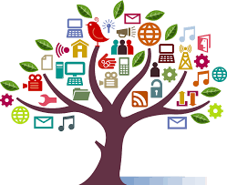

**SESSION 3  
Systems & Practices for Distributed Fundraising**

May 9, 2018



**Disclaimer**

All material is provided without any warranty whatsoever, including, but not limited to, the implied warranties of merchantability or fitness for a particular purpose. Any names of people or companies listed in this book or in its companion computer files are fictitious unless otherwise noted.

**Copyright**

©2018 CompassPoint Nonprofit Services unless otherwise indicated. All rights reserved. This publication, including any companion computer disk, or any component part thereof, may not be reproduced or transmitted in any form or by any means, electronic or mechanical, including photocopying, recording, storage in any information retrieval system, or otherwise, without the prior written permission of the author.

CompassPoint

500 12th St, Suite 320

Oakland, CA 94607

ph 510.318.3755

**Today’s Agenda**

9:00 Welcome, Updates on Actions & Learning

9:15 Small group learning

10:10 Identify How People Use Development Data and Communications

11:30 Video conference presenter: Yee Won Chong

12:15 Lunch

1:15 Small group learning: Creating New Practices

2:20 Break

2:35 Pairs: Systems Planning

3:20 Energizer!

3:25 Leaders Clinic: Tapping the Community Wisdom

4:05 Next steps

4:25 Closing

4:45 End

**COMMUNICATION AGREEMENTS for OUR LEARNING COMMUNITY**

* **Confidentiality** is often defined as “what’s said in the room stays in the room” and we agree not to discuss what happens here in a way that would identify any individual or organization. There is another dimension to confidentiality that includes “asking permission” to share or discuss any statement another person makes of a personal nature. It helps to remember that the story belongs to the teller, not the listener.
* **Move-up Participation**. Honor different beliefs and encourage empowerment by making a space for all voices, experiences and ideas to be heard and shared. Talking does not equal participation. Generous listening is a form of participating. If you speak a lot, try listening more. And it you tend to sit back and listen, consider speaking up more.
* **Intent is different than impact**, and both are important. It is also important to own our ability to have a negative impact in another person’s life despite our best intention. In generous listening, if we assume positive intent rather than judging or blaming, we can respond, rather than reacting or attacking when a negative impact occurs.
* **It’s okay to disagree**. Avoid attacking, discounting or judging the beliefs and views of yourself or others – verbally or non-verbally. Instead, welcome disagreements as an opportunity to expand your world. Ask questions to understand other people’s perspectives.

**LEARNING AGREEMENTS**

* **Embrace polarities**. Avoid binaries and embrace wicked questions (i.e. paradoxical truths), such as “How is it that we are an organization with a national identity and we are uniquely adapted to each local setting?”
* **Real play, not role play**. This space is an opportunity to practice meaningful conversations that will occur in your organizations.
* **Name elephants**. Be intentional about speaking the unspeakable; foster a culture of candor inside and outside your organization.
* **Be open to new ideas and perspectives**, and be open to having your current ideas and perspectives challenged.
* **Embrace inquiry**. Ask difficult, reflective questions as a matter of course.
* **Be ready for pivots**, from ambiguity to direction, from abstract to concrete, from options to decisions.
* **Don’t come to consensus too soon**. It’s okay to let things simmer and it’s okay to change our minds. Create a parking lot for unresolved issues that we need to reflect on and revisit later.

**SESSION THREE:   
Systems & Practices for Distributing Fundraising and Communications  
  
Today’s objectives:**

Through Bright Spots examples and peer sharing and learning we will:

* Share and identify uses of data that will support stronger development practices and distribution of fundraising.
* Consider how to distribute communication and development actions, supported by integrated systems.
* Identify at least 1 intentional practice your team will commit to trying between now and Session 4 on June 19th.
* Build upon sessions 1 & 2 by learning how other participants are using the Bright Spots ideas and tools.

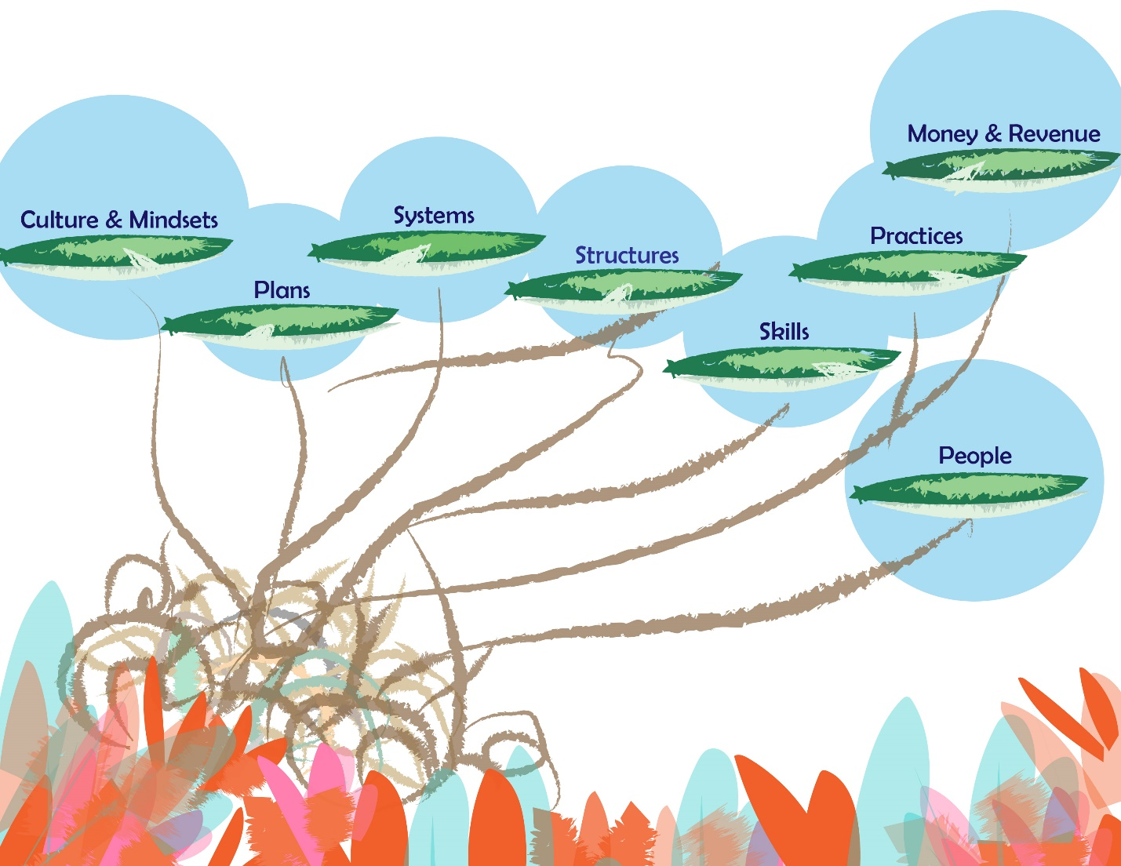

**REFLECTIONS and LESSONS FROM LAST SESSION**

*Over the past month, were more staff, volunteers, and board members involved in communications and fundraising? (Identify any changes you made in your internal systems to support this.)*

*Were specific people given specific roles to execute the fundraising? Who and what did you learn from that experience?*

*Has anything come up in discussions or actions re: power and fundraising? Is there more/less shared power connected to the recent fundraising?*

*Anything else that YOU have noticed about your approach to development since our last session in March?*

**NOTES**:

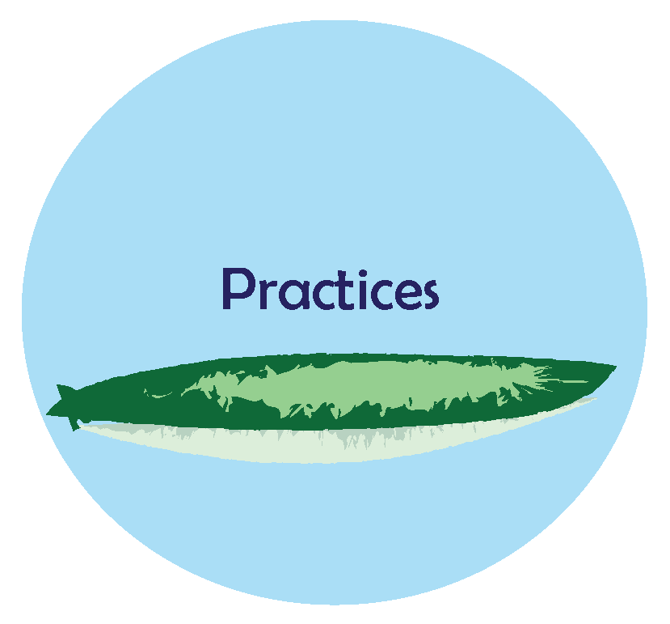

**How You Use the Data**

What data do you look at regularly?

What’s one example of how regular analysis of data prompted a significant shift in a development approach?

**How You Use Communications**

What’s one thing that occurred in your organization which was more successful because of your marketing and communications plan?

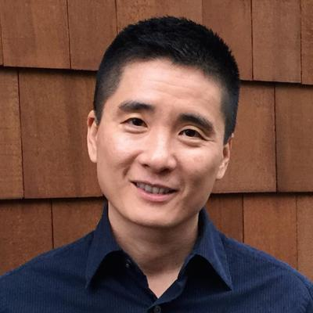

**Notes from Yee Won Chong’s presentation**(pre-reading: *Insights from a Methodical Communicator* from Grassroots Fundraising Journal, January-February 2015 issue)



**Bright Spots Book Club: Small Group Sharing**

* Take no more than 10 minutes to identify what the key ideas and “bright spots” were from the article.
* *In less than 10 minutes,* organize your group to demonstrate the ideas (short skit? Each person holding up a word and saying what it meant? Pantomime?) Aim for **connection** with audience, **not perfection**. ☺

**Sharing ideas effectively**

* Which share back did you learn the most from and why?
* Which share back made it easy to grasp or be open to new ideas and how did they do it?
* Which share back was “the best” and why?

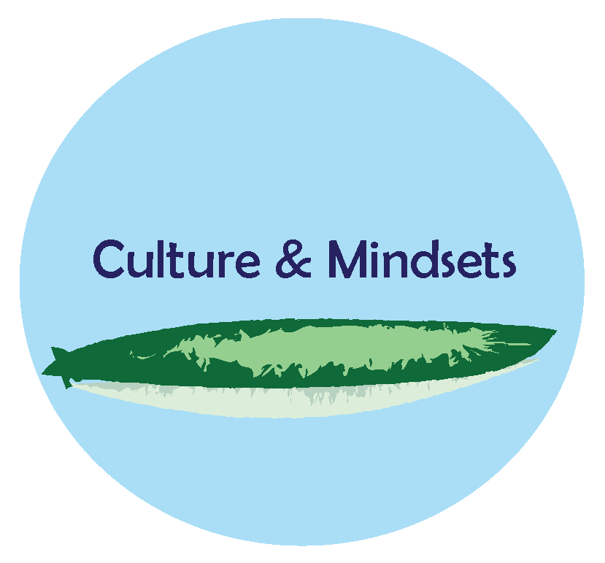**Bright Spot Organizational Mindsets**

* More important than having a perfect system is working whatever system you have with a stance of rigor and continuous improvement. Consider using the “Fundraising Experiments” form to stay in an intentional learning mode.
* Development and communications are inextricably linked; compelling, authentic communications are a powerful way to acquire, engage, and retain donors.
* The use of data is not just about having a donor database. It’s also surveying your donors; it’s getting feedback from your fundraisers on what messages are resonating; and it’s studying the performance of every fundraising campaign and event.

**In Pairs: Systems Goals**

* What do you already have in place, how are you using the system development, communication system?
* What shifts, changes are important to make?
* What can you start in the next week?
* What do you need from each other, and in the org to make those shifts?

**In pairs: What Practice Will Your Team Try?**

Consider committing to at least 1 new practice (consistent, intentional behavior) in any of these areas.

We will use/analyze _____________ data more regularly…

We will involve staff in _______________ more consistently…

We will build relationships with donors in this way…

What do we need to remind each other as we start these new practices?

|  |  |  |  |
| --- | --- | --- | --- |
| **FUNDRAISING EXPERIMENT WORKSHEET**  **An experiment is methodical procedure designed to verify, falsify, or establish a hypothesis or set of assumptions. This worksheet is designed to help you think through and plan an experiment related to fundraising.** | | | |
| **Goal of the Experiment:**  *Example: Retain current direct mail donors at a lower cost.* | | | |
| **Description of the Experiment:**  *Example: Send email appeals rather than snail mail appeals to current donors for whom we have email addresses.* | | | **Data to Track:**  *Example*   1. *# of donors (new and retained)* |
| **Our Assumptions:**  *Example: SAF donors are willing to give through email and will give the same amount through email as they do through direct mail.*  *Example: It will take less time and cost less to send fundraising appeals through email rather than mail.* | | |
| **The Plan of Action:** | | | |
| **Action Step** | **Responsible Person** | **By When** | **Resources and Information Needed** |
|  |  |  |  |
|  |  |  |  |
|  |  |  |  |
|  |  |  |  |
|  |  |  |  |
| **The Results (what happened and why):** | | | |

**Homework for Session 4: June 19th, 2018**

* If you haven’t read “Taking the Leap”, read it before session 4.

<https://www.z2systems.com/np/clients/grassroots/product.jsp?product=2783&catalogId=1&%20>

* Read Beth Rayfield’s article: “*If You Build it They Will Come…*” <http://www.grassrootsfundraising.org/2017/07/if-you-build-it-they-will-come-creating-a-culture-of-fundraising/#comment-118361>
* Read overview of Wheel of Change  
  <http://stproject.org/wp-content/uploads/2014/09/wheel-of-change-model.pdf>