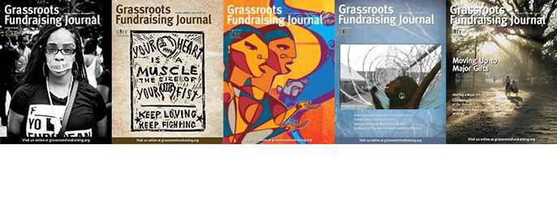**Here’s all the information you’ll need to start or renew subscriptions to the Grassroots Fundraising Journal**

Whether your group is brand new or well-established, run by volunteers, one paid staff person or a large staff, you’ll find tools in the Grassroots Fundraising Journal to help your organization grow. Subscribe to the Journal and tap into a constant stream of proven, practical strategies that will increase your income and diversify your sources of funding with special events, direct mail, major donor programs, membership campaigns, and more.

**Our subscription rates are on a sliding scale in order to keep them affordable and fair.**[**Click here**](https://www.z2systems.com/np/clients/grassroots/membershipJoin.jsp)**to get started.**

**You’ll also get unlimited access to the**[**Journal archive**](https://www.z2systems.com/np/clients/grassroots/catalog.jsp?catalog=1)**as part of your subscription–that’s over 475 practical, easy-to-read fundraising articles at your fingertips, 24/7!**

**How often does the Journal come out?**

The Journal comes out six times a year: Jan/Feb, Mar/Apr, May/Jun, Jul/Aug, Sep/Oct, Nov/Dec.

**I’d like to know more about the Journal before I decide to subscribe. Can I get a sample issue?**

You can **download a**[**sample issue here.**](http://139tbfcfrwi1dter6lduhvje.wpengine.netdna-cdn.com/wp-content/uploads/2011/08/SepOct2009GFJ.pdf)

[**Click here**](https://www.z2systems.com/np/clients/grassroots/catalog.jsp?catalog=1)to check out the GFJ article archive–all subscribers get free, unlimited access to the archive as part of their subscription price!

**What are my subscription and renewal options?**

You can order new subscriptions, gift subscriptions, and renewal subscriptions (print & digital or digital only) for either 1 or 2 years in the U.S. and internationally.