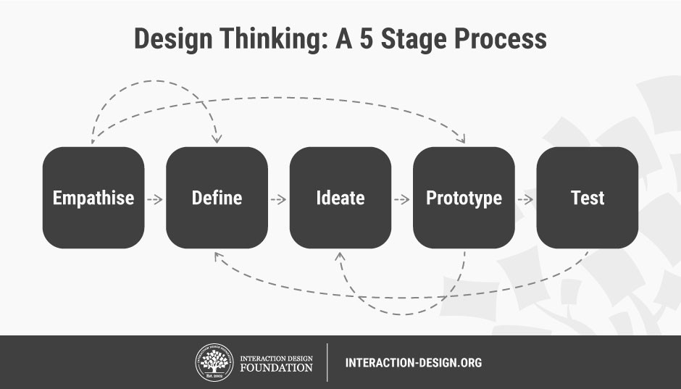

**5 Stages in the Design Thinking Process**

BY [**RIKKE DAM**](https://www.interaction-design.org/literature/author/rikke-1) AND [**TEO SIANG**](https://www.interaction-design.org/literature/author/teo)

*Design Thinking is a design methodology that provides a solution-based approach to solving problems. It’s extremely useful in tackling complex problems that are ill-defined or unknown, by understanding the*[*human needs*](https://www.interaction-design.org/literature/topics/human-needs)*involved, by re-framing the problem in human-centric ways, by creating many ideas in*[*brainstorming*](https://www.interaction-design.org/literature/topics/brainstorming)*sessions, and by adopting a hands-on approach in prototyping and testing. Understanding these five stages of*[*Design Thinking*](https://www.interaction-design.org/literature/topics/design-thinking)*will empower anyone to apply the Design Thinking methods in order to solve complex problems that occur around us — in our companies, our countries, and even our planet.*

In his 1969 seminal text on design methods, “*The Sciences of the Artificial*,” Nobel Prize laureate Herbert Simon outlined one of the first formal models of the Design Thinking process. Simon's model consists of seven major stages, each with component stages and activities, and was largely influential in shaping some of the most widely used Design Thinking process models today. There are many variants of the Design Thinking process in use today, and while they may have different numbers of stages ranging from three to seven, they are all based upon the same principles featured in Simon’s 1969 model.

We will focus on the five-stage model proposed by the Hasso-Plattner Institute of Design at Stanford (d.school). d.school is the leading university when it comes to teaching Design Thinking. The five stages of Design Thinking, according to d.school, are as follows: [Empathise](https://www.interaction-design.org/literature/topics/empathise" \o "What is Empathise?), Define (the problem), Ideate, Prototype, and [Test](https://www.interaction-design.org/literature/topics/test). Let’s take a closer look at the five different stages of Design Thinking.

**1. Empathise**

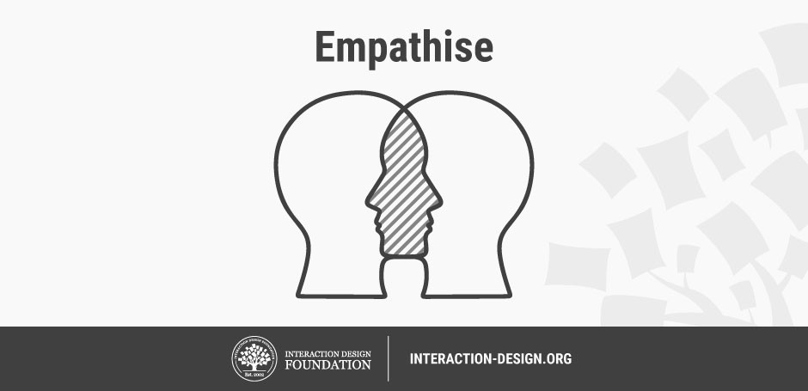Author/Copyright holder: Teo Yu Siang and [Interaction Design](https://www.interaction-design.org/literature/topics/interaction-design) Foundation. Copyright licence: CC BY-NC-SA 3.0

The first stage of the Design Thinking process is to gain an empathic understanding of the problem you are trying to solve. This involves consulting experts to find out more about the area of concern through observing, engaging and empathizing with people to understand their experiences and motivations, as well as immersing yourself in the physical environment to have a deeper personal understanding of the issues involved. Empathy is crucial to a human-centred design process such as Design Thinking, and empathy allows design thinkers to set aside his or her own [assumptions](https://www.interaction-design.org/literature/topics/assumptions) about the world in order to gain insight into users and their needs.

Depending on time constraints, a substantial amount of information is gathered at this stage to use during the next stage and to develop the best possible understanding of the users, their needs, and the problems that underlie the development of that particular product.

**2. Define (the Problem)** 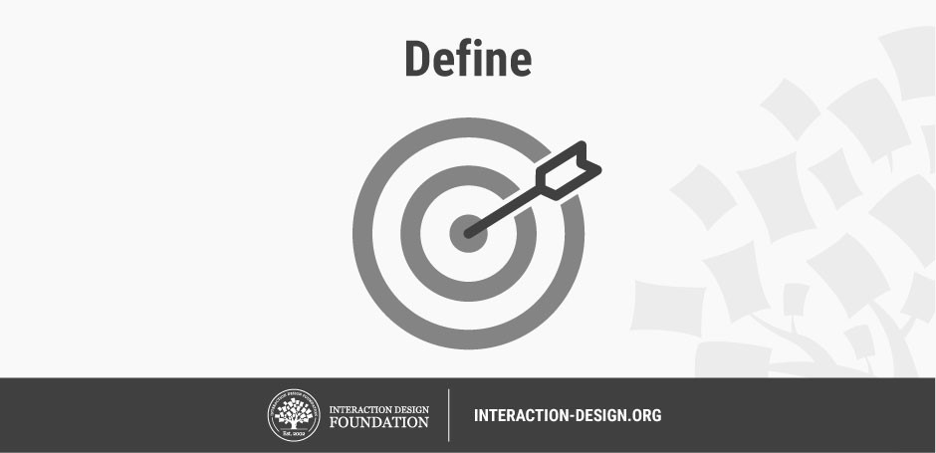

Author/Copyright holder: Teo Yu Siang and [Interaction Design Foundation](https://www.interaction-design.org/literature/topics/interaction-design-foundation). Copyright licence: CC BY-NC-SA 3.0

During the Define stage, you put together the information you have created and gathered during the Empathise stage. You will analyse your observations and synthesise them in order to define the core problems that you and your team have identified up to this point. You should seek to define the problem as a [problem statement](https://www.interaction-design.org/literature/topics/problem-statement) in a human-centred manner.

To illustrate, instead of [defining the problem](https://www.interaction-design.org/literature/topics/defining-the-problem) as your own wish or a need of the company such as, “We need to increase our food-product market share among young teenage girls by 5%,” a much better way to define the problem would be, “Teenage girls need to eat nutritious food in order to thrive, be healthy and grow.”

The Define stage will help the designers in your team gather great ideas to establish features, functions, and any other elements that will allow them to solve the problems or, at the very least, allow users to resolve issues themselves with the minimum of difficulty. In the Define stage you will start to progress to the third stage, Ideate, by asking questions which can help you look for ideas for solutions by asking: “How might we… encourage teenage girls to perform an action that benefits them and also involves your company’s food-product or service?”

**3. Ideate**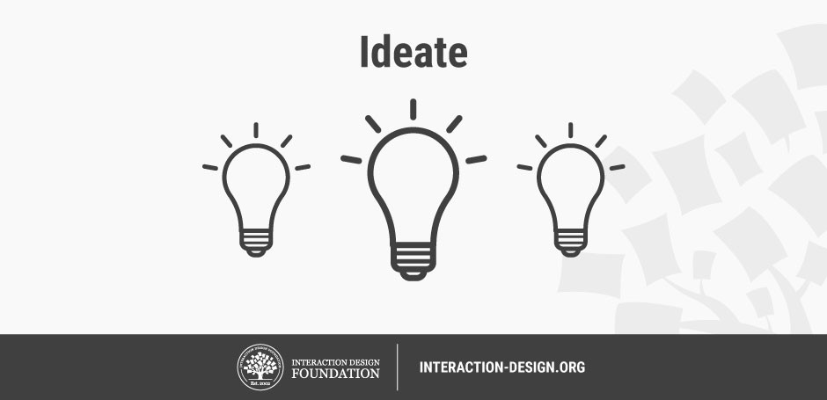

Author/Copyright holder: Teo Yu Siang and Interaction Design Foundation. Copyright licence: CC BY-NC-SA 3.0

During the third stage of the Design Thinking process, designers are ready to start generating ideas. You’ve grown to understand your users and their needs in the Empathise stage, and you’ve analysed and synthesised your observations in the Define stage, and ended up with a human-centered problem statement. With this solid background yourself and your team members can start to 'think outside the box' to identify new solutions to the problem statement you’ve created, and you can start to look for alternative ways of viewing the problem. There are hundreds of [Ideation](https://www.interaction-design.org/literature/topics/ideation) techniques such as Brainstorm, Brainwrite, [Worst Possible Idea](https://www.interaction-design.org/literature/topics/worst-possible-idea), and [SCAMPER](https://www.interaction-design.org/literature/topics/scamper). Brainstorm and Worst Possible Idea sessions are typically used to stimulate free thinking and to expand the problem space. It is important to get as many ideas or problem solutions as possible at the beginning of the Ideation phase. You should pick some other Ideation techniques by the end of the Ideation phase to help you investigate and test your ideas to find the best way to either solve a problem, or provide the elements required to circumvent the problem.

**4. Prototype**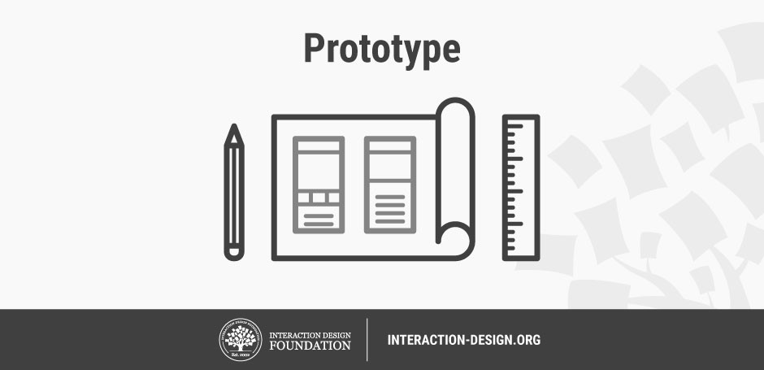

Author/Copyright holder: Teo Yu Siang and Interaction Design Foundation. Copyright licence: CC BY-NC-SA 3.0

The design team will now produce a number of inexpensive, scaled down versions of the product or specific features found within the product, so they can investigate the problem solutions generated in the previous stage. Prototypes may be shared and tested within the team itself, in other departments, or on a small group of people outside the design team. This is an experimental phase, and the aim is to identify the best possible solution for each of the problems identified during the first three stages. The solutions are implemented within the prototypes and, one-by-one, they are investigated and either accepted, improved and re-examined, or rejected on the basis of the users’ experiences. By the end of this stage, the design team will have a better idea of the constraints inherent within the product, the problems that are present, and have a better/more informed perspective of how real users would behave, think, and feel when interacting with the end product.

**5. Test**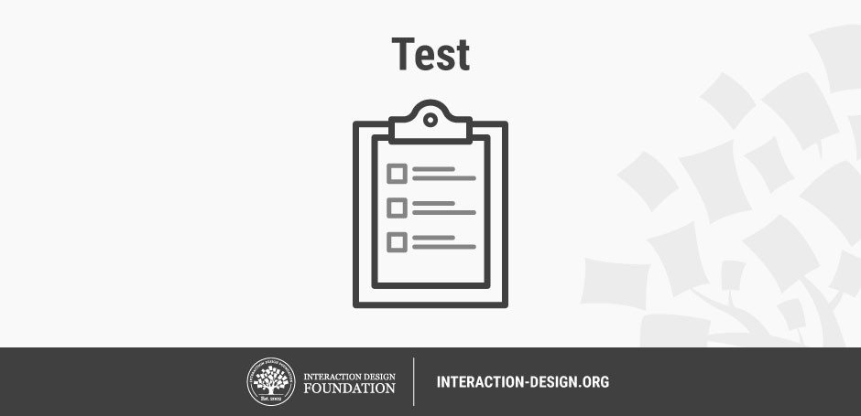

Author/Copyright holder: Teo Yu Siang and Interaction Design Foundation. Copyright licence: CC BY-NC-SA 3.0

Designers or evaluators rigorously test the complete product using the best solutions identified during the prototyping phase. This is the final stage of the 5 stage-model, but in an iterative process, the results generated during the testing phase are often used to *redefine* one or more problems and inform the *understanding* of the users, the conditions of use, how people think, behave, and feel, and to empathise. Even during this phase, alterations and refinements are made in order to rule out problem solutions and derive as deep an understanding of the product and its users as possible.

**The Non-Linear Nature of Design Thinking**

We may have outlined a direct and linear Design Thinking process in which one stage seemingly leads to the next with a logical conclusion at [user testing](https://www.interaction-design.org/literature/topics/user-testing). However, in practice, the process is carried out in a more flexible and non-linear fashion. For example, more than one stage may be conducted concurrently by different groups within the design team, or the designers may collect information and prototype during the entire project so as to enable them to bring their ideas to life and visualise the problem solutions. Also, results from the testing phase may reveal some insights about users, which in turn may lead to another brainstorming session (ideation) or the development of new prototypes.

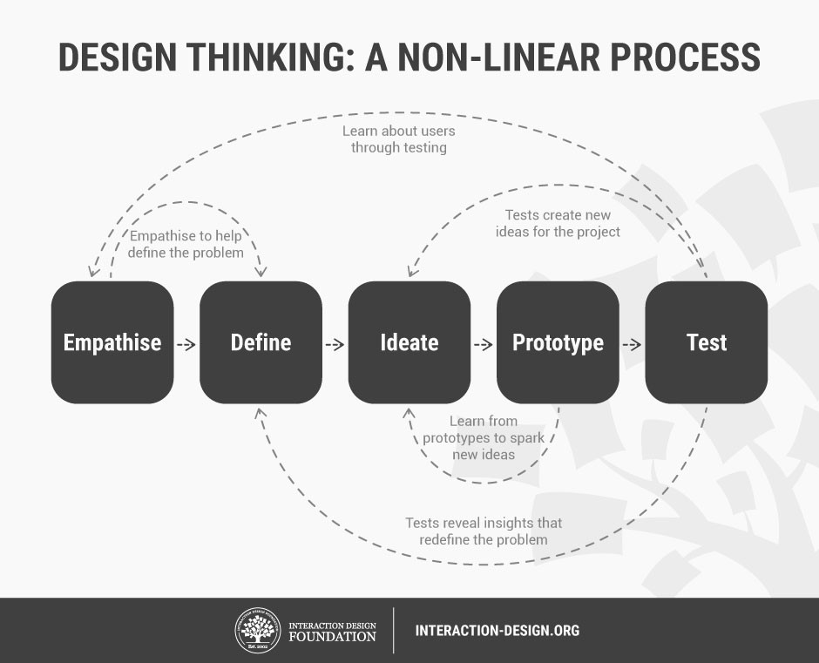

Author/Copyright holder: Teo Yu Siang and Interaction Design Foundation. Copyright licence: CC BY-NC-SA 3.0

*It is important to note that the five stages are not always sequential — they do not have to follow any specific order and they can often occur in parallel and be repeated iteratively. As such, the stages should be understood as different modes that contribute to a project, rather than sequential steps. However, the amazing thing about the five-stage Design Thinking model is that it systematises and identifies the 5 stages/modes you would expect to carry out in a design project – and in any innovative problem solving project. Every project will involve activities specific to the product under development, but the central idea behind each stage remains the same.*

* Design Thinking should not be seen as a concrete and inflexible approach to design; the component stages identified in the image above serve as a guide to the activities that you would typically find. In order to gain the purest and most informative insights for your particular project, these stages might be switched, conducted concurrently and repeated several times in order to expand the solution space, and narrow down on the best possible solutions.

As you will note from the image above, one of the main benefits of the five-stage model is the way in which knowledge acquired at the later stages can feedback to earlier stages. Information is continually used to both inform the understanding of the problem and solution spaces, and to redefine the problem(s). This creates a perpetual loop, in which the designers continue to gain new insights, develop new ways of viewing the product and its possible uses, and develop a greater understanding of the users and the problems they face.

**The Take Away**

In essence, the Design Thinking process is iterative, flexible and focused on collaboration between designers and users, with an [emphasis](https://www.interaction-design.org/literature/topics/emphasis) on bringing ideas to life based on how real users think, feel and behave.

Design thinking tackles complex problem by:

1. Empathising: Understanding the human needs involved.
2. Defining: Re-framing and defining the problem in human-centric ways.
3. Ideating: Creating many ideas in ideation sessions.
4. Prototyping: Adopting a hands-on approach in prototyping.
5. Testing: Developing a prototype/solution to the problem.

**References & Where to Learn More**

Herbert Simon, *Sciences of the Artificial (3rd Edition)*, 1996: <https://monoskop.org/images/9/9c/Simon_Herbert_A_The_Sciences_of_the_Artificial_3rd_ed.pdf>

Gerd Waloszek, *Introduction to Design Thinking*, 2012: <https://experience.sap.com/skillup/introduction-to-design-thinking/>