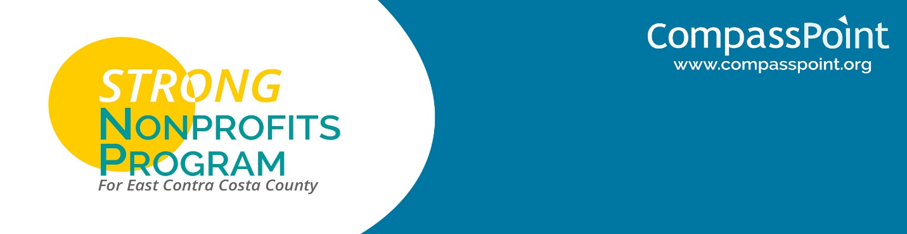

Joint Session with STRONG Participants & Funders  
December 8, 2017  
Brentwood Community Center

**AGENDA**  
9:30 – 12:30

9:00 Bagels & Coffee (Optional)

9:30 Welcome & Review of Format

9:40 Tiny Presentations

*Each organization in attendance (STRONG participants and funders) has a maximum of 3 minutes to name their organization, place it on the provided collective map, name their core purpose (not every program); name any formal networks in the region of which they are a part; and finally, name one burning, timely issue related to East County services and/or service providers. We will be timed! 3 minutes maximum. Please see prep guidelines on the other side of this agenda.*

10:30 Selecting Top “Burning Issues”

10:40 BREAK

10:50 Four Breakout Conversations on “Burning Issues”

11:25 Full Group Debrief and Advancing of Four “Burning Issues”

12:05 Group Announcements & Closing Reflection

12:30 Adjourn Joint Session

*NOTE: Funders will leave at 12:30 while STRONG participants will have lunch and continue their seminar till 3:00 pm.*

**PREPARATORY NOTES FOR YOUR “TINY PRESENTATION”**

Please prepare in advance so that you can deliver this tiny presentation in 3 minutes. Thank you!

Presentation Elements:

A. Organization name and founding year.

B. Locate your organization on the map, which will be hanging in our meeting space.

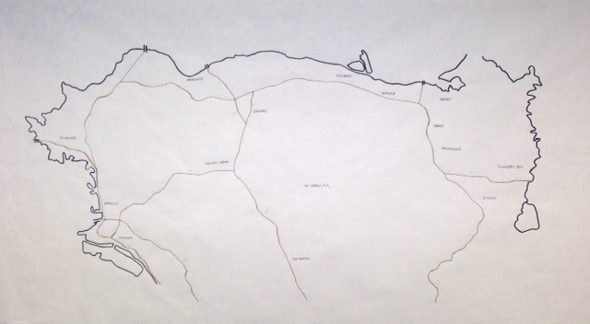

C. Name your organization’s core purpose/programming (without naming every detailed program or project).

D. Name any formal networks that your organization is a part of that would be relevant to this group of service providers in East County.

E. Share one timely, “burning issue” for East County clients, services, and/or service providers.