**Fundraising Bright Spots Program: Session #5**

**Notes from other presentations**

* What did they do?
* What did they learn?
* What are they doing now?
* What Bright Spots do you see/hear?

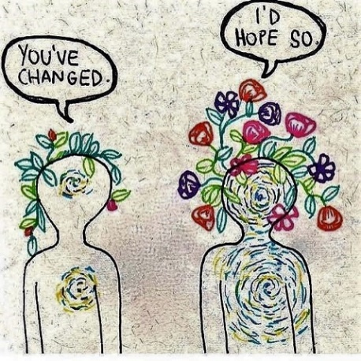**Notes from other presentations**

* What did they do?
* What did they learn?
* What are they doing now?
* What Bright Spots do you see/hear?