**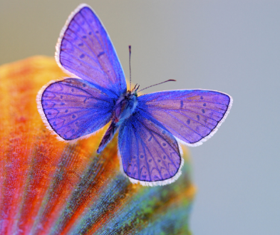***We delight in the beauty of the butterfly*, *but rarely admit the changes it has gone through to achieve that beauty.* –Maya Angelou

**Please Share Your Learning!** Today you will be sharing a part of your Bright Spots experience in your presentation. We would also like to document and learn from the specific changes, challenges and successes in your organization that are a part of the fundraising bright spots work.

**Organization: ______________________________**

We have been in the Fundraising Bright Spots learning community since February of this year. What experiments or changes has your pair focused on over the seven months?

What are the small and big successes over this time?

What challenges have you faced in making changes?

Do we have your permission to share this with other participants, funders and through our communications: with your organization’s name _______ anonymously ________