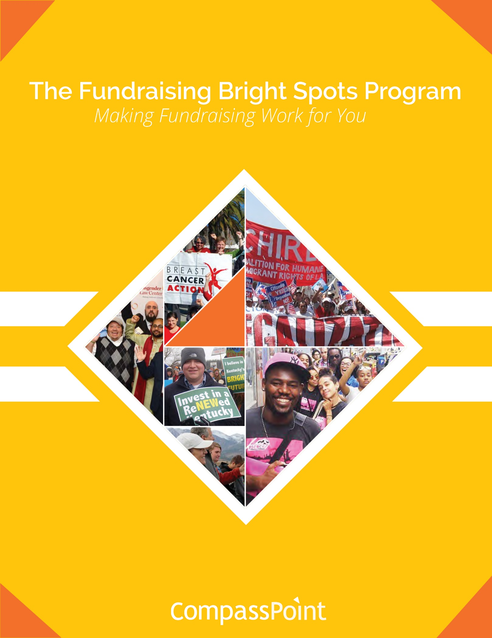

**Bay Area Fundraising Bright Spots Learning Community**

**Kick Off Gathering: September 27, 2018**

## Useful Logistics, Information, and References

1. We will have breakfast and lunch every session. Coffee, tea, and water will also be available.
2. Please sign in for each session. Sign in sheet can be found near the training room door.
3. Roster: We will be sending around the roster for you to review and revise if needed. This will be shared with your fellow participants.
4. **Restrooms** are down the hall past the elevators. The code to get in is **5003**.
5. **WIFI** is available and the network is **CPGuest**. The passcode is **CPWelcome**.
6. All materials and work completed in the sessions will be posted on the Bright Spots Resource Page: <https://www.compasspoint.org/fundraising-bright-spots-program-2018-follow-resources>
7. Please fill out evaluations of your learning experience using the survey link at each session. We use these evaluations to improve the learning space, content and community participation.
8. Schedule time with your partner and your coaches as far in advance as possible. You can set up a session with your coach in between each of the five sessions.

Disclaimer

All material is provided without any warranty whatsoever, including, but not limited to, the implied warranties of merchantability or fitness for a particular purpose. Any names of people or companies listed in this book or in its companion computer files are fictitious unless otherwise noted.

Copyright

© 2018 CompassPoint Nonprofit Services unless otherwise indicated. All rights reserved. This publication, including any companion computer disk, or any component part thereof, may not be reproduced or transmitted in any form or by any means, electronic or mechanical, including photocopying, recording, storage in an information retrieval system, or otherwise, without the prior written permission CompassPoint, 500 12th St, Ste 320, Oakland, CA 94607, 510-318-3755 or the author.

## Session One: Getting Grounded & Bright Spots Principles

**Today’s Objectives:**

* Establish a learning community; roles & learning agreements
* Create a baseline understanding of how fundraising happens in your organization
* Explore organizational beliefs & values related to fundraising and identify what is core to your organization’s identity
* Begin to assess alignment of your fundraising activities to your current revenue model

# 

# **Today’s Agenda:**

8:30 – 9:15 Coffee, Tea, and Breakfast

9:15 – 10:45 Welcome, Getting to Know Each Other, Community Learning Agreements

10:45- 11:00 Break

11:00– 12:15 Mapping Your Current Fundraising Environment

12:15 – 1:15 Lunch

1:15 – 2:30 Right Relationship/Right Revenue

2:30 – 2:45 Break

2:45 – 4:15 Exploring Core Values, Try On New Values

4:15 – 4:40 Coaching & Next Steps

4:40 – 5:00 Close/Adjourn

**Building** **our Learning Community!**

We are looking forward to beginning this journey with you, your learning pair and organization. It’s not often that you can be with other fundraising leaders to think together, imagine and try on new ways of fundraising and leading. We invite you to make this learning community a home that sustains and nurtures your work as well as the other twelve learning pairs and group!

A learning community requires each of us to be responsible for our learning, individually and collectively: to share what we know, what we don’t know, what we are curious about and what we are struggling with in order to deepen the conversations. It also requires building a collective space of respect for different experiences and attuning our listening for bright spots in each other. There may be a special role that you can offer to make the learning community form or become energized.

We will rotate these roles throughout the five sessions so that everyone can contribute to our collective learning, accountability and support.

**Beauty & Order:** help us keep the room ready for interaction and learning, resetting chairs, making sure folks use the green, blue and trash bins. We are a big group and need help sustaining beauty in the room.

**Gatherer:** we all commit to coming back on time; gatherers pay special attention to start times after breaks & calling people back to the room.

**Energy Keeper:** notice the energy of the group as well as your own and let the facilitators know if a stretch, energizer or break is needed.

**R**esilience

**R**esources

**R**elationships

To build trust,   
break down silos,   
and deepen mutuality,   
skills and practices.

To develop tools  
 and new ways of thinking   
about generating, navigating,   
and managing resources  
for sustainability

To cultivate ways of giving, asking and building support that do not diminish people, or reinforce social inequities.

**Learning Agreements**

* **Confidentiality** is often defined as “what’s said in the room stays in the room” and we agree not to discuss what happens here in a way that would identify any individual or organization. There is another dimension to confidentiality that includes “asking permission” to share or discuss any statement another person makes of a personal nature. It helps to remember that the story belongs to the teller, not the listener.
* **Move-up Participation**. Contribute to conversations for your learning and for others. Create a space for all voices, experiences and ideas to be heard and shared. Talking does not equal participation. Generous listening is a form of participating. If you speak a lot, try listening more. And it you tend to sit back and listen, consider speaking up more.
* **Intent is different than impact**, and both are important. It is also important to own our ability to have a negative impact in another person’s life despite our best intention. In generous listening, if we assume positive intent rather than judging or blaming, we can respond, rather than reacting or attacking when a negative impact occurs.
* **It’s okay to disagree**. Avoid attacking, discounting or judging the beliefs and views of yourself or others – verbally or non-verbally. Instead, welcome disagreements as an opportunity to expand your world. Ask questions to understand other people’s perspectives.
* **Embrace inquiry**. Ask difficult, reflective questions as a matter of course.

**Other agreements:**

**CompassPoint’s Learning Environment**

**We Believe…**

*We believe in Deep Respect. This means respecting the collective contribution of all the people who have worked together - and in different ways - co-created this learning space.*

*We believe in Gratitude. This means extending our gratitude to our participants, our clients, our partners, our CompassPoint staff, our caterers, and anyone else who enters our doors.*

*We believe in our Values. We are a deeply values driven organization, our values of Equity, Racial Justice, Multiculturalism, Integrity, Relevance, Learning, Partnership and Humor must show up in everything we do.*

**We Are Committed to…**

*We are committed to interrupting oppression in the spaces we convene. We cannot work to counteract systemic oppression while also allowing interpersonal manifestations of oppression to occur without being acknowledged and interrupted.*

*We are committed to equitable treatment of our staff. This means listening to those who have traditionally been unheard, viewing work with dignity that has often been unvalued and making visible all the work that often goes overlooked.*

*We are committed to creating a transformative space. This means we ask that people who enter our space come with a willingness to address their habits, perspectives, opinions, and stances that may limit the possibility of personal and collective transformation.*

**We Affirm…**

*We affirm that we will lead from a place of love. When conflict arises in our space, out of love for everyone involved, we must address it and acknowledge when harm is done.*

*We affirm that decolonization of our learning environment is imperative as we deepen our practice of centering Racial Justice and Equity.*

*We affirm that all are welcome in our learning environments. We invite you to please join us in upholding the sanctity of the space we are co-creating.*

**About the Program**

**The Fundraising Bright Spots Program: Making Fundraising Work for You**

This 8 month long intensive, will support your organization's **exploration, development, and implementation of a shared leadership approach to fundraising** that aligns to and builds on your organizational values, strengths, and identity. Research from our latest report, *Fundraising Bright Spots*, shines a light on how organizations that run successful individual donor programs thrive by taking on fundraising in a way that is:

* Core to the **organization’s identity**
* **Distributed broadly** across staff, board and volunteers
* Based on **authentic relationships** with donors
* Characterized by **persistence, discipline, and intentionality**

But how can these values play out for your organization when it comes to developing your own fundraising strategy? In this program, we’ll help you activate practices from successful grassroots fundraising models and individual donor programs highlighted in the Fundraising Bright Spots report and the Grassroots Fundraising Journal. You’ll get the **content, guidance, and support** you need to spark deep shifts in how you think about fundraising, and ignite a new **plan of action** that can sustain your organization’s social justice agenda now and for years to come.

**HOMEWORK**

Between each seminar, your team will have homework to continue analysis and development of your plan; guide you in bringing program content and learning back to staff and board; and vet proposed decisions with others within your organization to get feedback, increase ownership, and foster alignment.

**COACHING & PROGRAM ADVICE**

Your coach is a resource for how you utilize the program and create changes in your work and the organization. One of the biggest missed opportunities is when people leave a session with lots of ideas, yet cannot find the time, support or resources to enact them. Having a thirty- to sixty-minute call with your coach in between group sessions is a way for your team to stay connected to the Bright Spots program learning and the actions you and your partner hold important.

**Fundraising Bright Spots: Key Themes**

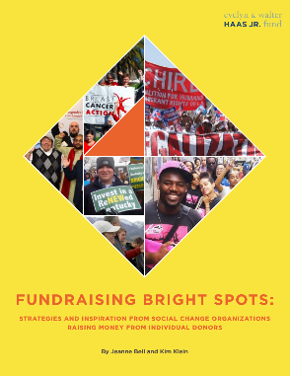**Fundraising is Core to the Organization’s Identity**

“Leaders and sharing power is the core of what we do. So this is about developing leadership that plays into fundraising.”

*Queer Women of Color Media Arts Project*

**Fundraising is Distributed Broadly Across Staff, Board and Volunteers**

“We applied our learning from Bright Spots to achieve 70% staff participation in our most recent fundraising campaign in March 2017, which raised $187,000 in three weeks from 1,100 donors. It was our most successful org-wide fundraising campaign to date.”

*Women’s Community Clinic*

**Fundraising Succeeds Because of Authentic Relationships with Donors**

“I’ve seen and been in so many conversations where fundraisers indicate a fear of having honest conversations with donors. But I don’t think we can do this work effectively if we can’t have honest, respectful conversations, including strong disagreements as needed, with our donors.”

*Vu Le, Nonprofit AF*

**Fundraising is characterized by Persistence, Discipline, and Intentionality**

“We don’t have a singular development plan. We have a system.”

*Jewish Voice for Peace*

**Mapping Your Current Fundraising System**

**Mapping Exercise**

This activity is foundational to the work your team will be doing together over the next six months. Having a clear understanding of the roles you activate for fundraising and development and the people who fulfill those roles is important before planning to make fundraising more widespread. It’s as important as your fundraising goals, strategies and, along with a database, the people and roles that comprise the current development system.

**Map It Out**

Draw a “map” of your current fundraising structure and environment. Do your best to document what is actually happening (versus what is aspirational or planned). As we move through this program together, your map will change as you analyze your system, adapt new ideas, and try things on.

1. Consider all the activities that occur during the year to raise money from individuals and institutions.

Create a list of those actions, organized around these categories: *Identifying prospective supporters; Cultivation of prospective supporters; Asking for new support and renewals; Recognition and Thanks; Stewardship.* List any events within these categories based on the function that the event is serving.

Example: a house party may be “asking for new support or renewals”, an open house might be “identifying prospective supporters” a gala event may be “Asking” as well as “Stewardship.”

| **Category** | **List all activities in the year** |
| --- | --- |
| **Identifying potential supporters “prospects”** |  |
| **Cultivation** |  |
| **Asking** |  |
| **Recognition** |  |
| **Stewardship** |  |

**On your own:Each person in pairs creates their own map to share and compare perspectives.**

**Once you have named most or all of your activities in a year, map out who is doing what.**

1. Start with yourself by putting your name in a circle. Since you are coordinating and leading much of this work, put your circle in the middle.
2. Add additional circles for other staff who are also playing more central roles, which require more time and responsibilities in development. Be specific in listing what activities or actions they are expected to do related to the development categories.
3. Create as many circles with people (i.e. the board may actually be many small circles if different members are doing specific and different actions than others. Name each person if you can.
4. Remember to add the donors, volunteers, and clients/constituents, elected officials who have played special roles in any of the activities you listed.
5. Now look at your map. Notice who is named. Now ask yourself if each person actually made an effort in the activity or if they are there in name only ☹. Cross out those activities that did not happen.
6. Place a positive symbol or a star by the people who are getting most of their activities done. Consider them your “bright spots” in fundraising. Note next to their name: *What did you learn in the last month about how and why they were able to do what they did in fundraising?*

**Now map it out further…**

1. What supports these bright spots? What ‘system tools’ are used to fulfill the fundraising functions? Name things like your database, email server, social media platforms, gift recordkeeping, and other processes with a box around each tool. Connect names of the people who maintain the tools by drawing a line to their circle.
2. What Allies and Opinion Makers have helped with your fundraising? (Think advisory council members, elected officials and public agency employees, activists from coalitions who have helped out, etc.)
3. What else would you include that we haven’t thought of?

**Paired work: Share your maps with each other.**

**Ask each other…**

* *What did each of us emphasize differently?*
* *Who are the people if any that we see as bright spots?*
* *What areas are we really covering, and what areas are we really missing?*
* *What else do your maps tell you?*

You will come back to this again to envision a future fundraising map- for now, take a photo of each of your maps and send them to each other and **send a copy to Emily Smizer, EmilyS@compasspoint.org** for future reference.

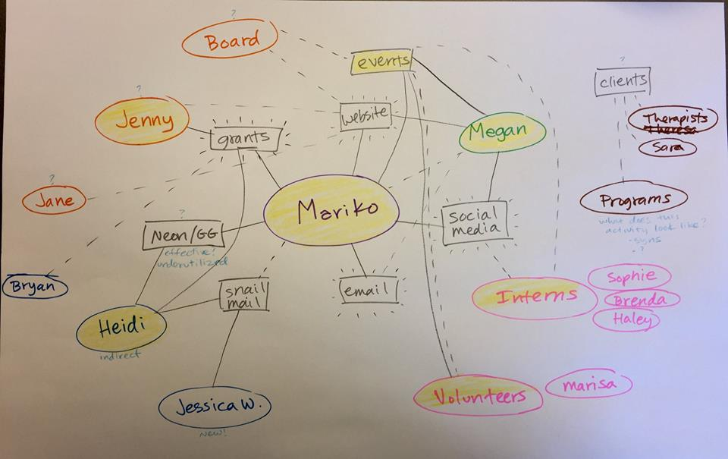

**Articulating Your Revenue Model**

A nonprofit revenue model is a framework for generating revenues that allows the organization to maximize its intended impact while also generating small surpluses that will feed the organization’s future efforts. Often, articulating the revenue model provides the leaders of the organization with focus and clarity as they pursue an optimal business model that allows the organization to thrive in achieving its intended impact.

As nonprofits, we have access to several different streams of funding, and while each of those streams offer us different benefits, each also requires us to develop different management structures and relationships. In years past, “revenue diversity” has often been lauded as a critical element of nonprofit financial management and fiscal health. However, as the sector matures, we are understanding more deeply the programmatic and infrastructure implications of different revenue strategies. Research by *The Bridgespan Group*, among others, has demonstrated that many organizations successfully grow through intentional investment in a dominant type of revenue that is aligned with its work and intended impact (and focus efforts on diversifying among several sources). It’s good to have one primary income type that is reliable and repeatable and a secondary unrestricted income source. Even having 8% of your income from annual giving can ease cash flow throughout the year—8% is one month of operating expense!

**EXAMPLES: REVENUE STREAMS**

* Foundation grants (restricted)
* Foundation grants (unrestricted)
* Corporate donations/sponsorships
* Tuition income
* Earned income, fees
* Membership income
* Individual contributions (unrestricted)
* Special event income

**Sources are within a stream, for example:**

**Stream** 🡪 Restricted foundation grants  
**Sources within that stream** 🡪 The California Endowment, Irvine Foundation, Ford Foundation

**EXERCISE**

**Complete the Revenue Model Worksheet** (separate attachment, also found on the web resource page).

**Right Revenue**

The state of your revenue working in concert with your intended impact and values. Rather than focusing solely on the question of income diversification, the fundamental question is this:

***Do you have the right revenue to pursue your intended impact in a financially viable manner that is aligned with your organizational values****?*

1. Does the current revenue mix reliably produce a modest surplus?
2. Do we have a reliable source of unrestricted support?
3. Are our largest sources of income paying for work that we deem essential to our intended impact?
4. Are we relying on a funding stream that is changing substantially, and is that change beyond our control?
5. Are we relying on a funding stream that is misaligned with our organizational values?

**Right Relationship**

Just as important as the source of income are the people behind that source. As we articulate your funding model, it is equally important to assess the degree to which you are in right relationship with those that support your organization. The question is:

***Are the people supporting your organization aligned with your organizational values, identity, and goals?***

“Donors do *not* give to your organization. They give *through* your organization to achieve their own desires…to fulfill their own aspirations…to live out their own values.”—Simone Joyaux

“I think we should take the best elements of the donor-centric model, and evolve it into the community-centric model. I think donors want to be neither ATMs nor royalty to be catered to. I think that most would like to be equal partners in the work toward creating an awesome community that they are a part of. If the donor-centric model puts donors in the center, the Community-Centric model focuses on the community as the most important element of our work.” —*Vu Le*

**EXERCISE**

1. Who decides? Within your principal source of funding, who are the particular set of people who dictate the flow of funds? What does that mean for the relationships and systems you need to attend to?
2. What are their motivations? Thinking of these people specifically, what do they want to achieve – for themselves and/or their communities – by giving to your organization? How do they think about and assess the value that your organization delivers?
3. What are the power dynamics in the relationships? Thinking of these people specifically, what power dynamics are at play between you and them? Do they responsibly use their power or do they wield their power inappropriately and/or oppressively?

**Exploring Core Values & Principles in Your Organization’s Fundraising**

Do you have core values or beliefs about fundraising and giving? Do those values and beliefs align with your organization’s values and the way it treats donors?

What if our learning community suspended the notion that they are not just your group’s donors? What if we challenged the idea that development needs to be *donor-centric*? We are inviting you to explore how the following principles and behaviors resonate with you and your group, as described in Vu Le’s article, *9 Principles of Community-Centric Fundraising.*

**Principles of Community-Centric Fundraising[1]**

**Principle 1:** **Fundraising must be grounded in Race, Equity, and Social Justice.** The conversations around fundraising must move beyond diversifying donors and tapping into marginalized communities to give, toward sometimes uncomfortable discussions regarding race and wealth disparities, etc. Many of us are having these conversations with our boards, colleagues, even volunteers. Donors, however, have mainly been exempt from participating in these crucial conversations, which is a disservice to our donors, and to the sector:

* All fundraising professionals must be trained in anti-racism, systemic oppression, equity, wealth disparity, intersectionality, and other areas important to social justice
* Where we can, we encourage donors to think about the above topics, and their roles and privileges within these areas, understanding that people are on different points on various continua.
* We invest in fundraisers who come from the communities that we serve.
* Larger organizations must be cognizant of their roles and minimize inequitable practices like [Trickle-Down Community Engagement](http://nonprofitaf.com/2015/01/are-you-or-your-org-guilty-of-trickle-down-community-engagement/), where they absorb the majority of the funding and donations and filter down small amounts to organizations led by marginalized communities who do the significant community engagement work.

**Principle 3: Nonprofits are generous with and mutually supportive of one another**. Nonprofits see and treat one another not as competitors (for the most part), but as critical partners with the common mission of strengthening the community.

* We do not let fear, scarcity mindset, or survival tendencies drive our decisions and actions when relating to other organizations
* We collaborate with organizations whose missions are interconnected with ours and support them to ensure they are also strong
* We introduce our donors to other nonprofits as appropriate
* We share grant opportunities and funder relationships as appropriate
* We give credit to other nonprofits publicly
* We generously share resources, ideas, and promising practices in fundraising and other areas

**Principle 4: All elements that strengthen community are equally valued and appreciated.** We respect, appreciate, recognize, and build relationship with our donors, and we use those same principles with others in the sector, including staff, board members, volunteers, and clients:

* Our staff play a critical role in building a strong and just community. We compensate them fairly, invest in their growth, and appreciate them as much as we appreciate donors.
* Our boards play critical roles in this work. We appreciate our board members as much as we appreciate our other donors.
* Our volunteers provide valuable skills and work and help to strength our community. We appreciate our volunteers as much as we appreciate donors.
* We see our clients not just as recipients of our services but vital contributors to the community. We appreciate our clients as much as we appreciate donors.

**Principle 6: We respect our donors’ integrity and treat donors as partners, which means occasionally pushing back.** I’ve seen and been in so many conversations where fundraisers indicate a fear of having honest conversations with donors. But I don’t think we can do this work effectively if we can’t have honest, respectful conversations, including strong disagreements as needed, with our donors:

* We provide opportunities for donors to further their understanding of the complexity of this work
* We respectfully and firmly push back when donors do or say things that may be detrimental to our work or to the community we are serving
* We are honest and transparent with our donors about the resources that it takes to comply with their wishes and to maintain relationships, and push back when that becomes excessive
* We do not adhere to donors’ wishes if it ever comes at the expense of our clients and community.

**Principle 7: We foster a sense of belonging in our fundraising work; we avoid treating anyone as an “other”.**  We need to be careful to avoid “othering” the people we serve and reinforcing the savior complex. We use fundraising to ensure everyone feels a sense of belonging:

* We authentically partner with our community members when asking them to be involved in fundraising efforts
* We are thoughtful of the impact on our community members when we ask them to share their stories for fundraising purposes
* We are thoughtful about what images we use on our website, brochures, social media, etc., in order to avoid reinforcing the existing archetypes and stereotypes.
* We use “we,” the collective “we” that includes the donor as part of the community doing this work. (I’m not against “you,” but sometimes it’s excessive. We need to balance out the “you” with the collective “we.”)

**Principle 9: We believe, and encourage donors to believe, that the work is holistic, not a collection of isolated segments.**We need to get people to see the work as a whole, not reinforce transactional thinking, which focuses on the split between program costs and “overhead,” as well as the division of our clients into discreet units supported by different individual donors. We need to get donors to see and appreciate that many elements are needed to make things run.

* We are transparent with financial reporting, but whenever possible, to report holistically, not segmented out by which donors paid for what. E.g., “Your $1,000, combined with the funding from grants and other donors, along with support with volunteers and staff, helped us serve 300 kids this year.” Not “Your $1,000 bought books and equipment for 10 kids, and none of your money went to overhead.”
* We encourage funders to understand and support core mission support, i.e., “overhead” or “indirect” expenses
* We do not exaggerate how low our core support expenses are, as this affects everyone in the sector.
* We avoid saying things like “We got a funder/donor to underwrite this event; 100% of your donations go to programs/services.”

Note: Vu Le offers **three additional principles**, which are found in the blog post here: <http://nonprofitaf.com/2017/05/9-principles-of-community-centric-fundraising/>

**EXERCISE**

We are inviting you to explore how the following principles and behaviors resonate with you and your group, as described in Vu Le’s article, *9 Principles of Community-Centric Fundraising.*

1. **Take 15 minutes on your own to review each of the Principles.**

Is there a principle described that your organization embraces in its beliefs and actions? **Underline** the bullet points in that principle that your group practices, and **add any other examples** of what your group does in this principle.

Identify a principle in the article that is very different, not at all aligned with how your group works. **Circle** the bullet point practices that ***you want*** to make a reality; **put question marks** next to the ones that you ***disagree with***, or are uncomfortable with.

Write down your notes including very specific practices your organization, your team, and/or you specifically are doing that supports any of these principles.

1. **We will split you up in 6 groups (no pairs in the same group)**

At each flip chart, use your sticker to locate how close you think your organization is to trying to live out these values. Say verbally why (bottom-line it) in one minute or less.

Write down any specific practices your organization is doing (or trying to do) related to that value.

**Example: Donor volunteer luncheon every quarter to deepen their knowledge of our work and our community. (#6)**

**Discuss with your Partner:**

What is NOT Core? What COULD be?

________________________________________________________________________________________________________________________________________________________________________________________________________________________________________________________________________________________________________________________________________________________________________________________________________________________________________________________________________________________________________________________________________________________________________________________________________________________________________________

What are you curious about that you will want to learn in this community? Name any questions you have, that you want to explore through this program.

________________________________________________________________________________________________________________________________________________________________________________________________________________________________________________________________________________________________________________________________________________________________________________________________________________________________________________________________________________________________________________________________________________________________________________________________________________________________________________

**Bright Spot Examples of Core Identity**

Traditionally, fundraising has been viewed as a supporting activity, an overhead cost, or as a means to a programmatic end. That’s not the case for the Bright Spots. For them, fundraising is part and parcel of organizational identity.

**Who they are and what they believe specifically informs how they approach fundraising from individuals.** Many of the Bright Spots identify as social justice movement-building organizations. For them, giving money is integral to being part of a movement. They involve their donors and members in fundraising as part of a broad array of engagement strategies such as strategic agenda setting, issue education, and political action.

**Fundraising the RISE way:** Respect, Inspire, Support, Empower

We **RESPECT** our donors and their commitments to RISE—their invested time, money, energy, and emotion—because our donors are activists, invaluable to our mission of ending violence and creating peace.

We strive to **INSPIRE** our donors with meaningful content sharing about RISE, our clients, and the movement to end gender-based violence.

We **SUPPORT** donors in getting involved in ways that are exciting and meaningful for them, and thank them with authentic appreciation.

We **EMPOWER** donors to be ambassadors to their communities, bringing our message and mission.

Bright Spots organizations could easily articulate how fundraising from individuals is inspired by and reflective of their organizational values. Their work reminds us that fundraising identity can’t be tacked on, hired, or manufactured to meet a budget shortfall; it is embedded in organizational identity:

* ***Unconditional acceptance, self-determination, and individualization***
* ***Member engagement is leadership development***
* ***Our work is building power and building the base***
* ***Think Before You Pink***

**Optional Homework: Create a Core Identity Statement**

Think of a time when your group’s fundraising AND message AND program fit together ‘just right’. Describe the details to each other.

* What were you doing well?
* What were others doing well?
* What did that strength look like, feel like?

1. **What words do you use to describe what is “core” in your organization’s identity?**

Consider:

* **What is your organization’s unique approach(es) to the work?**
* **What are your organizational values and principles?**
* **What are the positive attributes of your organizational culture?**

1. **In teams, write one to three brief phrases that describe your core organizational identity.**

*Guiding principles, values, and tenets that undergird everything that your organization does and that fundraising should generate from.*

__________________________________________________________________________________________

__________________________________________________________________________________________

__________________________________________________________________________________________

__________________________________________________________________________________________

__________________________________________________________________________________________

__________________________________________________________________________________________

__________________________________________________________________________________________

__________________________________________________________________________________________

__________________________________________________________________________________________

__________________________________________________________________________________________

**Homework**

**Before Session 2**, each team should complete the following homework:

* Debrief this session with your partner, clarify any roles, surface any agreements for how you can participate, and bring back ideas and new actions.
* Re-visit your revenue worksheet and determine what action or decision making is needed, if anything.
* Refine what you both think are (or could be) core values in fundraising.
* Have your first session with your coach, preferably before October 11th.

**How are you leaving today?**

**What will you share with others in your organization?**

**Brightness Self-Assessment**

*First do an individual assessment, then compare with your teammate.*

|  |  |  |  |  |
| --- | --- | --- | --- | --- |
| **Fundraising is Core to the Organization’s Identity** | | | | |
| **Mindsets** | **Strongly Disagree** | **Disagree** | **Agree** | **Strongly Agree** |
| 1. The decision to raise money from individuals—as well as the approaches used to do so—are steeped in existing organizational & community values. | 1 | 2 | 3 | 4 |
| 1. Being genuine about who we are and what we stand for as an organization is core to fundraising success | 1 | 2 | 3 | 4 |
| 1. Fundraising is a form of organizing and power-building, not merely a strategy for financing the organization’s work. | 1 | 2 | 3 | 4 |
| **Fundraising is Distributed Broadly Across Staff, Board and Volunteers** | | | | |
| **Mindsets** | **Strongly Disagree** | **Disagree** | **Agree** | **Strongly Agree** |
| 1. Fundraising is not the purview of a select group of professionals, but a process, if well-supported, that anyone can engage in. | 1 | 2 | 3 | 4 |
| 1. Development directors are organizational leaders focused on skill building, work culture change, and systems development to support others in fundraising. | 1 | 2 | 3 | 4 |
| 1. The conversation about fundraising goals and progress belongs everywhere. It’s not contained in a single department or confined to a single team. | 1 | 2 | 3 | 4 |
| **Fundraising Succeeds Because of Authentic Relationships with Donors** | | | | |
| **Mindsets** | **Strongly Disagree** | **Disagree** | **Agree** | **Strongly Agree** |
| 1. “Donor” is only one aspect of the many relationships that committed supporters forge with our organization. | 1 | 2 | 3 | 4 |
| 1. Authentic relationships with donors are part of a larger organizational culture that values relational rather transactional interactions with everyone. | 1 | 2 | 3 | 4 |
| 1. High trust and accountability among staff and board members allow leaders to weather fundraising’s inevitable ups and downs together. | 1 | 2 | 3 | 4 |
| **Fundraising is Characterized by Persistence, Discipline, and Intentionality** | | | | |
| **Mindsets** | **Strongly Disagree** | **Disagree** | **Agree** | **Strongly Agree** |
| 1. More important than having a perfect system is working whatever system we have with a stance of rigor and continuous improvement. | 1 | 2 | 3 | 4 |
| 1. Development and communications are inextricably linked; compelling communications are a powerful way to acquire, engage, and retain donors. | 1 | 2 | 3 | 4 |
| 1. The use of data is not just about having a donor database. It’s also about surveying our donors; getting feedback from our fundraisers on what messages are resonating; and studying the performance of every fundraising campaign and event. | 1 | 2 | 3 | 4 |

**Assessment Notes:**

____________________________________________________________________________________

____________________________________________________________________________________

____________________________________________________________________________________

____________________________________________________________________________________

____________________________________________________________________________________

____________________________________________________________________________________

____________________________________________________________________________________

____________________________________________________________________________________

____________________________________________________________________________________

____________________________________________________________________________________

____________________________________________________________________________________

____________________________________________________________________________________

____________________________________________________________________________________

**About the Bright Spots Program Team**

**CompassPoint Training Team**

**Berty Arreguin** is a project coordinator for CompassPoint and is responsible for supporting the Training Program. Prior to joining the CompassPoint Team, she interned in both the San Joaquin Central Valley and the Bay Area at the Central Valley Health Policy Institute and Prospera, which are both committed to helping low-income minority communities. Berty is passionate about helping underserved communities of color, and raising awareness of the health disparities among at-risk groups.  A transplant to the Bay Area, Berty enjoys exploring both the East Bay and the San Francisco Bay during her free time, while also making time to visit her hometown of Fresno to visit her family and friends. Berty has also volunteered as a tutor to Social Science students taking *Social Class and Inequality* and *Sociological Theory* courses at California State University, Fresno, and as a facilitator for the Summer Lunch Program at the Central California Regional Obesity Prevention Program.

**Emily Smizer** is a project coordinator for CompassPoint and is a key team member in ensuring that participants in our Cohort Leadership Programs have transformative learning experiences. She is an “outgoing introvert,” which means she enjoys a healthy balance of being behind the scenes and connecting directly with folks to ensure that their learning experiences help them to further their goals of equity and justice. Emily has a hunger for constant learning (and unlearning) and has deep gratitude for the educators in her life, both formal and informal. She believes that all people have a role in applying their lived and learned experiences toward our collective liberation. Outside of work, you can find her reading anything: from radical science fiction series, to long letters from her pen-pal, to Harry Potter speculative fan theories. She also enjoys exploring the East Bay on her bike – except for the hilly parts.

**Simone Thelemaque** is CompassPoint’s operations coordinator. She supports the CompassPoint team and all on-site program participants by helping to make our space inviting, inclusive, and safe. She also supports key human resource functions across our organization. Simone is passionate about healing intergenerational trauma within black and brown womxn by working to expose and correct the ways we participate in our own oppression. On any given day, you can find Simone lost in anything Octavia Butler, taking long magical walks with her daughter, or running lake Merritt.

**Co-Facilitators and Bright Spots Coaches**

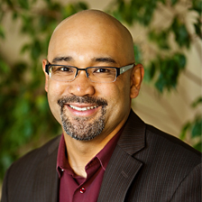 **Nelson Layag** is training director and a certified coach for CompassPoint. His is primarily responsible for the design and management of CompassPoint’s public training program. In addition to leading the training program, he facilitates and teaches on topics including leadership and management, performance management, peer coaching, project management, and instructional design. As a coach, Nelson has a passion for working with staff and leaders of social change organizations and believes in the power of human connection. He has been a fundraiser through CompassPoint and through his work on various nonprofit boards and political campaigns. What drives him is his deep held belief that we all can be a force for change, with each other, and for each other. He is currently serving as the Board President of Filipino Advocates for Justice. A lifelong “islander,” Nelson was born in the Philippines, grew up on Staten Island, and now lives on the island city of Alameda. He’s a drummer in a garage band when he has spare time from being a father of three.

**Steve Lew** is a project director at CompassPoint. He coaches emerging leaders as they grow in their fundraising, governance and leadership roles. Steve was CompassPoint’s development director and a senior manager for several years, and previously served as executive director and development director in HIV and cultural arts nonprofits in San Francisco. Steve’s work at CompassPoint has been deeply connected to building the strength of organizations, leaders, and networks in communities of color. He has co-designed and led the Fundraising Academy for Communities of Color and the Next Generation Leaders of Color Program and has been a fundraising and leadership coach for many of these participants for over a decade. Steve also stays in the fundraising mix as a volunteer for several organizing groups in the Bay Area.

**Bright Spots Coaches**

**T.  Kebo Drew, CFRE** is the Managing Director of Queer Women of Color Media Arts Project. Drew directs organizational development, strategic thinking, fundraising and communications for QWOCMAP. She joined QWOCMAP as its second staff member in 2007 as a Horizons Foundation Rickey William Leader Fellow, when she developed and expanded the QWOCMAP Community Partner program. She also conceived QWOCMAP’s signature presentation "Reels of Resistance: Film IS Social Justice Activism." Drew has professionally managed development, operations and events for corporations, community, arts and nonprofit organizations for over 15 years. She is also a member of the Frameline (SF LGBT Film Festival) Board of Directors. She holds a B.P.A. in Nonprofit Administration from the University of San Francisco. Born in Memphis, Drew is a 2nd generation activist.

**Andrea Lee** has been a tireless organizer for women’s, workers’ and immigrant rights for over 20 years. From 2004-2018, she had the privilege of serving as the Co-Director of Mujeres Unidas y Activas, a grassroots organization led by and for Latina immigrant women based in the San Francisco Bay Area.  During her tenure, Andrea helped MUA to increase its budget by 500% culminating a total organizational budget of over $2.5 million, grow from a staff of 4 to 30, found and lead vibrant local, state, and national domestic worker and immigrant rights coalitions, win new rights for immigrant women workers, and expand its scale to reach women to new geographic areas throughout the Bay Area with the opening of a new program in Union City.  Andrea is a skilled community organizer, popular educator, coalition-builder, strategic thinker, adept manager, and enthusiastic fundraiser.

**Tara Medve** is an experienced and results-driven development and communications professional with a proven track record in contributed revenue growth, strategic fund 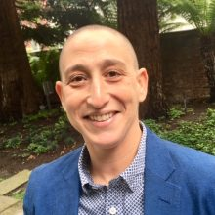development, grant management, donor engagement and cultivation, brand development and management, and event planning and production.

I’m a big picture thinker who likes to roll up their sleeves and dig into the details. My experience leading a nonprofit Development and Communications Department for many years has equipped me with the skills of a generalist—I’m comfortable with everything from database management and social media to annual fund planning and major gifts—but I’m particularly drawn to individual giving. I embrace a philosophy of engagement and abundance and employ a strength-based approach to coaching.

1. Excerpted from Vu Le, *9 Principles of Community-Centric Fundraising*. (<http://nonprofitaf.com/2017/05/9-principles-of-community-centric-fundraising/>)