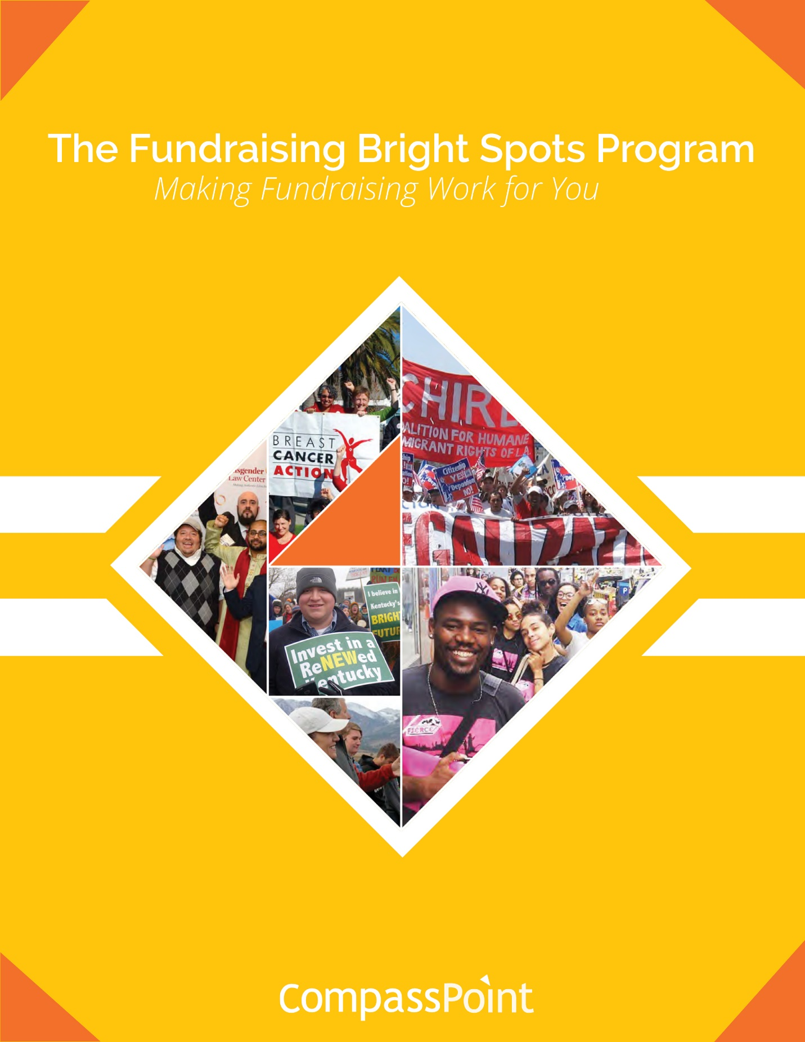

**Session 4: January 10, 2019**



**Session 4: Organizational Change**



***We delight in the beauty of the butterfly*,*****but rarely admit the changes it has gone through to achieve that beauty.***

**–Maya Angelou**

Disclaimer

All material is provided without any warranty whatsoever, including, but not limited to, the implied warranties of merchantability or fitness for a particular purpose. Any names of people or companies listed in this book or in its companion computer files are fictitious unless otherwise noted.

Copyright

©2019 CompassPoint Nonprofit Services unless otherwise indicated. All rights reserved. This publication, including any companion computer disk, or any component part thereof, may not be reproduced or transmitted in any form or by any means, electronic or mechanical, including photocopying, recording, storage in any information retrieval system, or otherwise, without the prior written permission of the author.

**COMMUNICATION AGREEMENTS**

* **Confidentiality** is often defined as “what’s said in the room stays in the room” and we agree not to discuss what happens here in a way that would identify any individual or organization. There is another dimension to confidentiality that includes “asking permission” to share or discuss any statement another person makes of a personal nature. It helps to remember that the story belongs to the teller, not the listener.
* **Move-up Participation**. Honor different beliefs and encourage empowerment by making a space for all voices, experiences and ideas to be heard and shared. Talking does not equal participation. Generous listening is a form of participating. If you speak a lot, try listening more. And it you tend to sit back and listen, consider speaking up more.
* **Intent is different than impact**, and both are important. It is also important to own our ability to have a negative impact in another person’s life despite our best intention. In generous listening, if we assume positive intent rather than judging or blaming, we can respond, rather than reacting or attacking when a negative impact occurs.
* **It’s okay to disagree**. Avoid attacking, discounting or judging the beliefs and views of yourself or others – verbally or non-verbally. Instead, welcome disagreements as an opportunity to expand your world. Ask questions to understand other people’s perspectives.

**LEARNING AGREEMENTS**

* **Embrace polarities**. Avoid binaries and embrace wicked questions (i.e. paradoxical truths), such as “How can we be both BOLD and humble in our asking?”
* **Real play, not role play**. Let’s try on ways of being, and ways of doing here in this room.
* **Name elephants**. Be intentional about speaking the unspeakable; foster a culture of candor inside and outside your organization.
* **Be open to new ideas and perspectives**, and be open to having your current ideas and perspectives challenged.
* **Embrace inquiry**. Ask difficult, reflective questions as a matter of course.

*All communities are sites of collective imagination, social processes rather than mere locations for living and work*.” - Manning Marable

**Session Four Objectives**

* Teams will apply “wheel of change” framework to better identify where and how to focus their fundraising bright spots efforts.
* Participants will have practiced coaching skills as a way to keep generating action, reflection and learning within their team and organization.
* Teams will leave more aligned around the specific changes they need to make within their team and extending outward through the organization.

**Agenda**

9:00 Time to re-connect over breakfast

9:30 Check in, share recent actions & learning

Your own shifts, big & small

Break

Wheel of Change & Coaching Time

Lunch

Peer Coaching on Organizational Hearts & Minds, Behaviors, Systems

Break

Action Planning

Preparing for our final session #5

5:00 End

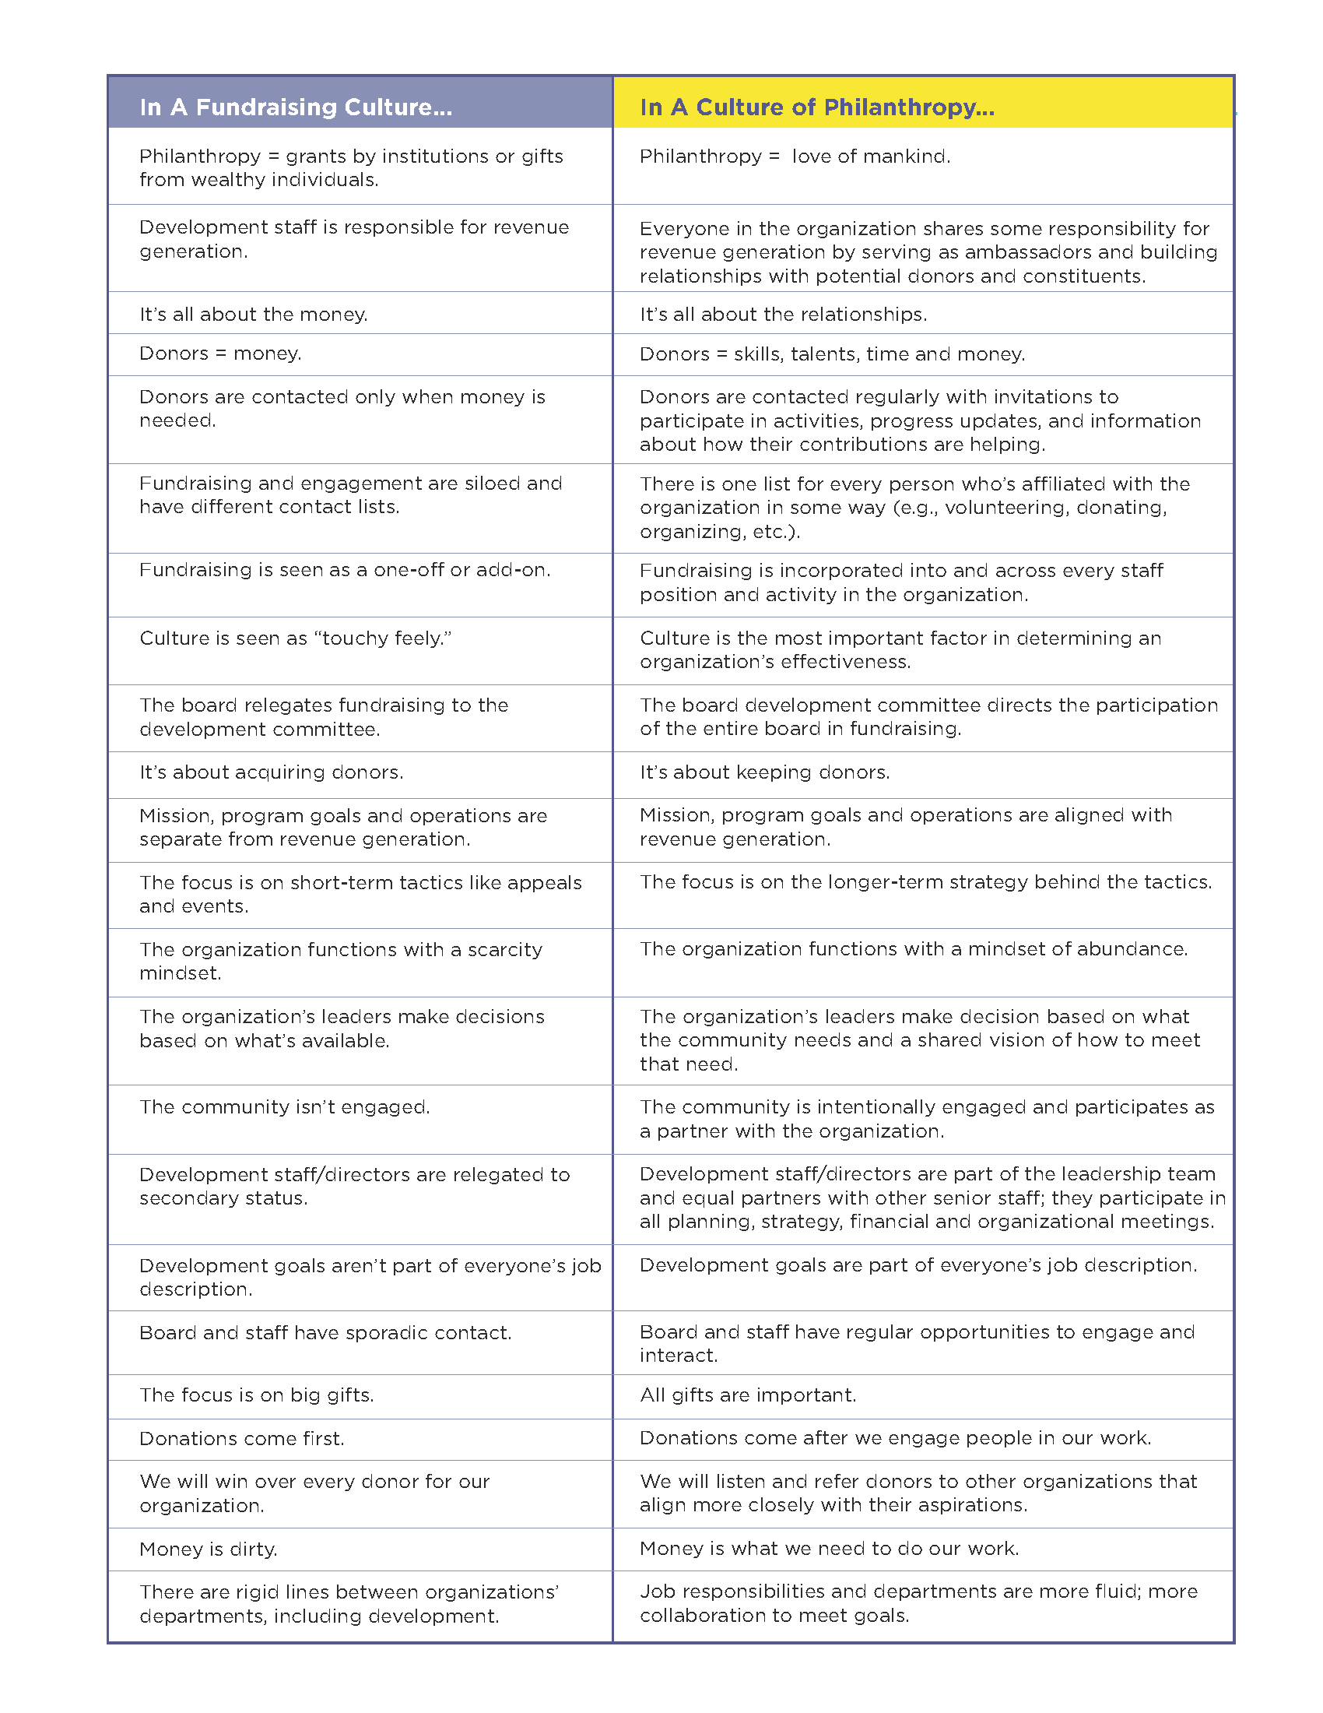**Culture of Philanthropy[1]**

**Wheel of Change Worksheet**

**CHANGE/GOAL:**

*Example:*

* *Goal: Have a “real” stewardship program for people who give major gifts.*
* *Challenges:   
  1. We don’t have good data on current donors to be able to properly segment and plan.   
  2. We need specific people in the organization to support the program but those expectations are not set.*

*3. Most of our largest donors are older and white, and most staff are younger people of color.*

**What shifts in “Hearts and Minds” do you think are necessary for the change to be successful?**

**What “Behaviors” or practices must you change to be successful? What about the behaviors of others in your organization?**

**What “Structures” do you need to change and/or create to be successful?**

**The Coaching Model[2]**

**Action**

**Learning**

**Reflection**

**Coaching Your Peers**

* Completely listen to the presenter – let your brain be quiet and maintain eye contact with presenter.
* Quickly ask useful questions about the presenter’s current perspectives, assumptions, actions.
* Limit advice– do not jump in and “save” the presenter by doing most of the talking yourself.
* Limit general discussion – focus on helping the presenter address their coaching goal.
* Avoid lecturing presenter, for example, saying “you should” or “you have to”.
* Help the presenter come up with specific actions during their time slot.

**Getting Coached**

* Present your coaching goal: what you want to get coached on.
* Use no more than **20%** of your time slot to explain your coaching goal.
* Explain your coaching goal in terms of the **here & now.**
* Use **“I” statements** as much as possible in your explanations.
* Briefly describe your feelings regarding the coaching goal.
* Don’t repeat yourself – explain your goal once.

**Coaching Inquiries**

**Goal setting**

What do you want to see happen?

What’s important about that?

What would success look like to you?

(If a number of goals/issues) What feels most important to focus on right now?

**Approach**

Have you ever done this before? What worked then?

How could you make it even more _____?

What action would really make a difference?

If you knew you’d succeed, what else would you do?

**On challenges**

What is challenging about this situation/person?

What is the meaning you are making of the situation?

What are the real barriers? What are the ones that may not be real?

What is within your power to address this situation?

What is another way to think about this challenge?

What is the benefit of confronting this challenge?

What would happen if you walked away from the challenge?

**Work relationship**

Why is this relationship important?

How is this issue important?

How would [the other party] describe this issue?

What is your role in this situation?

What might the person/situation be teaching you?

If you were viewing this situation as an interested observer, what would you be seeing?

**Reducing Overwhelm**

What can you stop doing so that you can make room for what’s important?

What can you stop tolerating?

If you only focused on one thing, what would that be?

**Eliciting Wisdom**

When you’re at your best, what would you be seeing or doing?

What do you know in your gut?

What might you do differently next time?

What does your heart tell you about this?

As we’ve talked about this, what is new that is emerging?

**Getting to Action**

What are you motivated to do in the next week?

What are your next steps?

How do you plan to achieve that?

How can you break that down into smaller steps?

If you could change one thing, what would it be?

What’s preventing you from…?

What talents or strengths can you call upon to tackle this?

What resources are available to you?

Imagine a point in the future where your issue is resolved. How did you get there?

**Accountability**

What is one step you can take this week to take on this challenge?

What is one thing you can do to shift this challenge by 1%?

Who can you go to for support?

What can you do if you run into another barrier?

What is the benefit of taking these steps?

When will you take these steps by?

How can I reinforce your commitment to action?

What can you do to build in some reward for taking action or accomplishing your goal?

**What’s Next on February 28th…**

**Sharing Your Bright Spots Learning!**

Most of the final session is focused on sharing learning from actions. Each pair will have 12 minutes to share (in any way you like) what has happened since the first session, and what you have learned.

* What happened?
* What did you learn?
* What are your group’s bright spots?
* How is this work connected to other organizational priorities going forward?
* Now what?

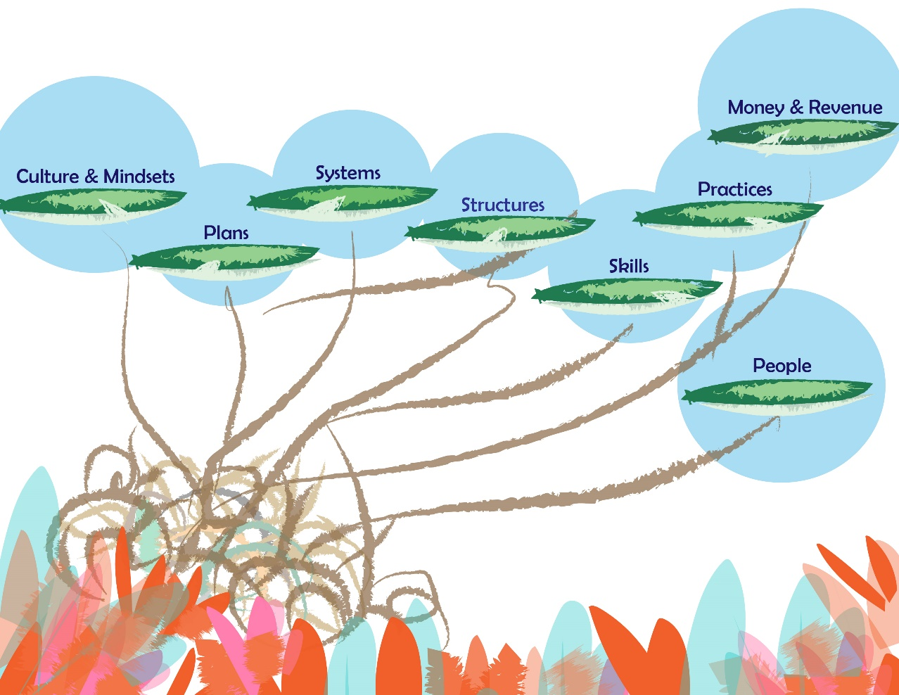

**Notes:**

1. Excerpt taken from: <http://www.haasjr.org/sites/default/files/resources/Haas_CultureofPhilanthropy_F1_0.pdf>
2. Excerpted from *Coaching Skills for Nonprofit Managers and Leaders* by Judith Wilson and Michelle Gislason, San Francisco: Jossey-Bass 2010.)