**Before 1880**

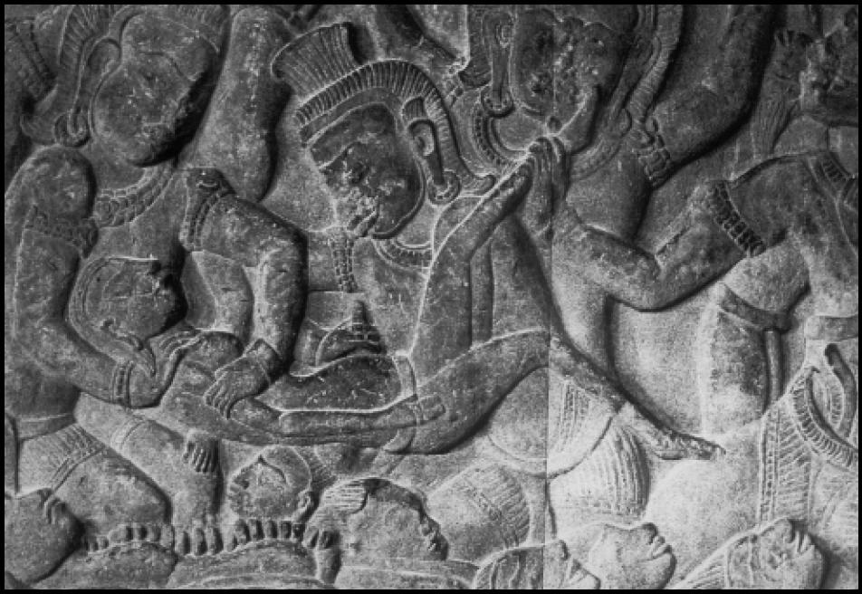

Abortion has been performed for thousands of years, and in every society that has been studied. It was legal in the United States from the time the settlers came until 1880.[1]

**Pre-Colonial**

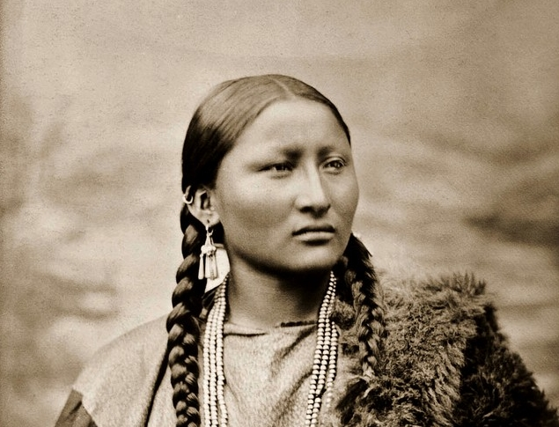

“Traditionally, in Native American communities . . . all decisions concerning a woman’s reproductive health were left up to her as an individual, and her decision was respected . . . Traditional elders’ knowledgeable about reproductive health matters would refer to a woman’s knowing which herbs and methods to use ‘to make her period come.’”[2]

**Pre-Colonial**

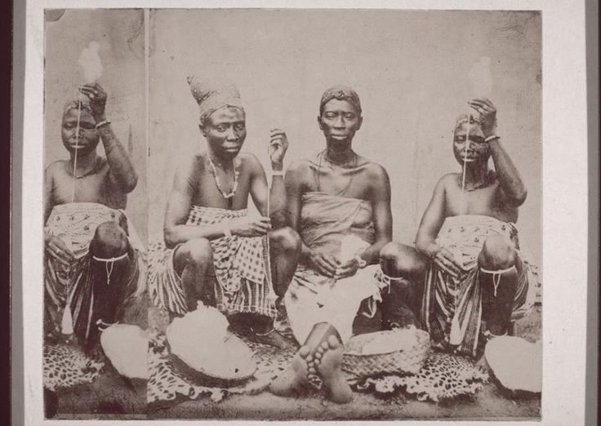

“Black women’s accomplishments and contributions to midwifery are often overlooked. Their birth work stems from practices and traditions that date back to pre-colonization. In their African communities, midwives were more than birth workers and would do so much more than just catch babies. They were also known as spiritual healers.”[3]

**Biddy Mason (1818-1891)**

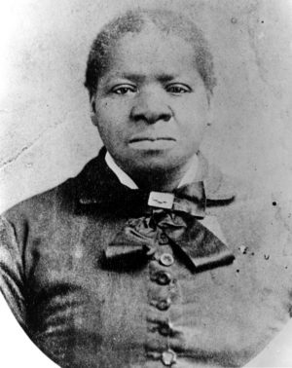“Biddy Mason was born into slavery in Georgia. She was given to her master as a “gift” for his wedding. Her slave owners converted her and the rest of their slaves to Mormonism. They traveled around the country for the Mormon Church. Around 1851 they settled in California, which was a free state, making any slave born or living in California free. Her master did not know of this law and planned to take his slaves to Texas to be sold. Biddy escaped to Los Angles and gained legal emancipation from slavery. She began working as a nurse midwife in Los Angeles. She later became one of the wealthiest black Americans in Los Angeles.”

“The rich tradition [of black midwifery] was passed down, from healer to healer and practiced even during slavery. Black women would not only attend the births of black women, but were often present and attended white women’s births.”[4]

**Mary Francis Hill Coley (1900-1966)**

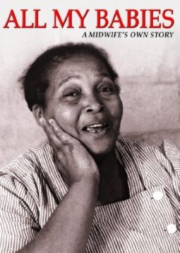

“In her time as a midwife Miss Mary attended over 3,000 births. Mary served both black and white families in the segregated south. She was known for not only being there for the birth but also provided postpartum care where she would cook, clean, and help families fill out birth documents.”[5]

**Margaret Charles Smith (1906-2004)**

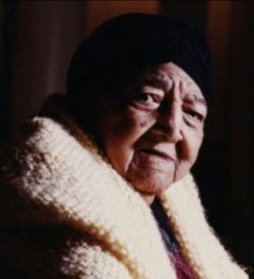

“Margaret Charles Smith is famous for being one of the last practicing Grand (Granny) midwives. Margaret had a very early interest in birth - she caught a baby at the age of five while waiting for the midwife. She went to midwifery school in 1949. Most of her patients were living in poverty and were malnourished. She would spend her days traveling far distances in the south, wading through waters just to get to her births. In her lifetime she helped deliver 3,500 babies.”[6]

**2004**

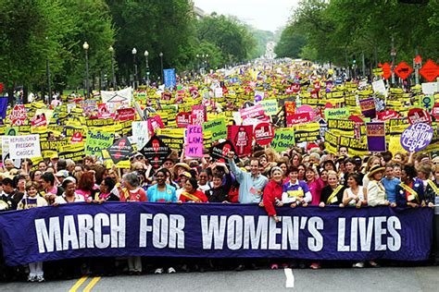

The March for Women’s Lives was one of the largest Marches in U.S. history fueled by the activism of leaders from reproductive justice organizations such as the Black Women’s Health Imperative and the National Latina Institute for Reproductive Health. They successfully advocated to rename the March from the March for Freedom of Choice to the March for Women’s Lives to represent the wider concerns of women of color and those facing multiple forms of oppression. [7]

**2016**



After serving more than 18 months in prison for feticide and neglect of a dependent, Purvi Patel’s conviction was overturned, and she was free. The feticide law was meant to apply to perpetrators of crimes against pregnant women not women who self-induced abortions. This outcome was good news for the abortion rights landscape as it overturned a misuse of the law.[8]

**2016**



Mike Pence elected as Vice President.



Donald Trump elected as President.

**2017**

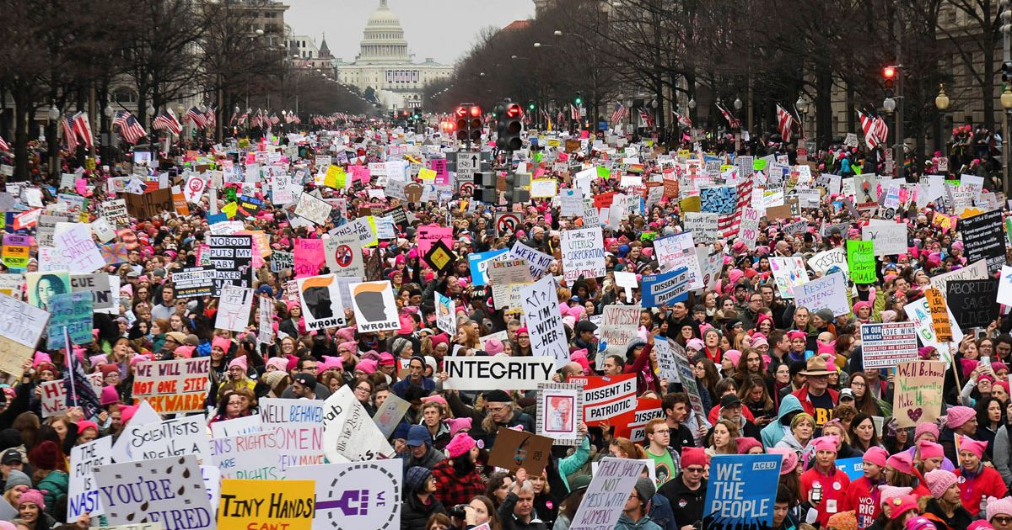

More than 3 million people participated in the one of the largest Marches in history on January 21, 2017—the Women’s March. People from countries around the world take to the streets to protest the sexism, racism, and xenophobia bolstered by Trump’s election.

**2017**

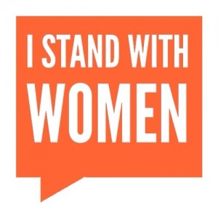

2017 saw a surge in the number of pro-choice bills introduced and passed at the state level. Some 645 bills were [introduced](https://www.nirhealth.org/wp-content/uploads/2018/01/NIRH_2016AR_P3_TS1-1-1.pdf) to protect access to reproductive health care, either by introducing new protections or reforming laws that criminalize abortion care.[9]

**2017**

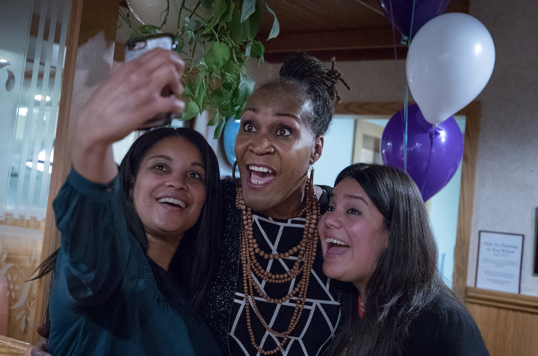

More women, LGBTQ people, and people of color than ever before [were elected](https://www.nytimes.com/2017/11/08/us/politics/democrats-women-minorities.html) in the fall of 2017, a growing rebuke to a conservative agenda that impedes progress toward civil rights for all.[10]

**2018**

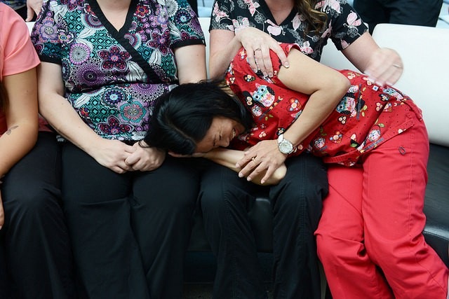

The Trump administration creates new Conscience and Religious Freedom Division to protect “Conscience Rights” of providers. “Religious freedom” protections apply to protecting health care providers from being sued or reprimanded at work if they refuse to engage in certain medical treatment, like providing an abortion, prescribing contraception, or even treating an LGBT person because of their religious beliefs.[11]

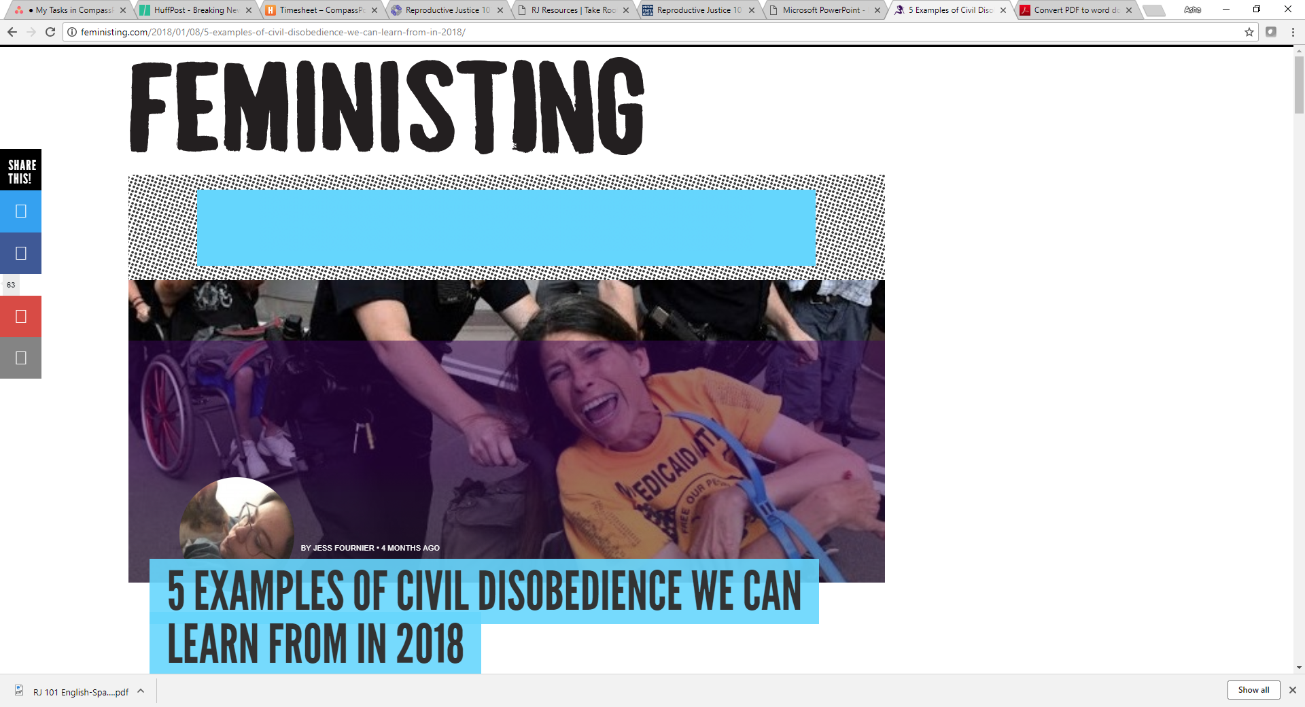**2018**

. . . marginalized folks fought back, marched, and campaigned unceasingly to protect ourselves, our friends, and our communities . . .

1. **ADAPT (disabled queer women & women of color) lead the fight against Affordable Care Act Repeal**
2. **Black activists take down confederate movements**
3. **German pilots stop deportation of asylum seekers**
4. **Boston interfaith coalition provides sanctuary for immigrants facing deportation.**
5. **Undocumented immigrants shut it down for a Clean Dream Act**[12]

1. <https://prochoice.org/education-and-advocacy/about-abortion/history-of-abortion/>
2. <https://www.prochoice.org/pubs_research/publications/downloads/about_abortion/indigenous_women.pdf>
3. <https://www.doulatrainingsinternational.com/brief-history-black-midwifery-us/>
4. <https://www.doulatrainingsinternational.com/brief-history-black-midwifery-us/>
5. <https://www.doulatrainingsinternational.com/brief-history-black-midwifery-us/>
6. <https://www.doulatrainingsinternational.com/brief-history-black-midwifery-us/>
7. Ross & Gutierrez, *Undivided Rights*, p. ix
8. [**https://www.colorlines.com/articles/purvi-patel-released-prison-after-feticide-conviction-overturned**](https://www.colorlines.com/articles/purvi-patel-released-prison-after-feticide-conviction-overturned)
9. <https://www.commondreams.org/views/2018/01/19/year-after-womens-march-how-bad-was-2017-reproductive-justice>
10. <https://www.nytimes.com/2017/11/08/us/politics/democrats-women-minorities.html>
11. <https://www.colorlines.com/articles/icymi-trump-administration-creates-new-division-protect-conscience-rights-providers>
12. <http://feministing.com/2018/01/08/5-examples-of-civil-disobedience-we-can-learn-from-in-2018/>