

**Session 4: Organizational Change**

June 19th, 2018

Disclaimer

All material is provided without any warranty whatsoever, including, but not limited to, the implied warranties of merchantability or fitness for a particular purpose. Any names of people or companies listed in this book or in its companion computer files are fictitious unless otherwise noted.

Copyright

©2018 CompassPoint Nonprofit Services unless otherwise indicated. All rights reserved. This publication, including any companion computer disk, or any component part thereof, may not be reproduced or transmitted in any form or by any means, electronic or mechanical, including photocopying, recording, storage in any information retrieval system, or otherwise, without the prior written permission of the author.

CompassPoint,

500 12th St, Suite 320 Oakland,

CA 94607

ph 510.318.3755

**COMMUNICATION AGREEMENTS**

* **Confidentiality** is often defined as “what’s said in the room stays in the room” and we agree not to discuss what happens here in a way that would identify any individual or organization. There is another dimension to confidentiality that includes “asking permission” to share or discuss any statement another person makes of a personal nature. It helps to remember that the story belongs to the teller, not the listener.
* **Move-up Participation**. Honor different beliefs and encourage empowerment by making a space for all voices, experiences and ideas to be heard and shared. Talking does not equal participation. Generous listening is a form of participating. If you speak a lot, try listening more. And it you tend to sit back and listen, consider speaking up more.
* **Intent is different than impact**, and both are important. It is also important to own our ability to have a negative impact in another person’s life despite our best intention. In generous listening, if we assume positive intent rather than judging or blaming, we can respond, rather than reacting or attacking when a negative impact occurs.
* **It’s okay to disagree**. Avoid attacking, discounting or judging the beliefs and views of yourself or others – verbally or non-verbally. Instead, welcome disagreements as an opportunity to expand your world. Ask questions to understand other people’s perspectives.

**LEARNING AGREEMENTS**

* **Embrace polarities**. Avoid binaries and embrace wicked questions (i.e. paradoxical truths), such as “How can we be both BOLD and humble in our asking?”
* **Real play, not role play**. Let’s try on ways of being, and ways of doing here in this room.
* **Name elephants**. Be intentional about speaking the unspeakable; foster a culture of candor inside and outside your organization.
* **Be open to new ideas and perspectives**, and be open to having your current ideas and perspectives challenged.
* **Embrace inquiry**. Ask difficult, reflective questions as a matter of course.

*All communities are sites of collective imagination, social processes rather than mere locations for living and work*.” - Manning Marable

**Session Four Objectives**

* Teams will apply “wheel of change” framework to better identify where and how to focus their fundraising bright spots efforts.
* Participants will have practiced coaching skills as a way to keep generating action, reflection and learning within their team and organization.
* Teams will leave more aligned around the specific changes they need to make within their team and extending outward through the organization.

**Agenda**

9:00 Time to re-connect over breakfast

9:30 Check in, share recent actions & learning

Your own shifts, big & small

Bright Spots Story on Group Change:   
Andrea Lee, former Co-Director of *Mujeres Unidas y Activas*

Break

Wheel of Change & Coaching Time

Lunch

Peer Coaching on Organizational Hearts & Minds

Break

Action Planning

Preparing for our final session #5

5:00 End

**Culture of Philanthropy\***

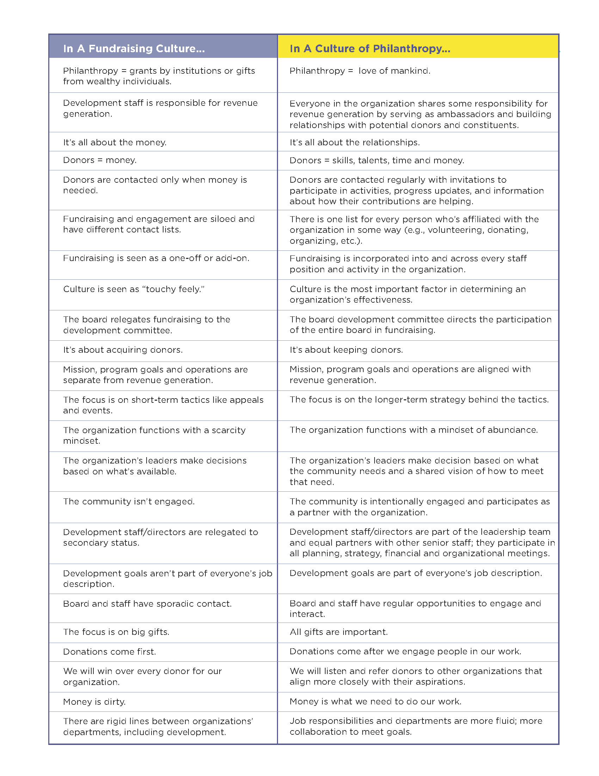

*Excerpt taken from: <http://www.haasjr.org/sites/default/files/resources/Haas_CultureofPhilanthropy_F1_0.pdf>

**Notes: Interview with Andrea Lee, Mujeres Unidas Activas.**

*Andrea is an experienced fundraiser, community organizer, and popular educator who joined MUA’s staff in 2004.  A passionate ally and advocate for MUA’s work to support personal transformation and build community power amongst Latina immigrant women in the Bay Area, Andrea has brought her skills in direct donor fundraising, administration and finance, long-term organizational planning and visioning, political strategy, and training of women and youth as effective community organizers and political actors to MUA.*

**__________________________________________________________________________________________________________________________________________________________________________________________________________________________________________________________________________________________________________________________________________________________________________________________________________________________________________________________________________________________________________________________________________________________________________________________________________________________________________________________________________________________________________________________________________________________________________________________________________________________________________________________________________________**

**Key ideas and principles that you want to apply to your Bright Spots changes:**

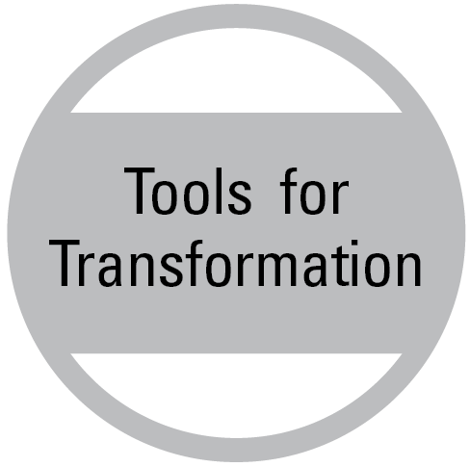**WHEEL OF CHANGE EXECUTIVE OVERVIEW**

By Robert Gass

Engaging in organizational change is a serious endeavor. There is often a significant investment of time, money, and energy. Change efforts also raise hopes and expectations, and failed attempts to make change can lead to disappointment, loss of confidence, and even cynicism about organizational integrity and competence.

Unfortunately, the sad truth is: **most change efforts fail!**

Organizational development is a huge and profitable business. One company alone, McKinsey & Company, has annual revenues of over $6 billion dollars and 94 consulting offices across 52 countries. Yet McKinsey itself reports research that shows ***70% of organizational change efforts fail!***[1]

This is a staggering statistic. Imagine choosing to undertake major surgery with a 70% rate of failure!

**What makes organizational change so difficult?**

Organizations are complex systems. Most change efforts focus on only one element of the system. Perhaps we are seeking to reorganize reporting relationships, create more teamwork, build a new strategic plan, increase accountability, reorganize a department, install a new performance management system, or improve communication.

The problem is that the piece of the organizational system we are trying to change is completely interconnected and interdependent with other parts of the system. All too often, we see well-intended changes efforts that fail to achieve the desired results:

* An attempt to implement an improved performance appraisal system gains little traction due to staff’s underlying lack of trust in management
* A strategic planning process yields poor results due to an unresolved lack of alignment around the vision for the organization
* A structural reorganization bogs down due to competition among senior managers
* Repeated attempts to reconcile what seems like interpersonal mistrust between several key staff fail due to an unaddressed lack of clarity in their roles and overlapping organizational mandates
* An effort to improve accountability breaks down due to a general lack of cultural competency, leading to miscommunication, confused expectations, unintentional slights, and hurt feelings among different social groups
* An initiative to build team spirit and cooperation is undermined by failing to change the nature of work plans which continue to focus on individual performance

Without a systemic approach, we often see what appears to be progress, perhaps even breakthroughs, only to watch the “changes” erode as things revert back to their original conditions:

A team goes to an off-site retreat to address issues of poor communication and low trust. They have what seems like a breakthrough together and make sincere commitments to change their ways. Three months later the good will has faded and old patterns of behavior have re-emerged because needed changes in organizational structure and processes weren’t made.

**Why do most change efforts fail?**

It is the failure to address organizations as interconnected, interdependent systems. Relevant dimensions of the organization are being left unattended.

What is needed is a systemic approach to change: one that deals with the various structures and processes of organizations while equally attending to the human beings that give it life and energy.

# The Wheel of Change

The Wheel of Change is a model for transforming organizations.

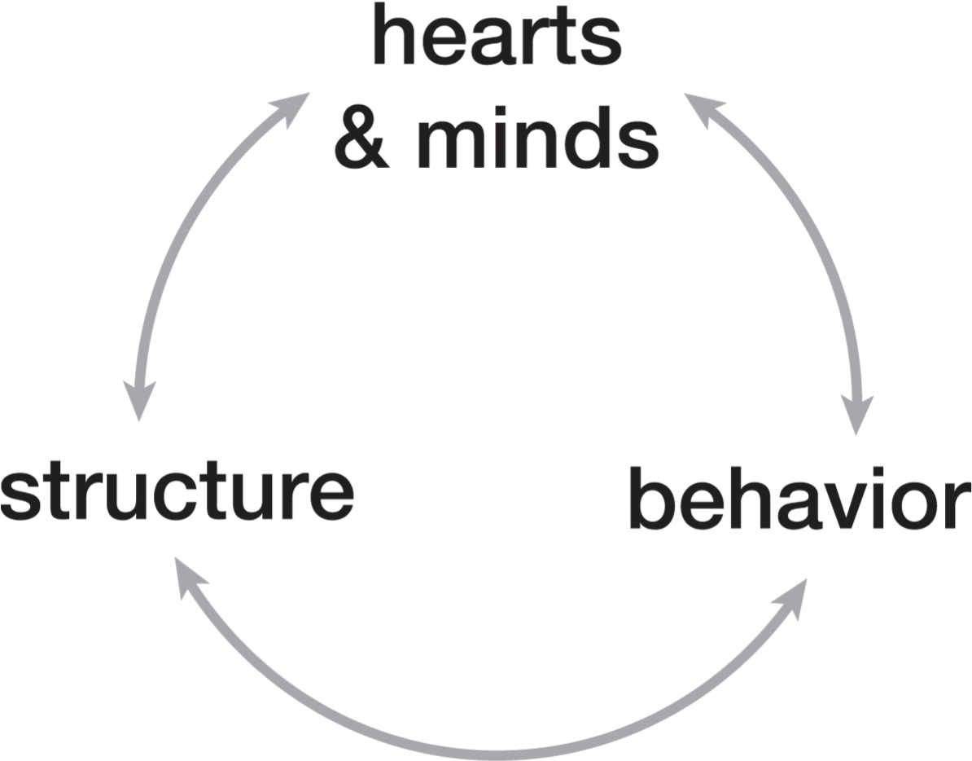

The Wheel of Change asserts that to create real and sustainable change, we must work skillfully with three domains of organizational life:

## Hearts & Minds

The full range of what people think and feel: their motivations, beliefs, emotions, perceptions, etc.

## Behavior

What human beings actually do: their words and deeds, the actual choices they make to speak or not speak, to act or not to act, their habits.

## Structure

The organization structures, systems, and processes through which work gets done.

These three domains continually reinforce each other, which is why organizational systems tend to resist change. However, through a transformational approach we can:

* Identify and address the critical elements in each of the 3 domains of organizational life
* Create a virtuous cycle in which changes in one domain evoke and reinforce change in the other two domains.

## Working with Hearts & Minds

Transforming organizations requires people to transform. The change process must skillfully engage with people, their hopes and fears, their thoughts, perceptions, beliefs and assumptions about reality. In the domain of Hearts & Minds this might look like:

* People joining in common cause around a compelling vision for change
* Commitment (not compliance) in order to generate energy and personal responsibility for making change
* Developing shared understanding of what’s required to make change happen
* The unleashing of creativity, new ideas, and innovation
* Examining and shifting underlying beliefs that may limit the change process
* Addressing issues of mistrust or interpersonal tensions that may be in the way of the change process
* Surfacing and addressing doubts and fears that inhibit people from making their full contribution
* A feeling of team, of belonging that inspires people to stand together and pull together

## Behavior

The second domain is Behavior. Changing the way people think and feel is critical, but not sufficient for transformation. Organizational change requires that the people who work there need to actually act differently. Transformation in Behavior might look like:

* New expectations are clearly articulated and formalized (sometimes called Team Agreements or Rules of the Road)
* People understand exactly what’s required of them
* Implementing new behaviors becomes an organizational priority
* A significant increase in open and honest communication
* Creating a feedback-rich environment to support behavior change
* Standards of accountability are raised and enforced
* Formal and informal processes are adopted to practice and develop new habits
* There is support for developing needed new skills through formal training, professional or peer coaching, mentoring, or self-study with web-based support (both technical skills and self-management and interpersonal skills)
* The inevitable mistakes that attend developing new habits and skills are not only tolerated, they are welcomed

## Structure

The third domain is Structure. Organizational structures are the way organizational resources are harnessed to do the work. They are foundational to organizational life and have enormous impact on both Hearts & Minds and Behavior. For example:

* Low staff morale or pervasive feelings of not being appreciated may stem from poor personnel policies
* Lack of accountability may stem from a poorly designed performance management system

A transformative approach to working in the domain of Structure might include:

* An orientation to strategy that emphasizes
  + Strategic thinking over fixed strategic plans
  + Planning for the unplanned
  + Innovation and breakthrough thinking; a willingness to challenge basic assumptions
* Clarity and transparency regarding allocation of power and decision-making
* Organizational design that emphasizes greater distribution of power, more nimbleness, and greater adaptability, and that promotes multi-dimensional connectivity rather than top-down or static organizational structures
* Creating this flexibility while not only maintaining but increasing accountability (a worthy challenge!)
* Increasing understanding and cultivation of an organization’s core competencies in order to help maximize institutional advantages and maintain strategic focus
* Bringing greater attention and discipline to work processes such as planning, decision making, how meetings are run, program evaluation, hiring, member engagement, and performance management.
* While making changes to structure, maintaining acute attention to the human dynamics at play to ensure full engagement and ownership of the intended changes by all stakeholders
* An orientation of continuous quality improvement to organizational functioning

The Wheel of Change can be applied equally well to organizational change of any scope and scale **–** from smaller, more discrete change projects to renewing, reigniting, or reinventing entire institutions. It is a model that can help to ensure that investing in organizational change will yield transformative and sustainable results.

**Wheel of Change Worksheet**

**CHANGE/GOAL:**

*Example:*

* *Goal: Have a “real” stewardship program for people who give major gifts.*
* *Challenges: 1. We don’t have good data on current donors to be able to properly segment and plan. 2. We need specific people in the organization to support the program but those expectations are not set.*

*3. Most of our largest donors are older and White, and most staff are younger people of color.*

**What shifts in “Hearts and Minds” do you think are necessary for the change to be successful?**

**What “Behaviors” or practices must you change to be successful? What about the behaviors of others in your organization?**

**What “Structures” do you need to change and/or create to be successful?**

**The Coaching Model**

**Action**

**Learning**

**Reflection**

(Excerpted from *Coaching Skills for Nonprofit Managers and Leaders* by Judith Wilson and Michelle Gislason, San Francisco: Jossey-Bass 2010.)

**Coaching Your Peers**

* Completely listen to the presenter – let your brain be quiet and maintain eye contact with presenter.
* Quickly ask useful questions about the presenter’s current perspectives, assumptions, actions.
* Limit advice– do not jump in and “save” the presenter by doing most of the talking yourself.
* Limit general discussion – focus on helping the presenter address their coaching goal.
* Avoid lecturing presenter, for example, saying “you should” or “you have to”.
* Help the presenter come up with specific actions during their time slot.

**Getting Coached**

* Present your coaching goal, what you want to get coached on.
* Use no more than **20%** of your time slot to explain your coaching goal.
* Explain your coaching goal in terms of the **here & now.**
* Use **“I” statements** as much as possible in your explanations.
* Briefly describe your feelings regarding the coaching goal.
* Don’t repeat yourself – explain your goal once.

**Coaching Inquiries**

**Goal setting**

What do you want to see happen?

What’s important about that?

What would success look like to you?

(If a number of goals/issues) What feels most important to focus on right now?

**Approach**

Have you ever done this before? What worked then?

How could you make it even more _____?

What action would really make a difference?

If you knew you’d succeed, what else would you do?

**On challenges**

What is challenging about this situation/person?

What is the meaning you are making of the situation?

What are the real barriers? What are the ones that may not be real?

What is within your power to address this situation?

What is another way to think about this challenge?

What is the benefit of confronting this challenge?

What would happen if you walked away from the challenge?

**Work relationship**

Why is this relationship important?

How is this issue important?

How would [the other party] describe this issue?

What is your role in this situation?

What might the person/situation be teaching you?

If you were viewing this situation as an interested observer, what would you be seeing?

**Reducing Overwhelm**

What can you stop doing so that you can make room for what’s important?

What can you stop tolerating?

If you only focused on one thing, what would that be?

**Eliciting Wisdom**

When you’re at your best, what would you be seeing or doing?

What do you know in your gut?

What might you do differently next time?

What does your heart tell you about this?

As we’ve talked about this, what is new that is emerging?

**Getting to Action**

What are you motivated to do in the next week?

What are your next steps?

How do you plan to achieve that?

How can you break that down into smaller steps?

If you could change one thing, what would it be?

What’s preventing you from…?

What talents or strengths can you call upon to tackle this?

What resources are available to you?

Imagine a point in the future where your issue is resolved. How did you get there?

**Accountability**

What is one step you can take this week to take on this challenge?

What is one thing you can do to shift this challenge by 1%?

Who can you go to for support?

What can you do if you run into another barrier?

What is the benefit of taking these steps?

When will you take these steps by?

How can I reinforce your commitment to action?

What can you do to build in some reward for taking action or accomplishing your goal?

**What’s Next on September 13th, 2018…**

**Sharing Your Bright Spots Learning!**

Most of the final session is focused on sharing learning from actions. Each pair will have 12 minutes to share (in any way you like) what has happened since the first session, and what you have learned.

* What happened?
* What did you learn?
* What are your group’s bright spots?
* How is this work connected to other organizational priorities going forward?
* Now what?

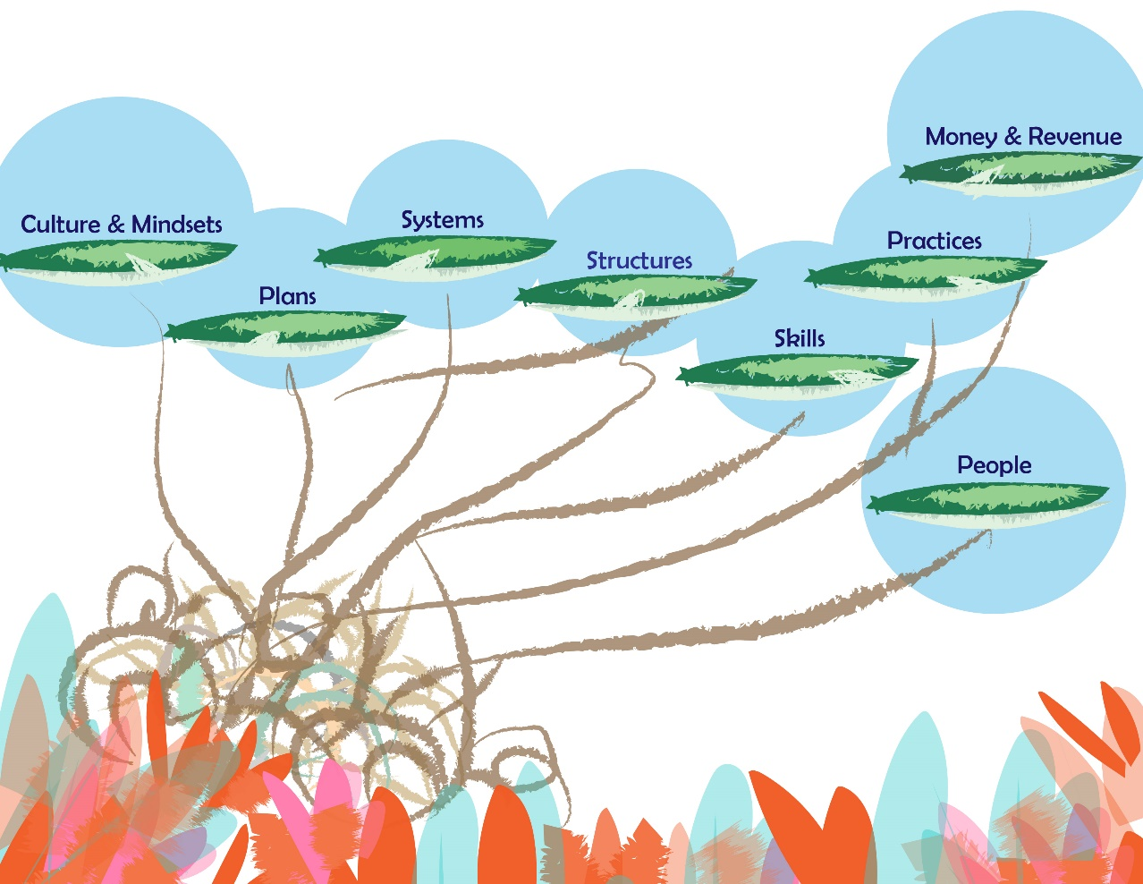

**Notes:**

1. http://www.mckinsey.com/clientservice/organizationleadership/TheInconvenient_Truth_About_Change_Management.pdf