**OVERALL PROGRAM OBJECTIVES**

At the end of the program, our intent is that you will have:

For nonprofits, financial viability and programmatic sustainability cannot be separated. It’s not enough to have a high-impact program if there’s no effective strategy for sustaining it financially. And neither is it enough to be financially stable: we build our organizations for impact, not for financial stability. Financial and impact information must be brought together in an integrated, fused discussion of strategy.

*Nonprofit Sustainability: Making Strategic Decisions for Financial Viability*

* A mindset that sustainability is an orientation, not a destination. An understanding that for organizations to remain relevant and viable, leaders need to adopt an ongoing and rigorous decision making practice that is driven by programmatic and financial imperatives.
* An understanding of your current revenue model and an articulation of your optimal model.
* A written plan that includes the following components:
* A financial assessment of current mission-specific and fund development programs
* Articulation of the organization’s problem statement and intended impacts
* An assessment of the impact of current mission-specific and fund development programs
* A set of decisions and high-level priorities to put the organization on a path towards increased organizational impact and financial sustainability.
* Alignment among your team members; a shared understanding of the new model, organizational priorities and leadership accountability.

**IN-PERSON SEMINARS**

Seminars will be a blend of facilitation and instruction; peer-learning; team work-sessions; and individual reflection. The sessions will be focused on the following themes:

**APRIL 7, 2016 SESSION ONE: Core**

* + A sustainability orientation requires continuous attention to both programmatic impact and financial health in a constantly changing environment.
  + Understanding and committing to what is truly core for your organization is a way to ground and orient yourself as you make strategic decisions that enhance sustainability.

**MAY 12, 2016 SESSION TWO: Context**

* + In social change work we must continuously learn from our work and refine our understanding of the problems we aim to resolve.
  + Getting clear on our current analysis of the problem provides a critical baseline for articulating and assessing our intended impact.

**JUNE 23, 2016 SESSION THREE: Engage and Align**

* + Meaningful engagement of other leaders throughout the system is critical to a sustainability orientation.
  + A deep alignment between our intended impact and revenue model is a requirement for long-term success.

**JULY 21, 2016 SESSION FOUR: Change**

* Reflection, continuous learning and celebration are important leadership practices that foster sustainability.
* Effective decision making requires both committing fully to a specific direction and remaining open to re-orienting as learning continues.

**HOMEWORK**

Between each seminar you will be given homework to continue analysis and development of your plan; guide you in bringing program content and learnings back to staff and board; and vet proposed decisions with others within your organization to get feedback, increase ownership, and foster alignment.

**RESOURCES AND TECHNICAL SUPPORT**

As a participant in this program, you have access to CompassPoint’s resources including publications, training material, webinars, templates and tools. These resources will be used to support implementation of your plan. You also have access to 1-1 phone consultation support with your facilitators to help in utilizing these tools, if needed.

**Access resources here:** [**www.compasspoint.org/oscp-resources**](http://www.compasspoint.org/oscp-resources)

**COMMUNICATION AGREEMENTS**

* **Confidentiality** is often defined as “what’s said in the room stays in the room” and we agree not to discuss what happens here in a way that would identify any individual or organization. There is another dimension to confidentiality that includes “asking permission” to share or discuss any statement another person makes of a personal nature. It helps to remember that the story belongs to the teller, not the listener.
* **Move-up Participation**. Honor different beliefs and encourage empowerment by making a space for all voices, experiences and ideas to be heard and shared. Talking does not equal participation. Generous listening is a form of participating. If you speak a lot, try listening more. And it you tend to sit back and listen, consider speaking up more.
* **Intent is different than impact**, and both are important. It is also important to own our ability to have a negative impact in another person’s life despite our best intention. In generous listening, if we assume positive intent rather than judging or blaming, we can respond, rather than reacting or attacking when a negative impact occurs.
* **It’s okay to disagree**. Avoid attacking, discounting or judging the beliefs and views of yourself or others – verbally or non-verbally. Instead, welcome disagreements as an opportunity to expand your world. Ask questions to understand other people’s perspectives.

**LEARNING AGREEMENTS**

* **Embrace polarities**. Avoid binaries and embrace wicked questions (i.e. paradoxical truths), such as “How is it that we are an organization with a national identity and we are uniquely adapted to each local setting?”
* **Real Play, Not Role Play**. This space is an opportunity to practice meaningful conversations that will occur in your organizations.
* **Name elephants**. Be intentional about speaking the unspeakable; foster a culture of candor inside and outside your organization.
* **Be open to new ideas and perspectives**, and be open to having your current ideas and perspectives challenged.
* **Embrace inquiry**. Ask difficult, reflective questions as a matter of course.
* **Be ready for pivots**, from ambiguity to direction, from abstract to concrete, from options to decisions.
* **Don’t come to consensus too soon**. It’s okay to let things simmer and it’s okay to change our minds. Create a parking lot for unresolved issues that we need to reflect on and revisit later.

**SESSION ONE: IDENTITY AND PURPOSE  
*What is Core?***

**Today’s objectives:**

* Understand what a *sustainability mindset* is, and begin to consider what it requires – of leaders and of organizations
* Begin to identify *what is core* for your organization
* Identify your organization’s current revenue model and begin to explore the implications of that model
* Begin to define your organization’s mission-specific and fund development programs for the matrix map analysis

**Identity and Purpose: What is Core?**



“**Who are we now**?” is a query that keeps us noticing how we are creating ourselves—not through words and position papers, but through our actions and reactions from moment to moment. All living systems spin themselves into existence because of what they choose to notice and how they choose to respond. This is also true of human organizations, so we need to acknowledge that we are constantly creating the organization through our responses.

To monitor our own evolution, we need to ask this question regularly. Without such monitoring, we may be shocked to realize who we've become while we weren't watching.

*– from “Bringing Life to Organizational Change”  
by Margaret J. Wheatley & Myron Kellner-Rogers*

**What is Sustainability?**

Sustainability is a word we hear regularly in the nonprofit sector, often as if it’s a golden panacea, a magical place in which our revenue and resource needs will simply regenerate and enable us to focus “all” of our efforts on our mission-centered work. It is not uncommon to still come across this thinking – including funders and sometimes misguided board members who ask how we intend to make our work sustainable “when the grant runs out.”

The reality is that if by sustainable we mean an ongoing, steady existence to our work, then we as a sector have largely managed to achieve that – in California nonprofits are now the fourth largest industry in the state, generating 15% of our State GDP.[1] Nonprofit organizations are deeply embedded into our communities and as a whole are likely here to stay – and many of these organizations subsist successfully for decades on grants and other forms of contributed income.

But although the sector persists, individual organizations clearly ebb and flow, start up and shut down. From an organizational perspective, then, what do we actually mean by sustainability? Most nonprofit organizations are here to do work that spans generations, whether it’s a focus on shifting systems and structures that continue to oppress people, providing a platform for advocacy and full engagement in our democracy, or sustaining safety net systems for people struggling with poverty and its affects. It’s the compelling impact of this very work that drives the revenue and resources that we seek to sustain over time – and, necessarily, in these kinds of long-term efforts both our understanding of the work and the resources available to support them shift over time.

**What’s possible when we align ourselves in a personally sustainable way?**

* We can be more creative
* We can take risks more comfortably
* We are more energized and able to weather challenges
* Moral is higher
* Teamwork is stronger

**WE ARE MORE PRODUCTIVE!**

What would it look like if we focused on the elements of sustainability in a more holistic way? One way of thinking about sustainability is when *we generate more than we consume*. There is a clear parallel here to organizational finances – where this shows up as surplus or profit in a given year. Regular surpluses *are* an important component of organizational sustainability, but what might it mean if *all* of our resources – human, financial, organizational and otherwise – were aligned in a way that is designed to generate more than what it takes in? What happens when we stop thinking of organizational sustainability solely in the context of renewable funding and focus on fueling our overall efforts in an aligned – and energizing – way?

**What is Adaptive Leadership?***– excerpted from The Practice of Adaptive Leadership by Ronald Heifetz, Alexander Grashow, and Marty Linsky*

**Adaptive leadership is specifically about change that enables the capacity to thrive.** New environments and new dreams demand new strategies and abilities, as well as the leadership to mobilize them. As in evolution, these new combinations and variations help organizations thrive under challenging circumstances rather than perish, regress, or contract. Leadership, then, must wrestle with normative questions of value, purpose, and process. What does thriving mean for organizations operating in any particular context? Adaptive success in an organizational sense requires leadership that can orchestrate multiple stakeholder priorities to define thriving and then realize it.

**Successful adaptive changes build on the past rather than jettison it.** In biological adaptations, though DNA changes may radically expand the species’ capacity to thrive, the actual amount of DNA that changes is minuscule. More than 98 percent of our current DNA is the same as that of a chimpanzee; it took less than a 2 percent change of our evolutionary predecessors’ genetic blueprint to give humans extraordinary range and ability. A challenge for adaptive leadership, then, is to engage people in distinguishing what is essential to preserve from their organization’s heritage from what is expendable. Successful adaptations are thus both conservative and progressive. They make the best possible use of previous wisdom and know-how. The most effective leadership anchors change in the values, competencies, and strategic orientations that should endure in the organization.

“Adaptive leadership is the practice of mobilizing people to tackle tough challenges and thrive.”

**Organizational adaptation occurs through experimentation.** In biology, sexual reproduction is an experiment: it rapidly produces variations—along with high failure rates. As many as one-third of all pregnancies spontaneously miscarry, usually within the first weeks of conception, because the embryo’s genetic variation is too radical to support life. In organizations, the process appears similar. Global pharmaceutical giants must be willing to lose money in failures to find the next profitable medicine. Those seeking to lead adaptive change need an experimental mind-set. They must learn to improvise as they go, buying time and resources along the way for the next set of experiments.

**Adaptation relies on diversity.** In evolutionary biology, nature acts as a fund manager, diversifying risk. Each conception is a variant, a new experiment, producing an organism with capacities somewhat different from the rest of the population. By diversifying the gene pool, nature markedly increases the odds that some members of the species will have the ability to survive in a changing ecosystem. In contrast, cloning, the original mode of reproduction, is extraordinarily efficient in generating high rates of propagation, but the degrees of variation are far less than for those in sexual reproduction. Cloning, therefore, is far less likely to generate innovations for finding and thriving in new environments. The secret of evolution is variation, which in organizational terms could be called distributed or collective intelligence. Likewise, adaptive leadership on economic policy would want to diversify an economy so that people are less dependent on one company or industry for sustenance. For an organization, adaptive leadership would build a culture that values diverse views and relies less on central planning and the genius of the few at the top, where the odds of adaptive success go down. This is especially true for global businesses operating in many local microenvironments.

**What is thriving*?***  
“Thriving” includes three characteristics:

* Preserving what’s core;
* Letting go of what’s no longer needed; and
* Organizing ourselves in ways that enhance our ability to flourish in new and more challenging environments.

**New adaptations significantly displace, reregulate, and rearrange some old DNA**. By analogy, leadership on adaptive challenges generates loss. Learning is often painful. One person’s innovation can cause another person to feel incompetent, betrayed, or irrelevant. Not many people like to be “rearranged.” Leadership therefore requires the diagnostic ability to recognize those losses and the predictable defensive patterns of response that operate at the individual and systemic level. It also requires knowing how to counteract these patterns.

**Adaptation takes time.** Most biological adaptations that greatly enhance a species’ capacity to thrive unfold over thousands, even millions, of years. Progress is radical over time yet incremental in time. It seems to work this way: a variant in the current population has the adaptive capacity in its time to venture a bit beyond the normal ecological niche for its kind, stressing itself near the margins of the range that it and its offspring can tolerate. For example, an unusual human being moves to colder or higher terrain and finds it can live there.

“Successful adaptations enable a living system to take the best from its history into the future.”

**What is Core?**

A dictionary definition of core names it as the “central, innermost, or most essential part of anything.” In his work, researcher and management consultant Jim Collins discusses an organization’s Core Ideology in the terms of deepening our understanding of it, not designing or creating it:

“You do not create or set core ideology. You discover core ideology. You do not deduce it by looking at the external environment. You understand it by looking inside. Ideology has to be authentic. You cannot fake it. Discovering core ideology is not an intellectual exercise. Do not ask, What core values should we hold? Ask instead, What core values do we truly and passionately hold? You should not confuse values that you think the organization ought to have – but does not – with authentic core values. To do so would create cynicism throughout the organization. (‘Who're they trying to kid? We all know that isn't a core value around here!’) Aspirations are more appropriate as part of your envisioned future or as part of your strategy, not as part of the core ideology. However, authentic core values that have weakened over time can be considered a legitimate part of the core ideology – as long as you acknowledge to the organization that you must work hard to revive them.

Core ideology needs to be meaningful and inspirational only to people inside the organization; it need not be exciting to outsiders. Why not? Because it is the people inside the organization who need to commit to the organizational ideology over the long term… You cannot impose new core values or purpose on people. Nor are core values and purpose things people can buy into. Executives often ask, How do we get people to share our core ideology? You don't. You can't. Instead, find people who are predisposed to share your core values and purpose; attract and retain those people; and let those who do not share your core values go elsewhere.’[2]

The question of core, then, is one of exploration and understanding, not of prescription and commanding. The question is essentially a human one easily applied to organizational form – what is it that we are uniquely designed to be and how do we grow into its full expression?

It’s the seeds of a plant that determine its ultimate characteristics. The seed of a redwood tree is unimaginably small but within it is an essential purpose to become what it must – one of the largest most enduring trees on the planet.

So what does this mean and why does it really matter from an organizational context? As we become deeply curious about what’s at our core as an organization, and work diligently to align ourselves with that, it becomes a true guide in our ongoing development.

Regarding organizational size, for example, it is not necessarily simply a question of if, when, and how to grow. The more compelling, and challenging, question about organizational size is – what size do we need to be in order to fully express what’s embedded in our core?

**EXERCISE: Reflected Best Organization**

1. Think of a time when your organization was at its best. Jot down as many details as possible. What happened? Who was there? Why does that particular experience come to mind?

**What’s Your Organization’s Core?**

* Unique approaches to the work
* Organizational values and principles
* Positive attributes of organizational culture
* Ingrained talents and strengths

1. Discuss what your stories tell you about what’s “core” for your organization and together identify what’s core:

* What is your organization’s unique approach(es) to the work?
* Organizational values and principles?
* Positive attributes of organizational culture?
* Ingrained talents and strengths?

1. Create a visual expression of what is core for your organization.

**REFLECTION: Exploring What’s Core**

How might we define what’s core to *who we are* as an organization?

**What is Nonprofit Sustainability?***-- excerpted from The Sustainability Mindset by Jeanne Bell and Steve Zimmerman*

“Sustainability encompasses both *financial sustainability* (the ability to generate resources to meet the needs of the present without jeopardizing the future) and *programmatic sustainability* (the ability to develop, mature, and cycle out programs to be responsive to constituencies over time).”

This definition does notencompass two separate, complementary ideas. Rather, the two ideas are of one piece and are not independent of one another over time. Great organizations develop, mature, and innovate their mission-specific programs in concert with the continuous development, maturation, and innovation of their fund development programs. Leaders who deeply understand this are able to guide their organizations to achieve deep impact and modest profitability.

Mission and resources cannot be separated in any useful or logical manner. Achieving great results requires great resources—time, money, partnerships, and community will—all of which must be intentionally and continuously cultivated. In fact, this notion of continuous is central to our point of view on sustainability.

While the matrix map (more on this later) process of assessing the impact and net financial return of each program in an organization’s business model engages an organization’s leadership in an intensive inquiry over several months, sustainability is an orientation, not a destination. It is not a one-time thing, not an episodic thing, not a senior management thing or a board of directors thing. It’s really a mindset and way of organizational being. The way of thinking about two bottom lines in a holistic way, the sharp financial analysis, and the co-created language around impact all live on well past the creation of the matrix map. When we do this work well, they become inextricably woven into the fabric and culture of the organization.

**Dual Bottom Line**

The dual bottom line provides a framework for thinking about the portfolio of activities in a nonprofit organization and assessing each activity based on both its mission impact and financial return. 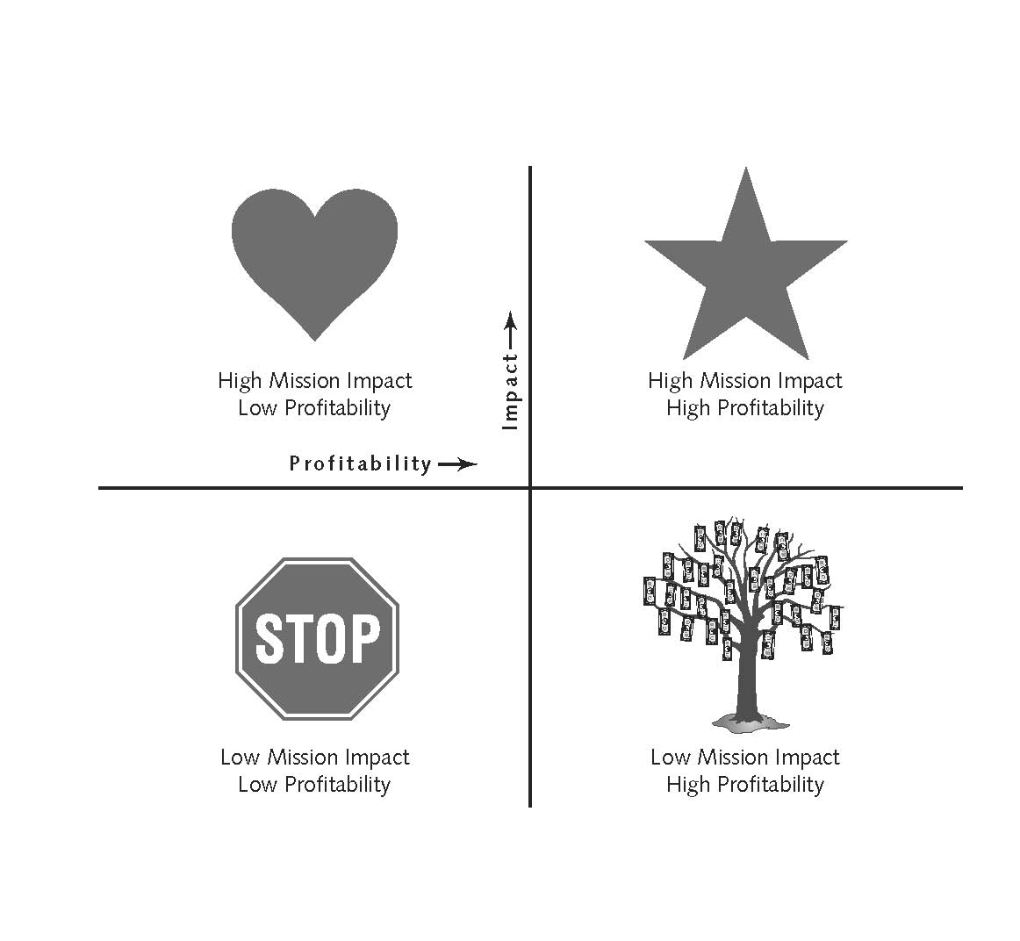

At any given moment, a nonprofit may have a portfolio of activities that are spread across the four quadrants shown in the figure. Locating activities in these quadrants through a systematic assessment of data – what we call creating a Matrix Map – will suggest a clear set of decisions that leaders need to make in order to foster the business model’s overall strength.

**Notes:**

**Identifying Your Revenue Model**

As nonprofits we have access to several different streams of funding and while each of those streams offer us different benefits, each also requires us to develop different management structures and relationships. In years past, “revenue diversity” has often been lauded as a critical element of nonprofit financial management and fiscal health. However, as the sector matures, we are understanding more deeply the programmatic and infrastructure implications of different revenue strategies. Research by The Bridgespan Group, among others, has demonstrated that many organizations successfully grow through intentional investment in a dominant type of revenue that is aligned with its work and intended impact (and focus efforts on diversifying among several sources). It’s good to have one primary income type that is reliable and repeatable and a secondary unrestricted income source. Even having 8% of your income from annual giving can ease cash flow throughout the year—8% is one month of operating expense!

With this in mind, the revenue question becomes not so much about how to diversify but about how to maximize the revenue streams that are most aligned with the organization’s goals and values. In articulating and nurturing the funding model for an organization, it can be particularly helpful to think about the people behind the funding streams:

* **Who decides?** Within your principal source of funding, who are the particular set of people who dictate the flow of funds? What does that mean for the relationships and systems you need to attend to?

Donors do *not* give to your organization. They give *through* your organization to achieve their own desires…  
to fulfill their own aspirations…  
to live out their own values. —Simone Joyaux

* **What are their motivations?** Thinking   
  of these people specifically, what do they want to achieve – for themselves and/or their communities – by giving   
  to your organization? How do they think about and assess the value that your organization delivers?

**Notes:**

**EXERCISE: Revenue Stream Analysis**

**Type of Revenue: ____________________________________________________**

□ Primary Stream □ Secondary Stream □ Other/Unknown

$$ of Current Annual Revenue: ____________ % of Current Annual Revenue: _____________

Type: □ Earned □ Contributed Unrestricted □ Contributed Restricted

Source: □ Individuals □ Governments □ Organizational □ Other _________________

**STABILITY RATING (rate 1-4 on each)**

**____ Flexibility:** How flexible is this revenue stream? On average, how easily can we use it at our discretion to maximize our impact? If we change our mind about program design or a particular strategy, do we need to “run it by” these funders first?

1 = not at all flexible; most sources in this stream monitor precisely how their funds are spent

2 = not very flexible; most sources in this stream are only interested in funding a particular program or activity, but might be open to potential shifts in our program direction

3 = somewhat flexible; most sources in this stream might be interested in funding a particular program or activity, but we have a fair amount of discretion in how we use it toward those ends

4 = very flexible; we have significant discretion as to how to use these funds to further our work

**____ Repeatability:** Is this a revenue stream that we can expect to count on as a regular stream of annual revenue? Are we relatively certain that we will continue to have consistent access to this type of revenue for the foreseeable future?

1 = not at all repeatable; this revenue stream is very sporadic and unpredictable – a “windfall”

2 = not very repeatable; this revenue stream is currently somewhat unsteady but has the potential to be more regular for our organization

3 = somewhat repeatable; we have developed a pattern of securing this revenue stream and have some multi-year commitments

4 = very repeatable; we have established a strong history with this revenue stream and have many multi-year commitments

**SURPLUS-GENERATING: YES / NO**

Do we consistently generate surplus from this revenue stream? To do so it must be both:

Y / N Unrestricted (contributed or earned), and

Y / N Profitable: the full cost of the activities supported by this revenue stream (including the systems and staffing required to manage it) is consistently less than the revenue they generate

If this revenue stream represents unrestricted funds (earned or contributed), what might it take to potentially generate or increase the surplus from this stream?

**RELATIONSHIP AND INFRASTRUCTURE REQUIREMENTS**

**Who decides?** Within this revenue stream, who are the particular set of people who dictate the flow of funds?

**What are their motivations?** Thinking of the people behind these funds specifically, what do they want to achieve – for themselves and/or their organizations or communities – by giving to your organization? How do they think about and assess the value that your organization delivers?

**What are the implications?** Given the needs and motivations of the decision-makers, as well as the nature of managing this type of funding stream, what are some of the implications of the relationships and systems you may need to tend to? What is strong? What needs attention?

**Notes:**

**EXERCISE: Revenue Stream Analysis**

**Type of Revenue: ____________________________________________________**

□ Primary Stream □ Secondary Stream □ Other/Unknown

$$ of Current Annual Revenue: ____________ % of Current Annual Revenue: _____________

Type: □ Earned □ Contributed Unrestricted □ Contributed Restricted

Source: □ Individuals □ Governments □ Organizational □ Other _________________

**STABILITY RATING (rate 1-4 on each)**

**____ Flexibility:** How flexible is this revenue stream? On average, how easily can we use it at our discretion to maximize our impact? If we change our mind about program design or a particular strategy, do we need to “run it by” these funders first?

1 = not at all flexible; most sources in this stream monitor precisely how their funds are spent

2 = not very flexible; most sources in this stream are only interested in funding a particular program or activity, but might be open to potential shifts in our program direction

3 = somewhat flexible; most sources in this stream might be interested in funding a particular program or activity, but we have a fair amount of discretion in how we use it toward those ends

4 = very flexible; we have significant discretion as to how to use these funds to further our work

**____ Repeatability:** Is this a revenue stream that we can expect to count on as a regular stream of annual revenue? Are we relatively certain that we will continue to have consistent access to this type of revenue for the foreseeable future?

1 = not at all repeatable; this revenue stream is very sporadic and unpredictable – a “windfall”

2 = not very repeatable; this revenue stream is currently somewhat unsteady but has the potential to be more regular for our organization

3 = somewhat repeatable; we have developed a pattern of securing this revenue stream and have some multi-year commitments

4 = very repeatable; we have established a strong history with this revenue stream and have many multi-year commitments

**SURPLUS-GENERATING: YES / NO**

Do we consistently generate surplus from this revenue stream? To do so it must be both:

Y / N Unrestricted (contributed or earned), and

Y / N Profitable: the full cost of the activities supported by this revenue stream (including the systems and staffing required to manage it) is consistently less than the revenue they generate

If this revenue stream represents unrestricted funds (earned or contributed), what might it take to potentially generate or increase the surplus from this stream?

**RELATIONSHIP AND INFRASTRUCTURE REQUIREMENTS**

**Who decides?** Within this revenue stream, who are the particular set of people who dictate the flow of funds?

**What are their motivations?** Thinking of the people behind these funds specifically, what do they want to achieve – for themselves and/or their organizations or communities – by giving to your organization? How do they think about and assess the value that your organization delivers?

**What are the implications?** Given the needs and motivations of the decision-makers, as well as the nature of managing this type of funding stream, what are some of the implications of the relationships and systems you may need to tend to? What is strong? What needs attention?

**Notes:**

**REFLECTION: Revenue Model Analysis**

****Reviewing your trend analysis pre-work, along with the work you’ve done above, consider:

* How can we build upon our strengths to take advantage of the internal or external factors that are driving increased revenue trends?
* Where do we need continued infrastructure investment to support and further develop our capacity to effectively manage and build upon those streams?
* What themes can we identify related to either the internal factors (our organizational capacity to manage particular streams) and/or external factors (changes in policies, funders’ priorities, partnership opportunities) that are influencing revenue trends? What do we need to tend to as an organization to address these themes?

**Notes:**

**The Matrix Map***-- excerpted from The Sustainability Mindset by Jeanne Bell and Steve Zimmerman*

The matrix map, a visual representation of an organization’s business model, demonstrates how mission-specific programs and fund development programs work together to create impact and financial viability, thereby reflecting the organization’s dual bottom line.

*SAMPLE: Tempest Theater Matrix Map*

Each mission-specific program and fund development program is plotted on the axis according to its rating, with mission impact on the vertical axis and profitability on the horizontal axis. Breakeven is in the middle of the horizontal axis, showing programs that generate a surplus to the right and those that don’t currently or cannot generate a surplus on the left.

The resulting picture presents a unified image allowing board and staff to understand the interaction of the programs with each other and the organization overall rather than looking at each program individually. Taken together it represents the organization’s business model, demonstrating the impact of each program or activity of the organization and the outcome of revenue generation and investment. This allows the board and staff to make strategic decisions by understanding the implications of each decision along multiple dimensions and strengthen the business model in the pursuit of sustainability.

|  |  |
| --- | --- |
| **What the Matrix Map Shows** | **How It Shows This** |
| What the organization does | Each bubble represents a different program of the organization. Both mission-specific and fund development programs are reflected on the map. |
| Profitability of each activity | Profitability is measured along the horizontal axis, with the vertical axis crossing at breakeven. The placement of the bubble along this axis shows the profitability of the program. Placement on the right signifies the program generates a surplus, while placement on the left indicates the program isn’t able to cover its full costs. |
| Profitability of the organization | A box explicitly states the financial bottom line reflected in the organization’s map. |
| Relative mission impact of each activity | The vertical axis represents the blended mission impact assessment for each program. Higher placement reflects greater assessed impact of that activity in both absolute terms and relative to other programs. To understand the impact better requires analyzing the criteria used for assessing impact and the scoring the program received. |
| Where the organization is investing its resources | The circle size represents the gross expenses of each program, allowing us to easily see where the organization is investing the majority of its resources. |
| Mix between programming and fund development | The color or shading of the circle identifies the primary purpose of the program: a mission-specific program or a fund development program. |

*-- from The Sustainability Mindset by Jeanne Bell and Steve Zimmerman*

|  |  |
| --- | --- |
| **REVENUE STREAMS** | **MATRIX MAP ANALYSIS** |
| Earned Income | **Blue** Bubble |
| Membership Income | **Blue** Bubble |
| Corporate Donations/Sponsorship | **Blue** Bubble (usually) |
| Government Contracts | **Blue** Bubble |
| Foundations-Restricted | **Blue** Bubble |
| Foundations-Unrestricted | **Green** Bubble |
| Individual Contributions (unrestricted) | **Green** Bubble |
| Special Events | **Green** Bubble |
| In-Kind | **Green** or **Blue** Bubble  * Zero profitability * Expense affects *size* of bubble |

**Current Program Portfolio**

At first glance, the thought of defining your organization’s programs may seem simple enough: you know which mission-specific programs you run, add in some fund development programs, and you have your list. But when was the last time you thought systematically about what your organization does and how it does it? While it may be easy to overlook this step, if you don’t spend some time thinking about how best to structure or group your programs, you might end up with a matrix map that doesn’t tell you what you need to know to meet your strategic issue and improve your sustainability.

**EXERCISE:** Identify how you want to group your organization’s mission-specific and fund development programs for the matrix map.

|  |
| --- |
| **MISSION-SPECIFIC PROGRAMS (BLUE BUBBLES ON THE MATRIX MAP)** |
|  |
|  |
|  |
|  |
|  |
|  |
|  |

|  |
| --- |
| **FUND DEVELOPMENT PROGRAMS (GREEN BUBBLES ON THE MATRIX MAP)** |
|  |
|  |
|  |
|  |
|  |
|  |
|  |

**HOMEWORK: Setting up for the Financial Analysis**

Before session 2, each team should complete the following homework (see sample below):

* Finalize your definition of mission-specific and fund development programs (*Sustainability Mindset*, Chapter 4)
* Financial analysis for matrix map (*Sustainability Mindset*, Chapter 6)
* *Optional Reading: Sustainability Mindset:* Chapters 4-6

**Profitability***-- excerpted from The Sustainability Mindset by Jeanne Bell and Steve Zimmerman*

Profitability is essential for nonprofits to be financially viable and sustainable, yet there sometimes lingers the archaic notion that nonprofits can’t, or shouldn’t, be profitable. Yet like any other business, a nonprofit organization needs to be profitable to secure its future. Senior leaders and board members sometimes bristle at the word *profitability*, because they think it implies a focus solely on profitability or that every program needs to be profitable. Neither of these is true. Not every program within a nonprofit can be profitable. Often organizations are founded because of market failure: there is a need for a service without a possible payer. In other cases, revenue may cover a portion of the total expenses, but not enough to break even. In the dual-bottom-line model, however, these programs may be essential for their contribution to the organization’s overall impact. Looking at them not individually but in relation to the financial profitability of other programs, both mission-specific and fund development programs, is essential.

Although not every program needs to be profitable, some need to be for the organization to be financially sustainable. The matrix map is about balance. For every program that can’t break even, another needs to generate a surplus if the organization is to be viable.

To be sustainable, nonprofits need to have some years when the organization as a whole is profitable. Profitability builds operating reserves, which allows organizations to invest in new, potentially higher-impact ideas before they have support from foundations or the marketplace. They also allow organizations to survive in economic downturns, maintaining services while adjusting their business models.

|  |  |  |  |  |  |  |  |  |  |  |  |  |  |  |  |  |  |  |  |  |
| --- | --- | --- | --- | --- | --- | --- | --- | --- | --- | --- | --- | --- | --- | --- | --- | --- | --- | --- | --- | --- |
| **SAMPLE ORGANIZATION** | |  | |  | | | |  | | |  | |  | | | |  | | | |
| **Financial Statements by Business Line** | | | | | |  | | | |  | | | |  | | | |  |
| **Basis: 2015 Actual** | |  | |  | | | |  | | |  | |  | | | |  | | | |  |
|  | **PROGRAMS** | | | | | | **FUNDRAISING** | | | | | **ADMIN** | | |  |  | | | |
|  | **Health** | | **Civic Engage-ment** | | **Housing** | | **Un-restricted Grants** | | **Special Events** | | | **Admin.** | | | **Shared** | **Total** | | | |
| ***Revenues*** |  | |  | |  | |  | |  | | |  | | |  |  | | | |
| Release from Restriction | - | | - | | - | | - | | - | | | - | | |  | - | | | |
| Foundation contributions | 194,500 | | 262,000 | | 37,500 | | - | | - | | | - | | |  | 494,000 | | | |
| Government contracts | 88,000 | | - | | - | | 40,000 | | - | | | - | | |  | 128,000 | | | |
| Individual contributions | - | | - | | - | | - | | - | | | - | | |  | - | | | |
| Membership / Events | - | | - | | - | | - | | 77,000 | | | - | | |  | 77,000 | | | |
| **Total Income** | 282,500 | | 262,000 | | 37,500 | | 40,000 | | 77,000 | | | - | | |  | 699,000 | | | |
|  |  | |  | |  | |  | |  | | |  | | |  |  | | | |
| **Total Expenses** | 83,035 | | 143,437 | | 105,540 | | 46,642 | | 50,765 | | | 85,405 | | | 150,025 | 664,850 | | | |
|  |  | |  | |  | |  | |  | | |  | | |  |  | | | |
| Shared Allocation – FTE % | 16% | | 36% | | 18% | | 6% | | 4% | | | 20% | | | -100% |  | | | |
| Shared Allocation | 24,550 | | 54,418 | | 27,414 | | 8,865 | | 5,455 | | | 29,323 | | | (150,025) | - | | | |
| Direct & Shared Expenses | 107,585 | | 197,856 | | 132,954 | | 55,507 | | 56,220 | | | 114,728 | | | - | 664,850 | | | |
|  |  | |  | |  | |  | |  | | |  | | |  |  | | | |
| Administration Allocation % | 20% | | 36% | | 24% | | 10% | | 10% | | | -100% | | |  |  | | | |
| Administration Allocation | 22,437 | | 41,263 | | 27,728 | | 11,576 | | 11,725 | | | (114,728) | | |  |  | | | |
|  |  | |  | |  | |  | |  | | |  | | |  |  | | | |
| **Fully Allocated Expenses** | 130,022 | | 239,119 | | 160,681 | | 67,083 | | 67,945 | | | - | | | - | 664,850 | | | |
|  |  | |  | |  | |  | |  | | |  | | |  |  | | | |
| **Net Income / Subsidy** | 152,478 | | 22,881 | | (123,181) | | (27,083) | | 9,055 | | | - | | | - | 34,150 | | | |

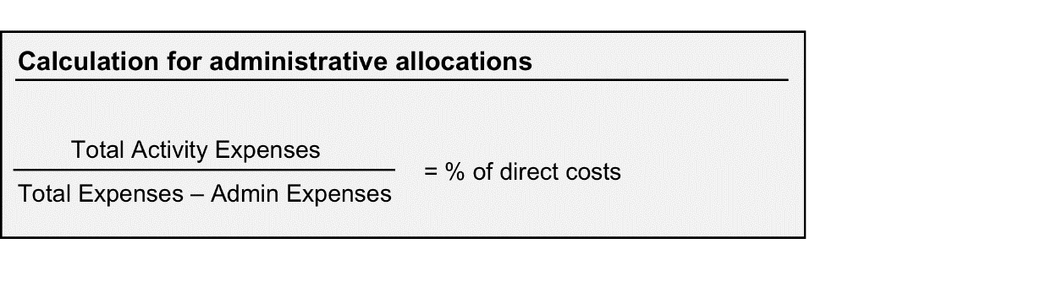

FYI/Reference Only:  
This is the formula used in the excel workbook to calculate the admin allocation.

**DISCUSSION QUESTIONS: In Organizational Teams**

* What were your most important insights from today’s conversation?
* As you begin this process, how ready do you think your organizational systems and culture are to support and foster the changes you will be introducing?
* What strengths will you draw on and what barriers will you face?

**Notes:**

1. “Causes Count: The Economic Power of California’s Nonprofit Sector,” CalNonprofits, 2014. http://calnonprofits.org/causes-count
2. “Building Your Company’s Vision,” Collins & Porras, Harvard Business Review, 1996.