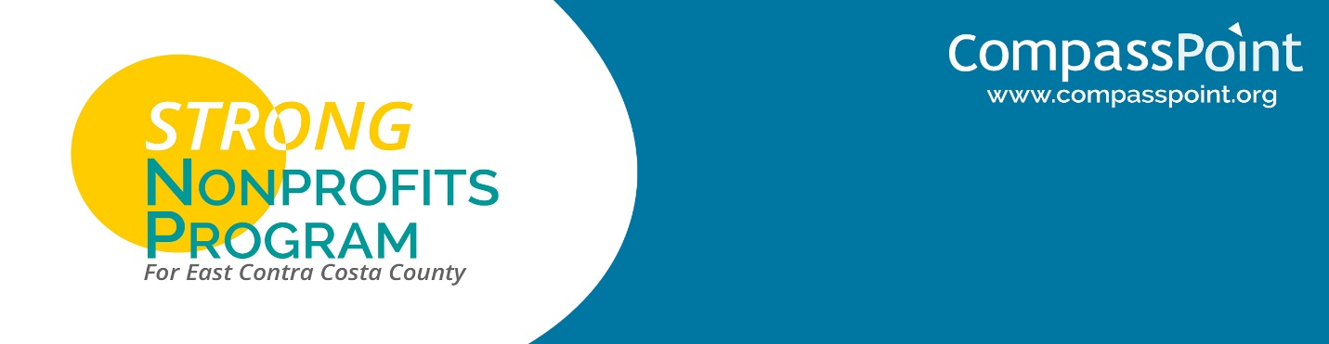

**STRATEGIC THINKING WORKSHEET**

**Group Discussion**

**1. What were the most important takeaways from listening to the funders?**

**2. What are the strategic implications of this morning’s discussions for East County nonprofits? What is this moment in time strategically for our region?**

**Team Discussion**

**1. What are the strategic implications of this morning’s discussions for our organization?**

**2. What is this moment in time strategically for our organization? What next actions can we identify to respond to this strategic moment in time?**